**Integrity, Equality, Respect, Responsibility, Ambition**

**Responsibility, Ambition, Integrity, Equality, Respect**

**Ambition, Integrity, Equality, Respect, Responsibility**

**Irvine Royal Academy**

**Higher Physical Education**

**Football Block**

Emotional and Physical Factors Impacting Performance

Features Covered

Emotional

* Fear
* Anger

Physical

* Cardio Respiratory Endurance
* Agility

[](http://www.google.co.uk/url?sa=i&rct=j&q=&esrc=s&source=images&cd=&cad=rja&uact=8&ved=0ahUKEwjymYrz4vfMAhXmC8AKHdc0Ci0QjRwIBw&url=http://www.clipartbro.com/categories/soccer-black-and-white-clipart-clipart&bvm=bv.122852650,d.ZGg&psig=AFQjCNGpSd8VK6d2SiX929J-ftPB4jTXOw&ust=1464353192204653) 

Contents Page

|  |  |
| --- | --- |
| **Page** | **Content** |
| 1 | Front Cover |
| 2 | Contents Page |
| 3 | Introduction to the Course |
| 4 | Factors Impacting on Performance |
| 5 | Agility |
| 6 | Cardio Respiratory Endurance |
| 7 | Fear |
| 8 | Anger |
| 9 | Methods of collecting information |
| 10-12 | Cooper Test and Illinois Agility Test |
| 13-14 | Sport Emotion Questionnaire |
| 15-17 | Discipline Record |
| 18 | Approaches to developing performance |
| 19-25 | Training within the activity (Interval and Continuous Training) |
| 26-27 | Principles of Training |
| 28-29 | Mental Imagery/Visualisation |
| 30-31 | Positive Self Talk |
| 32 | Recording, Monitoring and Evaluating |
| 33 | The purpose of monitoring and evaluating |
| 34-35 | Recording performance development - Training Diary |
| 36 | Monitoring performance development |

**Introduction to the course**

**Course content**

When studying Higher Physical Education you will learn about your own performance and how it can be improved. The process you go through will require you to reflect on what you already know from your study of PE and ask you to apply this knowledge further to unfamiliar situations.

You will learn about the factors that impact on performance and you will implement and evaluate approaches to develop performance further. This will be internally assessed. You will be required to demonstrate a broad and comprehensive range of complex movement and performance skills in TWO physical activities to pass the Performance Skills Unit.

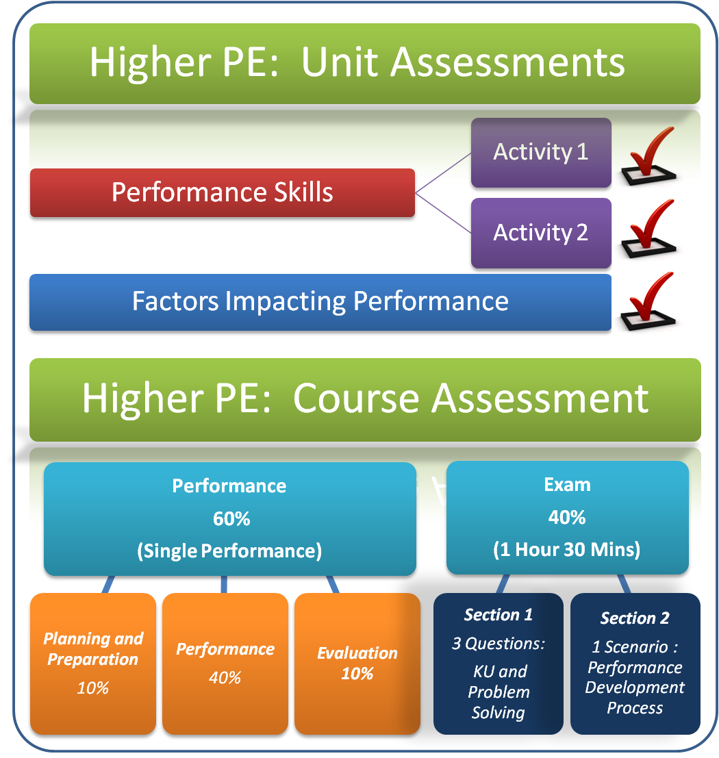

[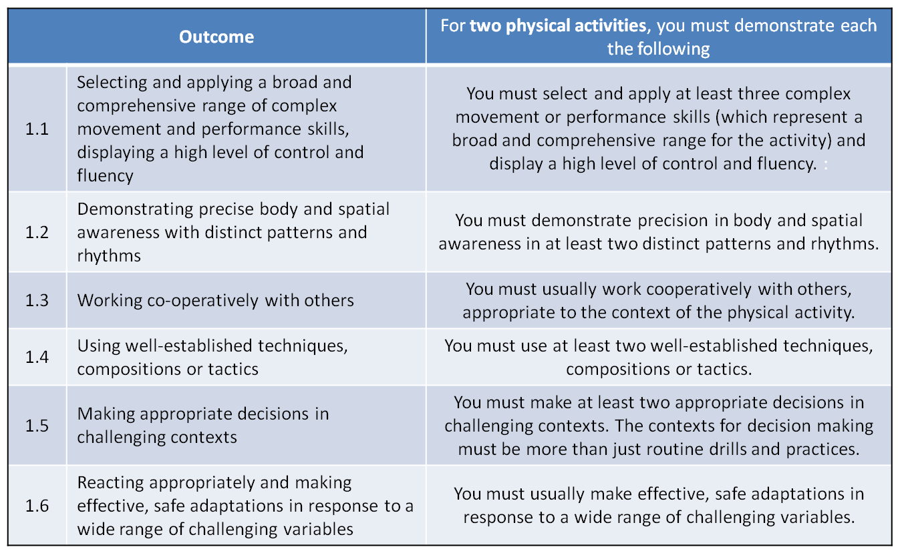](http://blogs.kincorth.aberdeen.sch.uk/higher/files/2013/12/HIGHER-PERFORMANCE2.png)

Factors Impacting on Performance

Factors (Features)

|  |  |
| --- | --- |
| **Physical (Fitness)** | **Emotional** |
| Cardio Respiratory Endurance | Fear |
| Agility | Anger |
|  |  |

The information in this section explains how different **factors** can have a **positive and negative impact on your performance** when competing in football.

The two factors we will focus on are **emotional and physical.** These factors are broken down into **features** and examples are provided explaining how these features will positively or negatively impact your performance.



**Physical Factor**

**Agility “Agility is the ability to turn or adjust position quickly whilst maintaining control and is a combination of speed, flexibility and balance”**

Agility is not just about the speed with which an individual can change direction. But it's also defined by the grace and fluidity of movement.

Agility is required for almost every performer in every activity. The ability to explosively start, decelerate, change direction and accelerate again quickly is particularly important in football.

How does agility **Impact Positively on performance**?

Agility is important in football as it enables a player to **change direction quickly** and fluently while remaining balanced and in control. Also, an agile player can **explosively** stop, change direction and increase speed again. This is vital when a player is in possession of the ball and attempting to beat an opponent or evade a challenge. In an attacking situation an agile player will be able to create space for themselves in order to **retain possession of the ball and create scoring opportunities for their team**. In a defensive situation they will be able to **close down** an opponent quickly, **respond** quicker to an opponent's movements/actions and stay **tight** to their marker.

How does lack of agility **impact negatively** on performance?

Lack of agility makes you an easy target on a football pitch because you are a player to be **exploited**. An inability to change direction quickly and fluently means you will be **unable to stay close to your marker** and respond to any movements/actions they make. This means that you will find it difficult to **put pressure on them** and **steal possession** of the ball. Also, they will be able to lose you and **create space for themselves** to receive a pass and create a scoring opportunity. When you are in possession of the ball you will find it difficult to **outmanoeuvre** an opponent as you cannot change direction quickly.

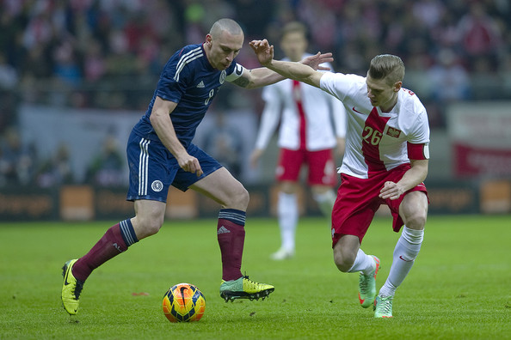

Physical Factor

**Cardio Respiratory Endurance**

**"The ability of the heart and lungs to provide the working muscles with oxygenated blood for a long period of time"**

**All football players need CRE to run and play the game at the highest intensity for prolonged periods of time.**

If you play any sport at a reasonable level then you must have an acceptable level of cardio respiratory endurance. **The length of a game of football and the dimensions of the field require a high aerobic capacity in order to sustain continuous movement up and down the pitch, to move forwards into attack and get back into defence**. The working muscles need to receive enough oxygen to allow them to work effectively.

How does good cardio respiratory endurance have a **positive impact** on your performance?

Cardio respiratory endurance (CRE) is required in order to **last the full 90 minutes** of the game in football. If a football player has good CRE they won't become breathless very quickly and therefore **their skill level will remain high throughout the entire game**. Also, you will be able to stay tight to an opponent for the full duration of the game, denying them space and time on the ball. **Good CRE also results in making the correct decisions during the game** e.g. when you are in the shooting circle passing to a team mate who is in a better scoring position rather than taking on a difficult shot. Finally, good CRE means that **your work rate will remain high throughout the game** and you can effectively fulfil your role in the team i.e. defence, midfield or attack.

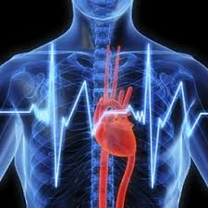

How does poor cardio respiratory endurance have a **negative impact** on your performance?

If you have poor CRE this **means fatigue and becoming breathless will happen quickly as the heart, lungs and blood system will be unable to supply sufficient oxygen to your muscles**. Subsequently, you will require **longer rest periods** during the game in order to recover, which means your **opponent will get away from you, you will be unable to move into space to receive a pass and you won't be able to get up and down the field to support in defence and attack**. Also, your skill level will deteriorate which could result in a poor pass which loses possession of the ball or a missed scoring opportunity in the shooting circle.

**Emotional Factor**

**Fear "Fear is an emotion induced by a perceived threat, which causes you to quickly pull away or in sporting terms, usually hide."**

**Impact on performance**

Fear produces **negative thoughts**, which directly impacts a football player’s confidence. Winning and losing is so important that fear of failure or fear of not performing well is at the forefront of a players mind.

If you **fear an opponent or opposition** then it is likely that your own **performance level will drop** significantly which will make it easier for the opposition to compete.

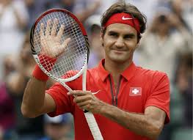 V 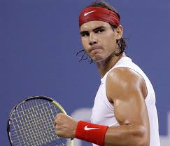

**Nadal has beaten Federer 23 times in 33 matches. It is said that Federer has a fear of playing Nadal, which is supported by their head to head record.**

Having a fear of failure can cause a player to become **convinced that the coach will drop him/her for the next match**. They will **feel uneasy** when the coach watches them play, because of a constant worry of what the coach is thinking. This will damage their performance, therefore this forces the coach to replace them for the next match. **The fear has been brought to life!**

Fear of failure prevents a player from moving outside their "comfort zone". **All top players take sporting risks at the potential cost of jeopardising their performance**. Risk taking is a fundamental component of being successful and it is only through bold and committed actions that football games are won and lost.

Fear of failure can cripple the player's **sense of adventure and the ability to take match winning risks**. The thought of making mistakes in front of team mates, coaches and spectators can be so paralysing that the player sits inside their comfort zone just doing the bare minimum.

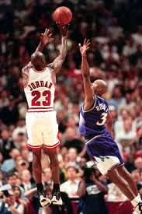When the player refuses to push outside the comfort zone **performances become reactive instead of proactive**. Instead of taking positive risks, which empower the player to influence the game, they allow the opposition to take control and dictate the play.

**Michael Jordan never feared taking a difficult shot to win the game!**

**Emotional Factor**

**Anger**

**"An emotion whereby the individual has normally been offended, denied, wronged and a tendency to react through retaliation. It is a strong, uncomfortable emotion after being provoked"**

**Impact on performance**

Anger in sport can be very useful in the right situation but more often than not it is about how you control your aggression that makes the difference. Opponents look to ways of irritating each other in the hope it puts them off a game plan or affects their performance.

Anger can take a number of different forms:

* **A player shouting at themselves after a bad shot or poor pass.**
* **Physically lashing out at an opponent e.g. dangerous tackle.**
* **Over aggression with a piece of equipment e.g. kicking ball away.**
* **Over exerting themselves in a skill such as increasing the power of their next hit pass.**

**Anger without control** will mostly affect performance **negatively** and will increase the number of poor decisions made.

**A player who can control their anger is much more effective** and it pays to practice good mental strength. The ability to control anger comes from practicing in competitive drills which apply pressure to your skill level e.g**. practicing against a much better opponent or even against more opponents than you.**

**Examples from football players**

"My opposite player was particularly good at protecting the ball and maintaining possession for his team. I was getting really annoyed at his good play and at myself for letting the team down. I was drawn into making silly fouls against him and eventually my anger and lack of self-control resulted in a yellow card and a free-kick in a dangerous area for the other team"

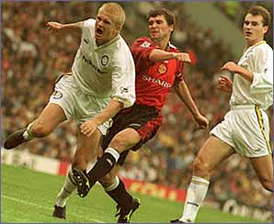 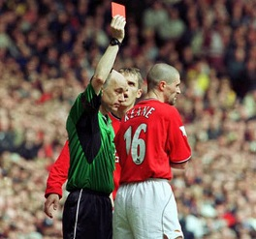

"I was playing football and noticed the defender was very slow. I was able to dribble past him quickly and either create a scoring opportunity for one of my team mates or take a shot at goal myself. This was getting him very angry and eventually he deliberately fouled me in the 18 yard box resulting in a penalty kick"

**Methods of Collecting Information**

The information in this section describes how you will **collect information** on the **factors impacting on your performance** in badminton.

It will also explain the **benefits** and **limitations** of using each method.

The methods of collecting information are as follows:

|  |  |  |
| --- | --- | --- |
| **Activity** | **Factor** | **Methods of collection** |
| **Football** | **Physical (Fitness)** | * Standardised Fitness Tests:  1. 12 Minute Cooper Test 2. Illinois Agility Test |
| **Emotional** | * Sport Emotion Questionnaire * Discipline Record |

[](http://www.privatelabelnutra.com/supplement-manufacturer-blog/wp-content/uploads/2012/08/shutterstock_102366094.jpg)

**PHYSICAL Feature – Cardio Respiratory Endurance**

**Standardised Fitness Test: Cooper Test**

The 12 minute run is a test that measures Cardio Respiratory Endurance.

* Run as far as you can in 12 minutes
* Set a steady pace that you can maintain for the 12 minutes of the run.

Scoring – The further you run, the better the score. Your score is the distance that you cover in metres in 12 minutes. Measure to the nearest cone.

Check and record your score using the norm chart below.

Metres covered in 12 minutes (before training) _______________

Metres covered in 12 minutes (after 3 weeks) ________________

|  |  |  |  |  |  |
| --- | --- | --- | --- | --- | --- |
| **Performer** | | **Performance Level** | | | |
| Age | Sex | Excellent | Good | Fair | Poor |
| 13 – 14 years | Male  Female | 2700  2000 | 2400  1900 | 2200  1600 | 2100  1500 |
| 15 – 16 years | Male  Female | 2800  2100 | 2500  1900 | 2300  1700 | 2200  1600 |
| 17 – 18 years | Male  Female | 3000  2300 | 2700  2100 | 2500  1800 | 2300  1600 |

**Physical Feature - Agility**

**Illinois Agility Test (Standardised Fitness Test)**

This shuttle run tests your speed and agility.

Equipment needed:

* A running lane, 10 metres long by 5 metres wide
* Stop watch

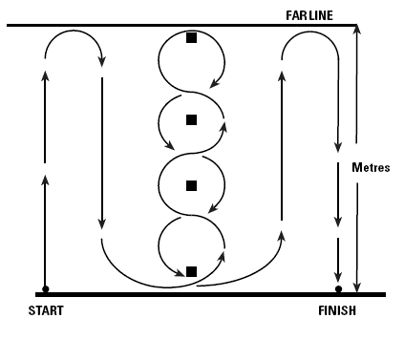

**1st Attempt: ______________________**

**2nd attempt: ______________________**

**3rd Attempt: ­______________________**

**Best score: _______________________**

**Category: ________________________**

**10**

The Illinois agility test is conducted as follows:

* Athlete lies face down on the floor at the start point.
* On the assistants command the athlete jumps to his / her feet and negotiates the course around the cones to the finish line.
* The assistant records the total time taken from their command to the athlete completing the course.

**Norms for the Illinois Agility Test**

The following are national norms for 16 – 19 year olds.

|  |  |  |  |  |  |
| --- | --- | --- | --- | --- | --- |
| **GENDER** | **EXCELLENT** | **ABOVE AVERAGE** | **AVERAGE** | **BELOW AVERAGE** | **POOR** |
| **MALE** | <15.2 secs | 15.2 – 16.1 secs | 16.2 – 18.1 secs | 18.2 – 19.3 secs | > 19.3 secs |
| **FEMALE** | <17.0 secs | 17.0 – 17.9 secs | 18.0 – 21.7 secs | 21.8 - 23.0 secs | > 23.0 secs |

**Illinois Agility Test**

A running lane 10 metres long by 5 metres wide was set up with 4 cones in the middle of the grid. At the start of this test, I lay face down on the floor. On the signal “GO” I got up as quickly as I could and followed the track shown in the diagram. I sprinted for 10 metres then weaved in and out of the cones and back and then sprinted to the finish line. Whilst I completed this, my partner timed my run. This test was completed 3 times with a full recovery in between each attempt to ensure maximum effort. My best score was compared to that of national norms of individuals of the same age and gender. Following agility training I could use this written evidence to assess my progress by repeating the test and comparing results.

**Cooper test**

A square running area of 25 x 25 metres is set up. Each player starts at a different cone. The aim is to attempt to run at a steady pace and cover as much distance as you can in 12 minutes. An observer will keep note of the number of laps you complete so that you can calculate your distance. Resting pulse should be taken before you begin and after finishing the run your pulse will be taken at 30s intervals to check recovery time.

**Benefits and Limitations of the Illinois Agility and Cooper Tests**

**Benefits**

* The use of Standardised Fitness Tests can give you clear information about the relevant components of fitness that you are trying to measure and therefore acts as a fitness indicator (identifies strengths and weaknesses in fitness).
* Also, the use of norms allow you to compare your score with those of the same age and gender around the world (valid and reliable results due to test conditions being standardised).
* It is important that any fitness assessments that you carry out are relevant to the nature of the activity that you are interested in improving (i.e. select areas of fitness that apply to football – CRE, Agility etc…which are all required at some point in the game).
* This method of testing can also be used for monitoring progress during a fitness training programme, gauging when adaptations to training are necessary and to evaluate any improvements at the end of the plan of action.

**Limitations**

* Results can be subject to inconsistencies in timing and recording, which can impact on the validity and reliability of results.
* Performance on these tests can be affected greatly by a performer’s motivation. If a performer doesn't give maximum effort during the test their score will not be a true reflection of their fitness levels.
* As both these tests can be conducted outside, the environmental conditions can affect the validity and reliability of the results. Also, the athlete’s choice of footwear and the surface they are running on can effect times greatly, which can impact on the validity and reliability of results.
* Pacing and practice can influence the scores attained.

**Emotional Features: Fear and Anger**

**SPORT EMOTION QUESTIONNAIRE**

Below you will find a list of words that describe a range of feelings that sport performers may experience. Please read each one carefully and indicate on the scale next to each item how you feel **right now, at this moment, in relation to the *upcoming* competition**. There are no right or wrong answers. Do not spend too much time on any one item, but choose the answer which best describes your feelings right now in relation to the upcoming competition.

|  |  |  |  |  |  |
| --- | --- | --- | --- | --- | --- |
|  | Not at all | A little | Moderately | Quite a bit | Extremely |
| Uneasy | 0 | 1 | 2 | 3 | 4 |
| Upset | 0 | 1 | 2 | 3 | 4 |
| Exhilarated | 0 | 1 | 2 | 3 | 4 |
| Irritated | 0 | 1 | 2 | 3 | 4 |
| Pleased | 0 | 1 | 2 | 3 | 4 |
| Tense | 0 | 1 | 2 | 3 | 4 |
| Sad | 0 | 1 | 2 | 3 | 4 |
| Excited | 0 | 1 | 2 | 3 | 4 |
| Furious | 0 | 1 | 2 | 3 | 4 |
| Joyful | 0 | 1 | 2 | 3 | 4 |
| Nervous | 0 | 1 | 2 | 3 | 4 |
| Unhappy | 0 | 1 | 2 | 3 | 4 |
| Enthusiastic | 0 | 1 | 2 | 3 | 4 |
| Annoyed | 0 | 1 | 2 | 3 | 4 |
| Cheerful | 0 | 1 | 2 | 3 | 4 |
| Apprehensive | 0 | 1 | 2 | 3 | 4 |
| Disappointed | 0 | 1 | 2 | 3 | 4 |
| Angry | 0 | 1 | 2 | 3 | 4 |
| Energetic | 0 | 1 | 2 | 3 | 4 |
| Happy | 0 | 1 | 2 | 3 | 4 |
| Anxious | 0 | 1 | 2 | 3 | 4 |
| Dejected | 0 | 1 | 2 | 3 | 4 |

*Scoring Instructions:*

**Fear** = (uneasy + tense + nervous + apprehensive + anxious)/5 = ________

**Dejection** = (upset + sad + unhappy + disappointed + dejected)/5 = _________

**Excitement** = (exhilarated + excited + enthusiastic + energetic)/4 = _________

**Anger** = (irritated + furious + annoyed + angry)/4 = _________

**Happiness** = (pleased + joyful + cheerful + happy)/4 = ________

**Sport Emotion Questionnaire**

The sport emotion questionnaire is used to collect information on the emotional factors that impact on my performance in football. It is completed before an important match and asks me to evaluate how I feel emotionally about the upcoming competition. The questionnaire is in a paper based format and lists words that describe a range of feelings that sport performers may experience e.g. Tense, Excited, Nervous, Angry.

For each word I evaluate how I am feeling using the following scale: **Not at all, a Little, Moderately, Quite a bit, Extremely.** After completing the questionnaire I use the marking scheme to calculate my scores for the following emotional Features: Fear, Dejection, Excitement, Anger and Happiness.

Example: **Fear** = (uneasy + tense + nervous + apprehensive + anxious)/5 =

**Benefits and Limitations of the Sport Emotion Questionnaire**

**Benefits**

* The written format provides a permanent record that allows for comparison at a later date.
* Strengths and weaknesses can be identified from the questionnaire which future performance development programmes and goal setting can be based upon.
* The performer is gaining lots of information on their emotional state. The more information they have on their performance the more accurate and valid the results.
* A coach/teacher/performer can get large quantities of information about Emotional factors in a relatively short period of time. Subsequently, strengths and more importantly weaknesses can be identified quickly and addressed through an appropriate development programme and monitoring process.
* Everyone in the class is answering the same questions. This reduces bias and increases the validity and reliability of the results because the performers are not being influenced by an interviewer.

**Limitations**

* The information which is being collected is based on a performer’s perception of their emotional state. Subsequently, this could impact on the validity of the results as it could be a bias assessment.
* It depends on the importance a performer places on the process. If a performer doesn't take the process seriously this will impact of the validity and accuracy of the results.
* Results could be inaccurate if a performer misinterprets the words.
* It can take a long period of time to collect and analyse the results.
* The questions being asked are only closed questions. A lack of open questioning means that the performer’s answers lack explanation, which could impact on the accuracy of the results.

**Emotional Feature: Anger**

Discipline Record

Name:

**Your partner will watch you playing a football match against opponents of similar ability to you. They will assess your discipline during the match using the record below. Each time they observe you exhibit one of the behaviours or actions listed they will place a tally mark in the appropriate box.**

|  |  |  |  |
| --- | --- | --- | --- |
| Behaviour/Action | First Half | Second Half | Overall Score |
| Negative body language to personal mistake |  |  |  |
| Negative body language to team mistake |  |  |  |
| Negative verbal reaction to personal mistake |  |  |  |
| Arguing with team |  |  |  |
| Arguing with the other team |  |  |  |
| Contesting referee’s decision |  |  |  |
| Decrease in effort |  |  |  |
| Foul |  |  |  |
| Cynical Foul |  |  |  |
| Act of sportsmanship |  |  |  |
| Off the ball incident |  |  |  |
| Use of positive praise |  |  |  |

Major incidents that affected discipline during the game

**Score:**

**Discipline Record**

To collect information on my emotional state (specifically anger) during a football match I used a discipline record. This record listed various emotional actions and/or behaviours that an athlete might exhibit during a match. They included:

* **Negative Body language**
* **Negative verbal exchanges with team mates, opposition, officials**
* **Effort levels**
* **The number of fouls committed**
* **Acts of sportsmanship**

Whilst playing a match against opponents of equal ability an observer marked down each time I exhibited one of these actions/behaviours by placing a tally mark in the appropriate box. They recorded this information for both halves of the match and calculated my total score for each action/behaviour at the end of the game. The discipline record was completed at the beginning and the end of the football block.

**Benefits and Limitations of using a Discipline Record**

**Benefits**

* The written format provides a permanent record that allows for comparison at a later date.
* Having an observer it provides objective feedback which is non-bias providing more accurate results.
* All tally marks can be converted into statistics which are hard to argue with.
* Strengths and weaknesses relating to emotions can be identified from the record which future performance development programmes and goal setting can be based upon.
* Objective feedback by a person with activity knowledge ensures validity and reliability of the results to create a detailed analysis of emotional state.
* By playing a full game of football against opponents of equal ability allows the observer plenty of time to collect valid, reliable and accurate information. The duration of the game gives the observer time to observe patterns of behaviour.

**Limitations**

* When you have someone else recording information on performance the validity of the results are dependent on the observers focus and attention during the match and the importance they place on the process.
* Football is a very fast paced sport and there is likely to be a number of incidents and patterns of play. If an observer takes their eye of the match to complete the record they may miss something which brings into question the reliability of the findings.
* The content of the disciplinary record has to be correct in the first place to focus on key elements of emotional performance.
* The information which is being collected is based on an observer’s perception of what represents a negative behaviour or action. Subsequently, this could impact on the validity of the results as it could be a bias assessment.

Approaches to Develop Performance

The information in this section provides you with **approaches** to developing **Emotional** and **Physical (Fitness)** Factors.

Each approach will be **explained** and the **benefits** and **limitations** will be **evaluated**.

The section will also incorporate **Mandatory Knowledge** which will have to be applied within your answers for homework tasks and final exam.

For **football** several approaches will be explained and evaluated.

|  |  |  |  |
| --- | --- | --- | --- |
| **Physical (Fitness)** | **Approach** | **Emotional** | **Approach** |
| Cardio Respiratory Endurance &  Agility | * Training within the activity (Interval Training and Continuous Training focus) | Fear & Anger | * Mental Imagery * Positive Self Talk |



**Physical Factor - Features: Agility and Cardio Respiratory Endurance**

**Training Approach: Training within the activity (Interval Training and Continuous Training Focus)**

|  |  |  |  |  |  |  |  |  |  |
| --- | --- | --- | --- | --- | --- | --- | --- | --- | --- |
|  | **Exercise 1**  **Split step ladder drill**  [http://1.bp.blogspot.com/-9I4ksTExEfE/T-YSMBrQEfI/AAAAAAAALyc/NUjOLrSc8xw/s1600/DSC_0080.JPG](http://www.google.co.uk/url?sa=i&rct=j&q=&esrc=s&frm=1&source=images&cd=&cad=rja&uact=8&docid=MB2GRwbYA3Cy8M&tbnid=5c9N6oi3UxpyiM:&ved=0CAUQjRw&url=http://smsxc.blogspot.com/2012/06/l3-bounding.html&ei=vZxsU7G_ItTG7AaSv4H4DA&psig=AFQjCNHXliD9uEn-mkRsROk4-zK-1CPTDw&ust=1399713235752656) | **Exercise 2**  **Dribble and Change Direction** | **Exercise 3**  **T-Drill**  **T Drill[T Agility TestT Agility TestT Agility Test](http://www.topendsports.com/testing/tests/agility-cone-drill.htm)** | **Exercise 4**  **Agility**  **Dribble** | **Exercise 5**  **Touch Left & Right** | **Exercise 6**  **Shoot & Run Round Marker** | **Exercise 7**  **Diagonal Sprint and Run Backwards** | **Exercise 8**  **Close control**  **Dribble** | **Exercise 9**  **Pass and Run** |
| **Work** |  |  |  |  |  |  |  |  |  |
| **Rest** |  |  |  |  |  |  |  |  |  |
| **Sets** |  |  |  |  |  |  |  |  |  |
| **Type of Training** |  |  |  |  |  |  |  |  |  |
| **Score** |  |  |  |  |  |  |  |  |  |
| **Heart Rate** |  |  |  |  |  |  |  |  |  |
| **Active recovery exercise** |  |  |  |  |  |  |  |  |  |

**Training within the Activity**

Training within the activity involves practicing the specific skills/techniques and movements as well as the fitness requirements of football. During each training session the performer replicates the movement patters, footwork and coordination which are needed during a game.

**Cardio Respiratory Endurance**

**Interval Training**

This involves alternating between periods of hard exercise and rest. For example, working for a set time and then resting for a set time. Interval training can be made harder by increasing the intensity or period of work. Interval training will only improve Cardio Respiratory Endurance if the work to rest ratio is 1:1, however this must be over a long period of time e.g. work for 1 minute and rest for 1 minute.

**Continuous Training**

Continuous Training is working continuously with no rest for a minimum of 20 minutes. The purpose of continuous training is to maintain a steady pace throughout the duration of the training. In order for improvements to be made your heart rate must be in the correct training zone (70-75% of maximum heart rate).

**Agility**

**Interval Training**

This involves alternating between periods of hard exercise and rest. For example, working for a set time and then resting for a set time. Interval training can be made harder by increasing the intensity or period of work. Interval training will only improve agility if the work to rest ratio is 1:3, however this must be over a shorter period of time than CRE e.g. work for 15 seconds and rest for 45 seconds. This ensures we are focussing on the quality of movements as opposed to developing Cardio Respiratory Endurance.

[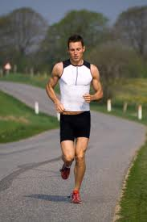](http://www.google.co.uk/imgres?q=Continuous+training+pictures&hl=en&gbv=2&biw=973&bih=530&tbm=isch&tbnid=yyxtNYnxLkUArM:&imgrefurl=http://edaviesbtecsport.blogspot.com/2010/09/continuous-training.html&docid=RjzC-5vQkm2MeM&imgurl=http://speedtrainingzone.com/images/long%20distance%20running.jpg&w=283&h=424&ei=D3cyT4kjiujxA-W1_IwH&)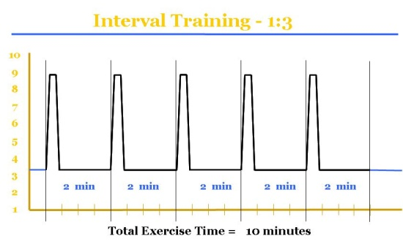

**Continuous Training**

Constant training for a minimum of 20mins. Usually a lower intensity. football drills lend themselves to this approach.

**FOCUS: CRE**

**Interval Training**

Short sharp high intensity work followed by recovery periods.

**FOCUS : CRE and Agility**

**Example Answer**

**Explain** an approach you used to develop a **physical factor** in football. (4 Marks)

**Starting Sentence**

*To develop Cardio Respiratory Endurance the approach I used was training within the activity using an interval training approach.*

**Description of the approach** (“short & sharp” to set the scene)

*Working with a partner I performed nine* football *specific exercises that focussed on developing the skills/techniques required in* football *as well as Cardio Respiratory Endurance. For example, in one of the exercises I continuously dribbled around a set of cones using a both feet. At each exercise I worked for 40 seconds and my partner rested for 40 seconds, we then switched roles.*

**Explanation** (This is where we are picking up the marks)

*Working for 40 seconds and resting for 40 seconds ensures a work to rest ratio of 1:1.Subsequently, exercises are performed at an intensity which will bring my heart rate into my training zone (70%). This means that I will be improving my Cardio Respiratory Endurance as opposed to another type of fitness. I used this training approach 3 times per week (Monday, Wednesday, and Friday). Rest days were included to allow my body to recover. Training fewer times would take longer to bring about any training effect as the body would not be under any stress. However, overtraining results in injury, fatigue and lack of motivation which is counterproductive. After 2 weeks I was finding that this training was easier to complete. Because my body had adapted to the training it was important to overload the body further to allow for progression. To progress I then stayed within my training zone for longer by introducing a further drill into my training session.* *One week further down the line I also upped my intensity by working at 75% of my maximum heart rate.* *The longer I can work in my aerobic training zone before working anaerobically the longer I can delay the onset of fatigue and lactic acid build up. As a result of this training, I was also able to produce a better quality of work where my skill level did not deteriorate. Targets set within each drill were increased as I was now working at a higher intensity. As a Midfield player in* football *this type of training is specific to the demands of my role. Good Cardio Respiratory Endurance is essential for a midfield player as they are continually making the transition from defence to attack and vice versa during the game. Also, their skill level must remain high throughout the full duration of the game (35 minutes each way). Another, type of training might focus on a different aspect of fitness which would be counterproductive.*

**Command Word: Explain**

**Key Content: Principles of Training applied to Cardio Respiratory Endurance**

|  |  |  |
| --- | --- | --- |
| **Principle** | **Why?** | **Justify?** |
| [http://t2.gstatic.com/images?q=tbn:ANd9GcQwPibRIDmiqzyHggNfGiHzTLYenISUQNmGwcsOkJZbc6K2NLKn](http://www.google.co.uk/imgres?q=stopwatch&um=1&hl=en&rlz=1T4ADFA_enGB461GB462&biw=973&bih=478&tbm=isch&tbnid=ahzqksvAAOVKqM:&imgrefurl=http://www.freeclipartnow.com/household/time/stopwatches/blue-stopwatch.jpg.html&docid=qumV6Qo8r16bYM&imgurl=http://www.freeclipartnow.com/d/26887-1/blue-stopwatch.jpg&w=281&h=350&ei=ZnMyT779DI_R8QPTpYiKBw&) **Duration** | * 8 weeks – adequate time scale to bring about training effects * 20 minutes recommended time to ensure specific energy system is developed | Fewer weeks training would result in less progress and longer to reach Cardio Respiratory endurance training goal. We would get fitter naturally by simply playing but working to a specific training programme using the principles of training would waste less time and speed endurance would develop quicker. |
| **Frequency** | * 3 times per week at the start of the programme (Monday, Wednesday and Friday) * Rest days allows the body to recover * Muscles adapt to the workload | Overtraining results in injury, fatigue and lack of motivation which is counter productive  Training fewer times would take longer to bring about any training effect as the body would not be under any stress. |
| http://sk-lifefitness.co.uk/wp-content/uploads/2011/05/heart_rate_monitor.jpg  **Intensity** | * 70-75% max heart rate ensured I worked the appropriate energy system. * 40 seconds work with 40 seconds rest, 3 sets * Easy to add progressions to interval training to overload | Forces skills and fitness to be performed at high intensity forcing quick decisions.  To work without training zones for age and aspect of fitness would result in training being pointless.  Training types must reflect the demands of the activity. |
| http://school.discoveryeducation.com/clipart/images/grlbskbl.gif**Specificity** | Training must be specific to:   * Aspect of fitness * Playing role * Own level of fitness and activity * Muscle groups, movement patterns, skills, tactics, spatial awareness, teamwork motivation developed through the activity | Working on an aspect of fitness not essential to my role or not as important to the activity would be counterproductive.  Training specifically within the activity means there is no delay between training and implementing improvements – results are immediate.  Although training outwith the activity will bring significant advances, a more competitive game like environment adds variety and sustains focus. |
| [http://t2.gstatic.com/images?q=tbn:ANd9GcQaJRGaT_F72ej84BhTRvrIII76EAPkGZcAwTX6sRMCkeChrPT16w](http://www.google.co.uk/imgres?q=sweating+athlete+clip+art&hl=en&rlz=1T4ADFA_enGB461GB462&biw=973&bih=478&tbm=isch&tbnid=Xncqsvle2JRUDM:&imgrefurl=http://www.clipartof.com/interior_wall_decor/details/Cartoon-Black-And-White-Outline-Design-Of-An-Exhausted-Black-Man-Sweaty-After-A-Work-Out-Poster-Art-Print-439771&docid=KANwTrwARHKhPM&imgurl=http://images.clipartof.com/small/439771-Cartoon-Black-And-White-Outline-Design-Of-An-Exhausted-Black-Man-Sweaty-After-A-Work-Out-Poster-Art-Print.jpg&w=314&h=450&ei=WXYyT6fBEsjf8gP-rOH7Bg&)**Overload (when & Why?)** | * The body adapts to stress the to become more efficient * Required to continue improvement * To increase thresholds * To work on a different energy system * To sustain motivation   Week 2 – Introduce an additional station into circuit  Week 4 – Introduce another session from 3 to 4  Week 6 – work at 75% of max heart rate by switching to continuous training | If stress is not applied to the body as it adapts to the work load then the fitness improvements will plateau.  Boredom and lack of focus can result in reversibility or injury. |
| [http://t1.gstatic.com/images?q=tbn:ANd9GcS1fy265TOHIerPuYotlIK-IvQD7iNsSD7Js6mf3J9-VcCnsG3w](http://www.google.co.uk/imgres?q=resting+clip+art%5d&hl=en&rlz=1T4ADFA_enGB461GB462&biw=973&bih=478&tbm=isch&tbnid=eLt1toow8BN2LM:&imgrefurl=http://www.fotosearch.com/illustration/feeling.html&docid=sh3FUCRQsSvjNM&imgurl=http://cdn2.fotosearch.com/bthumb/UNC/UNC002/u18588941.jpg&w=170&h=152&ei=kHYyT_-aNYis8gPQyLTeBg&)  **Reversibility** | * When the body’s fitness levels start to drop * Use it or lose it theory | Injury from pushing the body too much.  Sub maximum effort due to inefficiencies in training programme.  Working on the wrong aspect of fitness. |

Advantages

* All training takes place in the environment of the activity and so players become more familiar with game surroundings, court lines, improving spatial awareness and comfort.
* Fitness needs are specific to the activity and so will be more relevant to the activity i.e. movement patterns etc.
* You can work on both skills and fitness at the same time through drills- The effects on the muscles replicate those of a real game situation. Through using the ball hand eye coordination can be improved.
* Training with team mates is more motivating resulting in more intense training. Training on your own does not have the same competition and incentive.
* You can combine several aspects of fitness within the same session. By combining CRE and Agility it develops your ability to perform efficiently for a longer duration.
* Training within the activity can be more competitive and so mirrors a real game where sharpness and staying power must be maintained helping to build confidence.
* You can vary the training to prevent boredom and sustain focus and interest.

Disadvantages

* When combining skills and fitness some stations may require complex skills and thought processes. Subsequently, the quality of movements may suffer as the performer’s attention is misdirected.
* If a performer struggles with their lefts and rights, movements will not be completed at as high intensity reducing the repetitions possible.
* If a performer has poor Cardio Respiratory Endurance this could be counterproductive to improving their agility. If an athlete is tired and lethargic (particularly towards the end of the circuit) intense/sharp movements will not be achieved.

**Principles of Training *Mandatory Knowledge***

For a training programme to be effective you need to apply certain principles of training to your performance.

**SPECIFICITY**

This is the key principle in training and is crucial to performance improvement. Your training has to be specific to your performance needs for your chosen activity and must be relevant to your own levels of fitness and ability.

In order to ensure that you are selecting the correct type of training for your activity, you would need to look closely at the activity and assess the areas of fitness which are crucial to performance in the activity and your role within it. All basketball training will be carried out in a basketball context to reflect the movement patterns, skills and physical demands of the game.

To develop **cardio respiratory endurance**, the drills will be performed continuously at a **moderate intensity** for a long period of time (20 minutes) whereas for **speed endurance** the drills will be performed at a **higher intensity** for a **shorter** period of time with a rest for recovery in between.

**PROGRESSIVE OVERLOAD**

Progressive overload occurs when you exercise at increasingly greater levels. You progressively add to the demands of your fitness programme as your body adjusts to the benefits of your current fitness programme.

The underlying fundamental principle of training is that whatever demands you make of your body, the body will adjust to cope with the demand. If you ask your body to work for a longer time without rest, it will become more endurable etc.

Regardless of the initial level of work rate, the group of muscles will slowly adapt to the increased intensity of work.

**To overload we adapt one of the following principles:**

**FREQUENCY**

The number of training sessions per week is generally known as **frequency of training.** This should be at least **3 times per week** (Monday, Wednesday and Friday) although elite performers train much more than this.

***Frequency depends on:***

* Your initial level of fitness
* Time and facilities that are available to you
* Type of improvement desired

**INTENSITY**

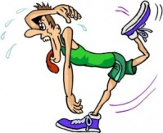You must train at an appropriate level so that you will OVERLOAD your body (put more pressure on your body than normal). In aerobic endurance training, your heart rate must be at 70% of maximum in the training zone. For speed endurance work your heart rate must be at 85% of maximum heart rate (180bpm or more). In speed endurance work, the intensity of work is always high but can be varied by adjusting the amount of recovery time you allow between bursts of activity.

**DURATION**

[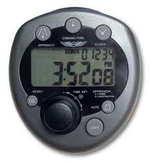](http://www.google.co.uk/imgres?q=timer&um=1&hl=en&rlz=1R2ADFA_enGB461&biw=973&bih=478&tbm=isch&tbnid=4JlQFwT99DdBRM:&imgrefurl=http://www.allbestwallpapers.com/timer_wallpapers.html&docid=oHVEaUN1avbMnM&imgurl=http://www.allbestwallpapers.com/tagwallpaper/timer-wallpapers.jpg&w=278&h=300&ei=kWsyT4WaDIyn8gPBl-XgBg&)This refers to the length of time that a performer trains for, for example:

* The length of each session should be at least 20 to 30 minutes to reflect the activity
* The length of the training programme e.g. 8 week programme

Aerobic endurance training requires a longer training programme of about 10 weeks.

Speed endurance training requires a much shorter 8 week programme.

**REVERSIBILITY**

All the alterations that the body, group of muscles or energy systems make, can slowly reduce or not be maintained if the training programme is not carried out regularly. The adaptations that the body makes during training can be lost if training is interrupted for any length of time. This of course may be an unforeseen problem such as injury or illness. However, the longer the performer had been training before the set back, the slower the loss of training and the quicker he/she will regain their fitness level after resuming training. If you exercise less than usual, your fitness decreases; and if you exercise the same as usual, your fitness stays the same.

[](http://www.google.co.uk/imgres?q=couch+potato&um=1&hl=en&rlz=1R2ADFA_enGB461&biw=973&bih=478&tbm=isch&tbnid=fGyrLN_-O9YyaM:&imgrefurl=http://midwestrunningmom.blogspot.com/2010/03/just-lazy-couch-potato.html&docid=qrN73_eCTjpp1M&imgurl=http://1.bp.blogspot.com/__IZw0K9t4qU/S64SirlqvgI/AAAAAAAAARc/75diF0b7qNw/s1600/lazy_couch_potato.jpg&w=476&h=451&ei=rmsyT8z3KoK98gO9vqngBg&)

***“Use it or lose it!”***

**Emotional Feature - Fear**

**Mental Imagery/Visualisation**

Mental imagery, or visualisation sometimes called mental rehearsal, involves the athlete imagining themselves in an environment performing a specific activity using all of their senses (sight, hear, feel and smell). The images should have the athlete performing successfully and feeling satisfied with their performance.

Visualisation is proving to be an understandably popular mechanism with elite athletes eager for marginal gains. The use of imagery primes their muscles to perform correct technique and to execute appropriate actions in competition, but it also conditions their mind to think clearly about how they will react to certain pressures, situations and problems. Consider it a ‘mental warm-up or walk through” of what you want to see happen. A vivid picture and strong feelings are like a magnetic attraction so be careful of what you picture with feeling, because you will be pulled in that direction. For the novice, Mental imagery may well improve confidence, relieve anxiety and help to control arousal levels.

[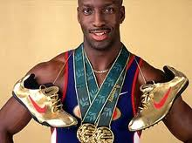](http://www.google.co.uk/imgres?q=michael+johnson&um=1&hl=en&biw=1366&bih=587&tbm=isch&tbnid=22NWtlKHj6NR8M:&imgrefurl=http://ukchoc.com/2011/10/24/top-10-black-sportsman-5-michael-johnson/&docid=NUopcXk3e_4f8M&imgurl=http://ukchoc.com/wp-content/uploads/2011/10/Michael-Johnson.jpg&w=275&h=206&ei=vw5BT-OJE4ej0QWXtLiPDw&z) ***“Throughout my career, any time I wasn’t doing something that required my full attention; my mind defaulted back to visualising races. Several times a day, I would automatically imagine the gun going off and myself contending with a different scenario each day. Running through my options in my mind before I ever hit the track was critical” (Michael Johnson, Olympic champion, athletics)***

**How it works?** 

It is safe to assume that we all know our brain is a complex machine. It relies on Electrical transmissions through the neural pathways which fuel our senses. When we learn new skills our brain cells form new connections improving memory- therefore skills. Knowledge is stored in our brain and as we learn it changes and becomes upgraded- with thousands of hours of practice. Imagery/visualisation is a short cut which primes our mind for what it ultimately instructs our bodies to do. It is also like downloading new software and our brains upgrade quicker.

[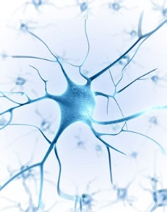](http://understandingcontext.com/wp-content/uploads/2013/12/Neuron-Branches-300.jpg)You rehearse entire sequences in your brain without moving a muscle. Every part of a skill or performance is repeated over and over again. The brain is activated when we imagine a movement. Rehearsal in your mind creates pathways in the brain cells as if executing the skill/performance, grooving the actions. Pathways are therefore already in place when a performer carries out the performance leading to confidence, self-belief and success.

**When should it be carried out?**

This approach is carried out daily and focuses on different elements of the performance. Targets are set for all mental training to replicate goals during practice. Every eventuality should be visualized so that the performer is fully prepared for unpredictable situations. **It is equally if not more important than the physical training**.

**How to apply mental imagery?**

* This method is used regularly by many of the world’s best tennis players. Novak Djokovic and Andy Murray both use imagery to prepare for games. Djokovic was taught to visualise his shots to the accompaniment of classical music by his first coach.
* Murray has even been known to [make several visits to a deserted Centre Court](http://www.theguardian.com/sport/2012/jun/24/wimbledon-2012-andy-murray-centre-court) in advance of Wimbledon in order to mentally acclimatise to the environment. “I have sat on Centre Court with no one there and thought a bit about the court, the matches I have played there,” Murray said. “I want to make sure I feel as good as possible so I have a good tournament.”
* A basketball player will use imagery in a free through situation and close their eyes visualizing successful execution. (mechanics, flight of the ball, sound of the swoosh etc)
* A cyclist will rehearse their race knowing where all the uphill sections of the course are, where he or she plans to overtake, where the tight more technical section are etc.
* A gymnast will rehearse set skills in their routine and gradually develop this visual picture so that the full routine is linked together and performed fluently in the performers mind with an audience.

Advantages

* It can motivate the athlete by recalling images of success in past competitions or beating a competitor in competition.
* It can reduce negative thoughts by focusing on positive outcomes.
* Refocus the athlete when the need arises e.g. if performance is feeling sluggish, imagery of a previous best performance can help get things back on track.
* Set the stage for performance with a complete mental run through of the key elements of their performance to set the athletes desired pre-competition feelings and focus.
* Having rehearsed any eventuality you will be able to cope with pressure allowing you to remain calm and stay in control.

Disadvantages

* Some athletes may imagine negative previous performances in past competitions or against a particular opponent, which can impact on performances and results.
* This type of approach takes a lot of practice for it to have a positive impact. Performers must use it every day in order to master the technique, especially with fast paced and complex sports like football.
* You must be physically able and proficient at football for this technique to be successful. If you are unable to perform the basic skills and movement patterns of the game, imagery will be ineffective.
* In the moment, this approach can be forgotten as distractions and external factors result in the performer missing the cue which identifies that fear.

**Emotional Feature - Anger**

**Positive Self Talk**

Everyone has an [inner voice](http://pps.sagepub.com/content/6/4/348.abstract) which can be either helpful or unhelpful – the angel on one shoulder (helpful) and the devil on the other (unhelpful). It is vital to remember that the devil is only your brain playing tricks on you and to pay more attention to the angel!



Positive self talk can be like an internal coach, encouraging you, boosting your confidence, believing in you, and motivating you to achieve your goals.

If you feel anger building up inside you during the game using positive self talk will help you to maintain composure, particularly after making a mistake or error. The **3 R's** approach is an excellent method to take:

1. **Recognize** that you are dwelling on the mistake, which limits your ability to focus on the next phase of play.

2. **Regroup** by interrupting this negative chain of thought. This requires you to battle your own emotions and dispute your irrational thinking. Using positive self talk helps in this situation e.g. saying to yourself "Be patient, you're better than that".

3. **Refocus** is then crucial for the next phase of play. Ask yourself what you need to focus on right now to do your best in the next phase of play. The answer will help you refocus on the game.

**When to practice the 3 R's approach?**

The 3 R's approach can be practiced during every training session, particularly during pressure drills, conditioned games or practice matches. These methods of practice replicate similar pressures to what you would experience in a game which can be unpredictable and open. Subsequently, you are likely to experience the same types of emotions e.g. getting angry when you make a mistake.

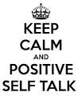

Advantages

* It can reduce negative thoughts by focusing on positive outcomes.
* Refocus the athlete when the need arises e.g. a performer is angry after making a mistake, positive self talk can help get things back on track by composing the athlete and getting them to focus on what's important in the game.
* Having continually practiced positive self talk during training sessions you will be able to cope with game pressures allowing you to remain calm and stay in control.

Disadvantages

* This type of approach takes a lot of practice for it to have a positive impact. Performers must use it every day in order to master the technique, especially with fast paced and complex sports like football.
* You must be physically able and proficient at football for this technique to be successful. If you are unable to perform the basic skills and movement patterns of the game, positive self talk will be ineffective.
* In the moment, this approach can be forgotten as distractions and external factors result in the performer missing the cue which identifies that anger.



**Recording, Monitoring and Evaluating**

**[](http://www.brindlemedia.net/wp-content/uploads/2012/11/Evaluate.jpg)**

The information in this section explains the purpose of monitoring and evaluating performance development in football.

It will explain different methods for recording and monitoring performance development for both Emotional and Physical Factors.

**The Purpose of Monitoring and Evaluating Performance**

* Evaluating performance will allow you to see if performance has improved and also if the training programme has worked. You may have to make adaptations/progressions to your approaches.
* If results are positive then this can improve motivation to develop performance even further.
* New strengths and weaknesses can be identified and future development needs can be agreed.
* The information from the evaluation process can also be used to plan a new training programme that will be specific to the new weakness identified.





**Recording Performance Development**

**Training Diary**

After each training session you will use your diary to **record your progress**. After each session this diary must be completed.

|  |  |  |  |  |  |  |  |  |  |
| --- | --- | --- | --- | --- | --- | --- | --- | --- | --- |
|  | **Exercise 1**  **Split step ladder drill**  [http://1.bp.blogspot.com/-9I4ksTExEfE/T-YSMBrQEfI/AAAAAAAALyc/NUjOLrSc8xw/s1600/DSC_0080.JPG](http://www.google.co.uk/url?sa=i&rct=j&q=&esrc=s&frm=1&source=images&cd=&cad=rja&uact=8&docid=MB2GRwbYA3Cy8M&tbnid=5c9N6oi3UxpyiM:&ved=0CAUQjRw&url=http://smsxc.blogspot.com/2012/06/l3-bounding.html&ei=vZxsU7G_ItTG7AaSv4H4DA&psig=AFQjCNHXliD9uEn-mkRsROk4-zK-1CPTDw&ust=1399713235752656) | **Exercise 2**  **Dribble and Change Direction** | **Exercise 3**  **T-Drill**  **T Drill[T Agility TestT Agility TestT Agility Test](http://www.topendsports.com/testing/tests/agility-cone-drill.htm)** | **Exercise 4**  **In-out cone**  **Dribble** | **Exercise 5**  **Touch Left & Right** | **Exercise 6**  **Shoot & Run Round Marker** | **Exercise 7**  **Diagonal Sprint and Run Backwards** | **Exercise 8**  **Close control**  **dribble** | **Exercise 9**  **Pass and Run** |
| **Work** |  |  |  |  |  |  |  |  |  |
| **Rest** |  |  |  |  |  |  |  |  |  |
| **Sets** |  |  |  |  |  |  |  |  |  |
| **Type of Training** |  |  |  |  |  |  |  |  |  |
| **Score** |  |  |  |  |  |  |  |  |  |
| **Heart Rate** |  |  |  |  |  |  |  |  |  |
| **Active recovery exercise** |  |  |  |  |  |  |  |  |  |

|  |  |  |  |
| --- | --- | --- | --- |
| **Date** | **Aim of the Session** | **Description of Session** | **Describe how you felt the session went**  **(Reflection on practices and goals)** |
|  |  |  |  |
|  |  |  |  |
|  |  |  |  |

**Why is a training diary appropriate?**

* The format of the training diary offers an opportunity to clearly identify the aim of each session. This is important as it focuses planning on practices/approaches that are specific to targeted areas, leading to a greater purpose of training.
* A training diary can give an enormous amount of information about what has happened in the past and how training has gone in the past. When [planning](http://www.brianmac.co.uk/plan.htm) future training , information of this kind is invaluable to ensure programmes of work are appropriate and specific to development needs.



**Monitoring Performance Development**

The best way to monitor your progress is through regular feedback. You should collect data before you begin your programme then you can compare subsequent data to see if your fitness levels have increased. You can receive feedback from your teacher or coach highlighting your progress and you have your own internal feedback coupled with knowledge of performance and knowledge of results.

The following methods could be used to **monitor** performance development throughout a training programme:

* **Standardised Fitness Tests**
* **Teacher Feedback**
* **Knowledge of results**
* **Discipline Record**
* **Sport Emotion Questionnaire**