Integrity, Equality, Respect, Responsibility, Ambition
Responsibility, Ambition, Integrity, Equality, Respect
Ambition, Integrity, Equality, Respect, Responsibility
Irvine Royal Academy
Higher Physical Education

Recording, Monitoring and Evaluating performance
Physical, Mental, Emotional and Social Factors

MONITORING is about systematically collecting information that will help you answer questions about your performance. You can then use this information to help you evaluate.
Checkpoint

EVALUATION is about using monitoring and other information you collected to make informed judgements about your performance. It is also about using the information to make changes and improvements.

RECORDING,MONITORING AND EVALUATING PERFORMANCE

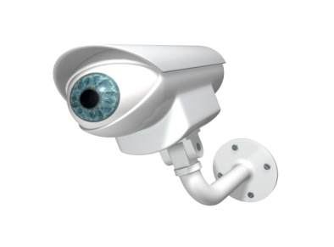
When you undertake a development programme it is important to monitor and evaluate the effectiveness of your programme. This fulfils a number of important tasks. Firstly it provides a record of the progress you are making or not. This then means that your programme can be adjusted appropriately to ensure progression. Actually seeing that your skill level is improving has a motivational effect. You feel a sense of achievement and a realisation that all your hard work is paying off. This would indicate if you were achieving your short-term training goals on the way to achieving your longer-term goals. This ensures a freshness and excitement when training and prevents your interest from waning and your performance plateauing. You are less likely to start to question the value of your training as you see results.

The benefits of monitoring and evaluating are outlined below:

- To make sure that the content/training methods within your programme are suitable and having the desired effect.

- To make sure that the programme is demanding enough. This will help gauge when it is appropriate to progressively overload or intensify the programme.
- To continue to identify strengths and weakness of your whole performance.

- To allow you to make adaptations/modifications to your performance, so that you can
refine your practices to your precise needs and keep practices challenging.

- To allow you to make comparisons in your most recent and final performances against your
initial one, to see whether you programme was successful or not.

- It can be motivational, especially when you are succeeding, as you want to continue to
Improve and gives you a better understanding of yourself and your performance.

- Allows you to see whether you have achieved your training targets/goals.

- Let’s you know where further remediation is needed, ie observe and track patterns and trends and adjust accordingly.

- Can set the way forward/next steps in your new training targets/goals.

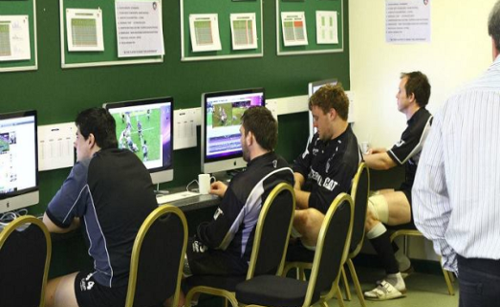
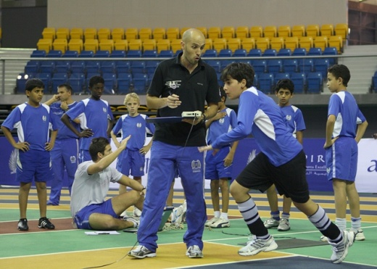

Why might a development Programme be ineffective??????

6
5
4
3
1
2
Feedback Checklist

For Feedback to be effective;
Relevant

-To the performer (s) and the area of weakness.
Timing

-Frequent and immediate to allow the performers to reflect and make corrections quickly whilst the information is fresh in their minds.
-Players must be open to listening to the feedback and willing to accept constructive criticism
Acceptance

Objective and Subjective

- Increases validity and reliability and creates a clearer picture of performance and
the progress being made.

Importance of sources of feedback in the monitoring process

Internal Feedback (Subjective)  Own thoughts and Feelings.  - Internal sensory feedback informs this process.  - Self Awareness  - Questionnaires | Knowledge of Results (Objective)  External feedback from a variety of sources such as video, Observation Schedules, competitive results, and practices scores. | Coach’s Feedback  Verbal communication from the coach constantly during practice and performance.
Usually, this method is in the form of either a training diary or by revisiting a questionnaire. Thoughts are recorded quickly after performance or training before feelings have changed or forgotten. | This method produces statistics. The statistics produced should relate to the weak area which is being developed. For example, if a player has identified the overhead clear as a limitation in a training session or game. | Verbal or written feedback should be given in each training session and game by a coach or teacher which is specific to the area you are trying to develop.
Internal feedback  - Encourages self-reflection of their training.  - Encourages confidence, motivation and focus as they are become more successful.  - Very specific to self so a true reflection.  - Regular and immediately after performance/training leading to more accuracy. | Objective is more reliable and accurate as it comes from an external source. Impacts positively on confidence and motivational levels through the hard facts highlighting improvements. | The teacher and coach has a detailed knowledge of the sport and the development area, therefore his opinion and advice is invaluable to improve factors. Because feedback is regular, and immediate players can make alterations quickly. The coach can prevent bad habits forming and their feedback focusses the performer/team and can be a source of positivity and motivation.
Subjective feedback can always be impacted by how the performer feels (Mood) at that specific moment. Their personal opinions and thoughts on performance could be very different from the coach | Knowledge of results highlights exactly what it says but it does not detail or delve into why these results are being achieved. Also poor results can de-motivate a player. However, poor results do not always suggest no progress is being made. For example, an observation schedule may highlight few points are still being made in 1st attack however results may not reflect early technical progress or increased understanding of roles etc. | There is always the potential of a clash between player(s) and coach, especially if underachieving. This approach may make the players less receptive to listening to the coach. If feedback is not given frequently and immediately after errors then by the time the coach/teacher addressed the problem it has been forgotten by the players.

Mandatory Knowledge

Overview of Feedback

Positive effect on Learning

Impact on the Information processing system

- Gain knowledge from various sources (model performer) to identify and correct faults.
- As a performer progresses through the stages of learning they are able to draw on past experiences to improve and strengthen performance. More self-aware and knowledgeable to assess own performance.
- Results in a quicker motor response due to muscle memory and improved decision making.
Monitoring progress

- Through feedback received during practice and competition swift adaptation to a programme can be made.
- Assess if on track to hit long term targets.

Data Collection

- Through comparison to a model performer a visual picture of performance enables detection and correction of issues in performance.
- Set training priorities specific to needs.
- Highlights stage of learning, social development stage or tactical limitations.

Motivation/Concentration

- Positive feedback - gives purpose, drive and determination to training and competition.
- Sustains focus and directs a team/performers attention inwards.

How can you record your progress?

How should we monitor progress?

Evaluating Approaches and Monitoring tools

Example Answers
Explain the importance of recording and evaluating performance. 2 Marks
It is important to record and evaluate training to ensure it is appropriate. If a performer frequently analyses their performance, they can see where they are through comparison to data and statistics from previous weeks. If it is noticeable that training is not challenging enough, it will be altered to ensure improvements of sub factors with each session. However, if training is recognised as too difficult, it will be reduced so that there is steady and realistic pace of improvement. Recording and evaluating performance also evokes motivation of a performer. If they are doing it well it will drive them to continue to work hard and be successful. Even if not on track this will motivate them to work harder to get back on track towards their long term goal and keep training fresh and interesting.

Explain at least two difficulties that might be encountered when monitoring and evaluating the impact of mental and physical factors on performance. 6 Marks
In general, if a performer is not in the right mental state results will be inaccurate. If a performer is tired they will not be in the correct frame of mind (Battling fatigue and self-doubt) to play at their best as their decision making will be hindered and will have lapses in concentration and be unable to control emotions. Movements will be more laboured as they have no real energy to bring to the match reducing skill level and success on the day. If coming back from injury monitoring can be frustrating as scores and results are down on their high expectations.
One major difficulty when monitoring and evaluating the impact of physical factors using a Stroke Repertoire Observation Schedule is linked to the focus and knowledge of the observer. If the observer has a limited knowledge base they will be unable to make quick informed judgements in open play on whether a shot is effective or ineffective. Their perceptions may be very different from the reality which questions the validity of the results. This can be off putting and frustrating for a performer who is looking to develop their stage of learning and data is inaccurate and not a true reflection of their performance. This could direct their attention to the wrong area of performance. In turn the observer might not place much importance on the process meaning they switch off, lose focus and motivation which reduces the quantity of information especially in open play when games are so fast paced. This restricts the detailed picture a performer gets of performance with so much information omitted.
One major difficulty when monitoring and evaluating the impact of mental factors using a mental toughness questionnaire is based on the validity and accuracy of the results gained. It depends on the importance a performer places on the process. If a performer doesn't take the process seriously they will most likely rush through the questions and not put much thought into their answers. Also, a performer may misinterpret a word or question which will once again lead to inaccurate results. Finally, the information which is being collected is based on a performer’s perception of their mental state. Subsequently, this could impact on the validity of the results as it could be a bias judgement.

Monitoring Approach – Video Analysis
Evaluate the effectiveness of the selected monitoring method.
Video analysis was a great tool for monitoring our progress when developing the social factor. We could see how each player interacted on the court and how well each unit worked cooperatively to both defend and attack. It was also possible for us to observe where we as individuals were not fulfilling roles effectively and alert us to what we needed to do to improve our contribution to the team. Siting as at team was great for reflecting on our strengths and limitations and everyone was comfortable expressing their thoughts and ideas. However, it was a very time consuming process and it was not always possible to get the use of the ipads restricting how often we could monitor via this approach.
Issue tightness lost signal

Same for badminton

