Integrity, Equality, Respect, Responsibility, Ambition
Responsibility, Ambition, Integrity, Equality, Respect
Ambition, Integrity, Equality, Respect, Responsibility


Irvine Royal Academy
BGE Physical Education

Successful Learners

Responsible Citizens

Effective Contributors

Confident Individuals

Name……………………………………………………….

Class…………………………………………………………

This booklet is for you to keep track of your progress in P.E.

It is designed to help you and your teacher monitor your progress within your learning as you work through your activities.

It will give you the opportunity to record information about areas which have been successful and areas for further development.

This means that when you come back to each activity, you (and your teacher) will be able to use this learning log to remind you of what you need to build on to help improve your practical performances further.

The list on the following pages outlines the core learning targets for all activities. When you feel you have achieved a learning target, you should tick the “pupil check” box. Your teacher will confirm this by ticking the box beside it. This will help you track your progress and identify what you should next focus on. When you have achieved all targets and completed the end of topic Knowledge & Understanding assessment you will have successfully achieved the level for that activity.

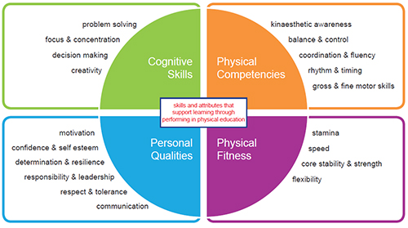
Athletics - Learning Intentions

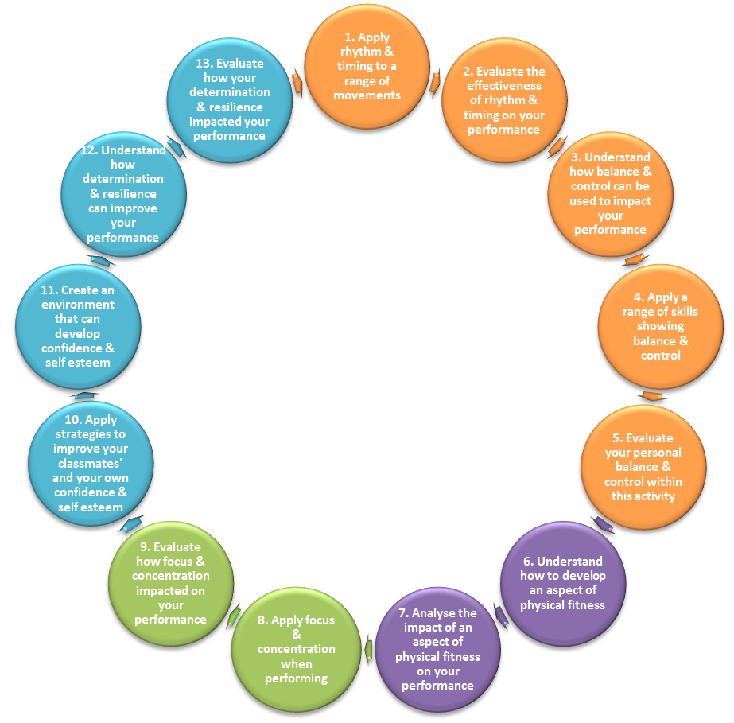
These are the learning intentions that your teacher will share with you during your activity.

These will help you develop and progress through this activity.
NUMERACY – Measure and Time:

Use different methods to measure distance, speed & time.

Show an understanding of my speed through using distance and time.

LITERACY – Listening and Talking:

Contribute and allow others to contribute in discussions.

Using suitable vocabulary to communicate effectively.

Show understanding of what I watch & listen to.

Athletics – Third Level

Can you state two events you have taken part in during the athletics block for each discipline?
Track | Throw | Jump

State 2 safety rules for a throwing event?
- …………………………………………………………………………………………
- …………………………………………………………………………………………

During a long distance running race why is it important to pace yourself? ……………………………………………………………………………………………………………………………………………………………………………………………………

Can you describe how you would measure the result of three different events?
- ……………………………………………………………………………………….
- ……………………………………………………………………………………….
- ……………………………………………………………………………………….

Third level Athletics targets | Pupil  Check | Teacher Check | Date
I can control my approach, take-off & landing during jumping events
I can use reactions & basic sprint technique to cover a short distance
I can pace myself to complete a longer distance run
I can measure times & distances accurately

I can select the correct jumping technique appropriate to my ability
I can participate in a range of different throwing events
I can work as part of a team to move a baton around a running track
I can use all equipment safely & correctly

I can follow safety protocols while performing different events
I can work cooperatively to identify strengths & areas of development
Third Level Athletics Achieved
(Signed and dated)
Self-reflection:  Strengths within performance | Self-reflection:  Areas for development within performance
Teacher feedback:  Strengths within performance | Teacher feedback:  Areas for development within performance

Athletics – Fourth Level
If you were awarded 5 points for a win, 4 for second, 3 for third, 2 for fourth and 1 point for fifth, can you identify the podium places for the following athletes?
 | 100m  (Min/Sec) | 800m  (Min/Sec) | Shot  Metres | Long (m)  Metres | High (m)  Metres
Athlete 1 | 11.23 | 2:45.54 | 5.00 | 6.23 | 0.90
Athlete 2 | 12.67 | 1:55.23 | 18.21 | 5.45 | 1.10
Athlete 3 | 14.45 | 1:59.11 | 12.32 | 3.21 | 2.00
Athlete 4 | DNF | 2:04.67 | 15.73 | 2.10 | 1.65
Athlete 5 | 11.75 | 3:01.01 | 16.72 | 5.99 | 1.85

1st
3rd
2nd

Everyone has an athletic event suited with their own personal physical strengths. Can you identify what event is your strongest and explain why? ……………………………………………………………………………………………………………………………………………………………………………………………………When and how would you show your integrity during athletics? ……………………………………………………………………………………………………………………………………………………………………………………………………
Fourth level Athletics targets | Pupil  Check | Teacher check | Date
I can perform and improve my performance in a throwing event
I can perform and improve my performance in a jumping event
I can work independently and with a team to develop my athletic skills
I can perform and improve my performance in a track event
I can identify my strengths in Athletics

I can give feedback to my team mates to help them improve their performance
I can organise my team to take part in an athletics event
I can perform a role within a team

I can compete in an athletics event demonstrating good etiquette
I can support my team mates during practice and competition
Fourth Level Athletics Achieved
(Signed and dated)
Self-reflection:  Strengths within performance | Self-reflection:  Areas for development within performance
Teacher feedback:  Strengths within performance | Teacher feedback:  Areas for development within performance

Central Net Games - Learning Intentions

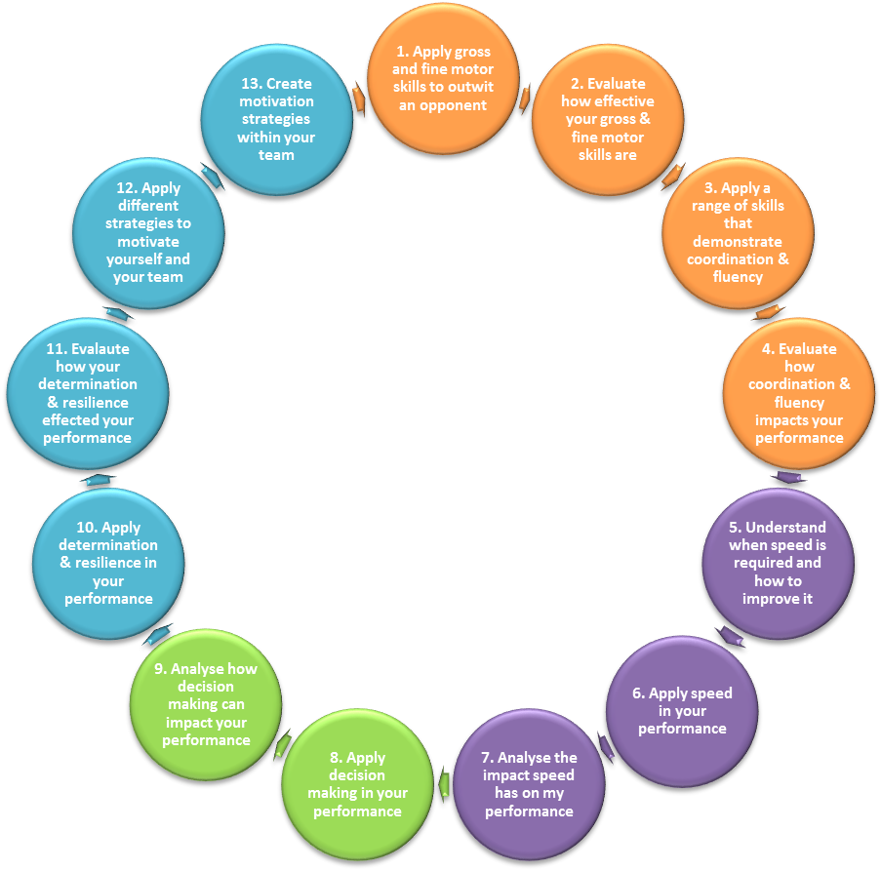
These are the learning intentions that your teacher will share with you during your activity.

These will help you develop and progress through this activity.
LITERACY
Writing: Creating Listing Using Information
Reading: Finding information Using Information
Listening and Talking: To your partner To a group To your teacher

NUMERACY – Fractions and Percentages:
Using performance analysis to identify strengths and areas of development
Using data to calculate my percentage of success

LITERACY - Listening and Talking:
Contribute and allow others to contribute in discussions

Use suitable vocabulary to communicate effectively

Show understanding of what I watch & listen to

NUMERACY – Fractions and Percentages:
Using performance analysis to identify strengths and areas of development
Using data to calculate my percentage of success

LITERACY - Listening and Talking:
Contribute and allow others to contribute in discussions

Use suitable vocabulary to communicate effectively

Show understanding of what I watch & listen to

LITERACY - Listening and Talking:
Contribute and allow others to contribute in discussions

Use suitable vocabulary to communicate effectively

Show understanding of what I watch & listen to

LITERACY
Writing: Creating Listing Using Information
Reading: Finding information Using Information
Listening and Talking: To your partner To a group To your teacher

LITERACY
Writing: Creating Listing Using Information
Reading: Finding information Using Information
Listening and Talking: To your partner To a group To your teacher

LITERACY
Writing: Creating Listing Using Information
Reading: Finding information Using Information
Listening and Talking: To your partner To a group To your teacher

LITERACY
Writing: Creating Listing Using Information
Reading: Finding information Using Information
Listening and Talking: To your partner To a group To your teacher

NUMERACY
Estimating and Rounding: Using information to estimate Rounding up and Down
Measure and Time: Speed Distance Time Navigation
Fractions/Percentages: Performance Analysis Success Rate
Number Processes: Addition Subtraction Multiply Division

LITERACY
Writing: Creating Listing Using Information
Reading: Finding information Using Information
Listening and Talking: To your partner To a group To your teacher

NUMERACY – Fractions and Percentages:
Using performance analysis to identify strengths and areas of development
Using data to calculate my percentage of success

NUMERACY – Fractions and Percentages:
Using performance analysis to identify strengths and areas of development
Using data to calculate my percentage of success

NUMERACY – Fractions and Percentages:
Using performance analysis to identify strengths and areas of development
Using data to calculate my percentage of success

NUMERACY – Fraction and Percentages:

Using performance analysis to identify strengths and areas of development.

Using data to calculate my percentage of success.

LITERACY – Listening and Talking:

Contribute and allow others to contribute in discussions.

Using suitable vocabulary to communicate effectively.

Show understanding of what I watch & listen to.

Badminton – Third Level

The main shot you have learned is an ……………….………......... It should be hit towards the ………………………of the court with....................................

If the shuttle lands on the line is it in or out? …………………………..

You can use tactics in all sports. Describe a tactic you have used in badminton? ………………………………………………………………………….
………………………………………………………………………………………………….

Can you describe a competition format you have used while playing badminton? ………………………………………………………………….
………………………………………………………………………………………………....
………………………………………………………………………………………………....

On the diagram below shade in a ½ court singles playing area
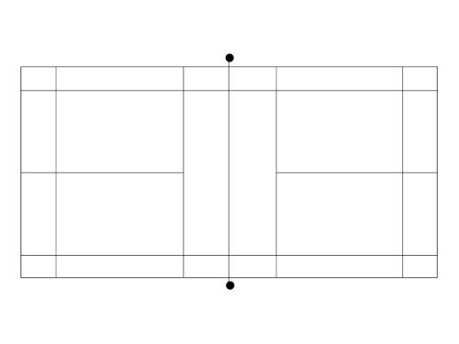
Third level Badminton targets | Pupil  Check | Teacher check | Date
I can play a serve over the net

I can play an overhead clear

I use sidestep/ chasse footwork to move around the court
I can return quickly to the ready position after each shot
I can move my opponent away from the middle of the court
I understand the rules of badminton

I can keep score when playing or officiating

I demonstrate fair play and etiquette

I can take responsibility for setting up a court or equipment
I can identify strengths & areas to develop by completing observation schedules.
Third Level Badminton Achieved
(Signed and dated)
Self-reflection:  Strengths within performance | Self-reflection:  Areas for development within performance
Teacher feedback:  Strengths within performance | Teacher feedback:  Areas for development within performance

Badminton – Fourth Level

Mark on the following diagram the shot trajectories.
A – Overhead Clear
B – Smash
C – Drop Shot
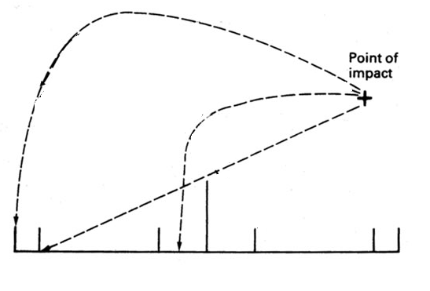
What side of the court would the server serve from if they had 7 points on a full court game? Left / Right

Shade out the areas not used in a full court singles playing area
Explain why you would use a short serve? ……………………………………………………………………………………………………………………………………………………………………………………………………
Fourth level Badminton targets | Pupil  Check | Teacher check | Date
I can use one service technique effectively

I can show consistency & fluency playing an Overhead Clear
I can play a range of overhead and underarm shots
I can cover the court effectively

I can identify opponents position & exploit space/weakness
I can identify two strengths & one area to develop
I can use this information to effectively improve performance
I can take responsibility for monitoring my improvements
I can understand the differences in the rules between doubles & singles
I can understand & participate in different types of competition
Fourth Level Badminton Achieved
(Signed and dated)
Self-reflection:  Strengths within performance | Self-reflection:  Areas for development within performance
Teacher feedback:  Strengths within performance | Teacher feedback:  Areas for development within performance

Volleyball – Third Level

Why is it important to play the ball high when passing to a team mate? …………………………………………………………………………………………………………………………………………………………………………………………………….

Can you name the two main passes used in volleyball? ………………………………………………………………………………………………….

If the ball lands on the side-line of the court is the ball in or out? ………………………………………………………………………………………..

Volleyball is 6v6 game. In school you have played small sided games (2v2, 3v3, 4v4). Can you explain why? ……………………………………………………………………………………………………………………………………………………………………………………………………
………………………………………………………………………………………………….

Describe a tactic a team would use to win a point in volleyball? ……………………………………………………………………………………………………………………………………………………………………………………………………………………………………………………………………………………………………….

Third level Volleyball targets | Pupil  Check | Teacher check | Date
I can play a volley shot

I can play a dig shot

I can perform an underarm serve to start a game
I can effectively move around the court

I can keep the score whilst participating or officiating
I can identify what shot I should play

I understand and can follow the basic rules of volleyball
I demonstrate good sporting behaviour

I can work as a team to use three touches

I can organise myself and others during a game
Third Level Volleyball Achieved
(Signed and dated)
Self-reflection:  Strengths within performance | Self-reflection:  Areas for development within performance
Teacher feedback:  Strengths within performance | Teacher feedback:  Areas for development within performance

Volleyball – Fourth Level

Identify a skill you have developed during volleyball. What type of practice did you do to improve this skill?
Skill ………………………………. Type of Practice ……………………………….

What is the benefit of being able to spike the ball in volleyball? ……………………………………………………………………………………………………………………………………………………………………………………………………

You need to work as a team during volleyball. What can you do to be a successful team member? ……………………………………………………………………………………………………………………………………………………………………………………………………

Can you complete the following P.A.R analysis stating two basic points for each phase to play a volley pass?
 | Volley Pass
Preparation

Action

Recovery

Fourth level Volleyball targets |  | Pupil  Check | Teacher check | Date
I can play a passing volley and an attacking volley
I can play a dig shot high into the air

I can perform an accurate serve to start a game
I can play a variety of shots including attacking shots
I know the role of the setter and can demonstrate when at the net
I can use good footwork to move around the court
I can select the right skills to use during a game
I know when and how my team mates should rotate on the court
I am able to cooperate and work with team mates
I can work as a team to use three touches to build an attack
Fourth Level Volleyball Achieved
(Signed and dated)
Self-reflection:  Strengths within performance |  | Self-reflection:  Areas for development within performance
Teacher feedback:  Strengths within performance |  | Teacher feedback:  Areas for development within performance

Fitness - Learning Intentions

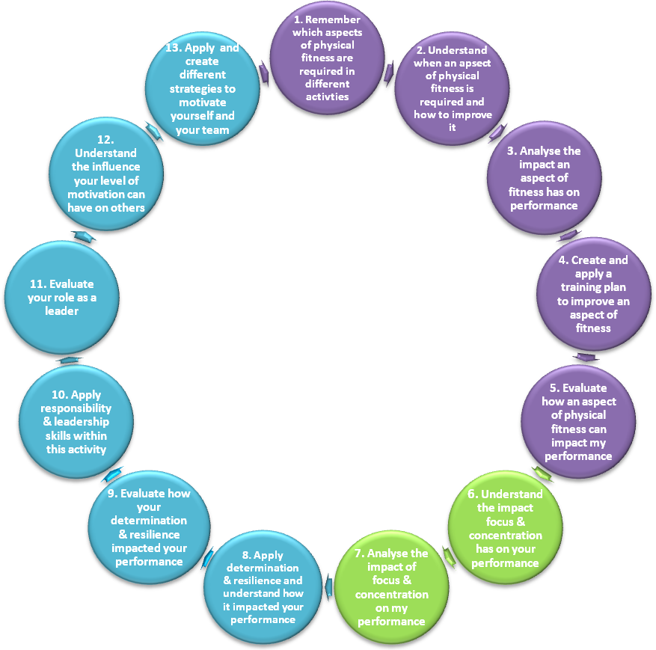
These are the learning intentions that your teacher will share with you during your activity.

These will help you develop and progress through this activity.

NUMERACY – Estimating and Rounding:

Using information to estimate to calculate training zones.

Rounding up and down to calculate weights and resistances.

LITERACY – Writing, Listening and Talking:

Recording information.

Using suitable vocabulary to communicate effectively.

Show understanding of what I watch & listen to.

My Fitness Profile

Aspect of Fitness | Test | Score | Date | Score | Date
Cardio Respiratory Endurance | 12 Minute Cooper  20m Leger
Strength | Grip Strength
Strength | 5rep chest press
Strength | 5rep lat-pull
Strength | 5rep squat
Muscle Endurance | 30s press-ups
Muscle Endurance | 30s dips
Muscle Endurance | 30s step-ups
Muscle Endurance | 30s sit-ups
Power | Vertical jump
Power | Broad jump
Power | Med ball throw
Speed | 30m Sprint
Flexibility | Sit & Reach

Identify your strongest aspect of fitness by placing a star next to your score

Fitness – Third level

Identify the Aspect of Fitness you need to develop and describe how you would do this? ...............................................................
............................................................................................................................................................................................................

Identify one reason why you should warm-up before starting any exercise? ......................................................................................................

Why should everyone’s exercise programme be different? ……………………………………………………………………………………………………………………………………………………………………………………………………

Identify one method of making an exercise easier? ………………………………………………………………………………………………….

Identify one method of making an exercise harder? ………………………………………………………………………………………………….

Which aspect of fitness would you need the most for the following activities?
100m …………………………………………………..
Gymnastics ………………………………………….
Basketball ……………………………………………
Third level Fitness targets | Pupil  Check | Teacher check | Date
I know how to test my speed, CRE & ME and have completed tests
I understand how to improve my Cardio Respiratory Endurance (CRE)
I understand how to improve my muscular endurance
I understand how to improve my speed

I know why and how to make my training harder to increase my fitness
I can monitor my heart rate by finding and checking my pulse
I have worked out my training zone

I can use a range of fitness machines safely

I can use different exercises to develop each muscle group
I can effectively carry out my own warm up

I can keep myself motivated in challenging situation
Third Level Fitness Achieved
(Signed and dated)
Self-reflection:  Strengths within performance | Self-reflection:  Areas for development within performance
Teacher feedback:  Strengths within performance | Teacher feedback:  Areas for development within performance
Fitness – Fourth Level

Identify three sports. State the main aspect of fitness related to it and how you would test the aspect of fitness. Finally, give a method of training to develop the aspect of fitness.
Sport | Aspect of Fitness | How do you test? | How do you train?

What are the three stages of an effective warm-up?
- ………………………………………………………………………………………..
- ……………………………..............................................................
- ………………………………………………………………………………………..

Link the following principles of training terms with the correct definitions. (Draw a line to connect)
Specificity  Progression  Reversibility  Overload |  |  | Any adaptation that takes place as a result of training will be reversed when you stop training. If you take a break or don’t train often enough you will lose fitness.
 |  |  | Fitness can only be improved by training more than you normally do. You must work hard.
 |  |  | Training must be matched to the needs of the sporting activity to improve fitness in the body parts the sport uses.
 |  |  | Start slowly and gradually increase the amount of exercise and keep overloading.
 | Fourth level Fitness targets |  |  | Pupil  Check | Teacher check | Date
 | I can use & understand the terms frequency, intensity & duration
 | I know what progression is and know how to use it during training.
 | I know what overload is and how to use it during training.
 | I can adapt training to be specific to personal requirements
 | I understand the effects of reversibility
 | I understand the concept of rest & recovery to improve fitness
 | I can link aspects of fitness to different sports
 | I can monitor the effects of training
 | I can identify future developmental needs
 | I can take responsibility to complete a warm-up/cool down
Fourth Level Fitness Achieved
(Signed and dated)
 | Self-reflection:  Strengths within performance |  |  | Self-reflection:  Areas for development within performance
 | Teacher feedback:  Strengths within performance |  |  | Teacher feedback:  Areas for development within performance

Gymnastics - Learning Intentions

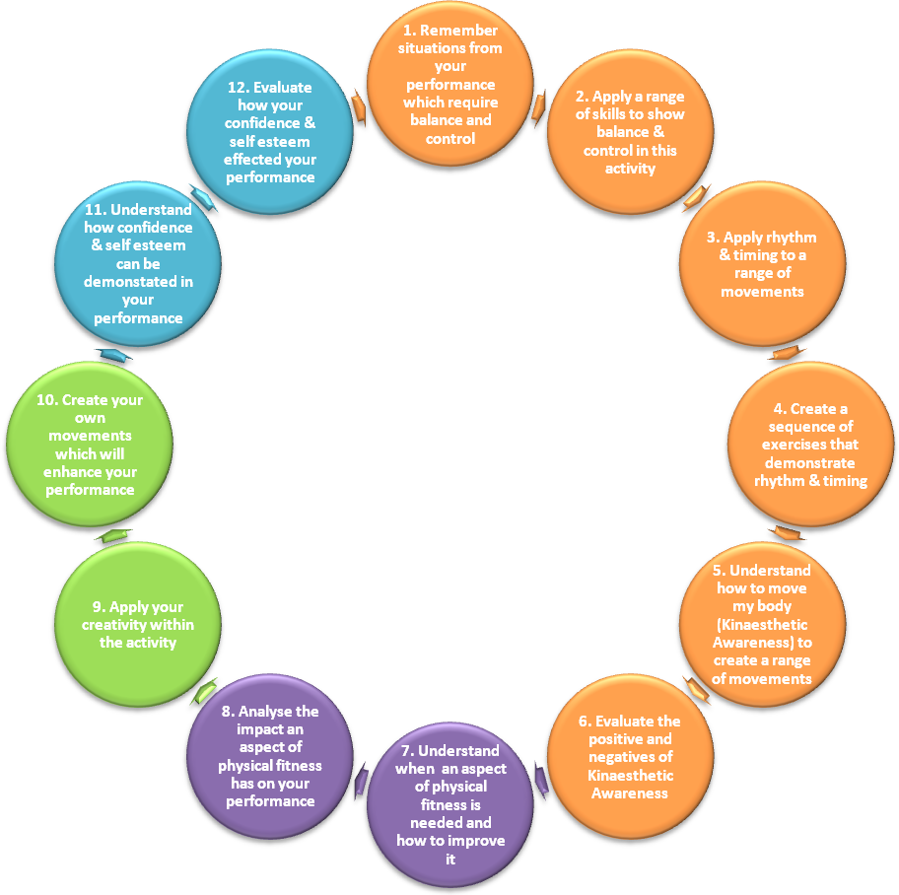
These are the learning intentions that your teacher will share with you during your activity.

These will help you develop and progress through this activity.

NUMERACY – Fractions and Percentages:

Using performance analysis to identify strengths and areas of development.

Use data to calculate my percentage of success.

LITERACY – Listening and Talking:

Contribute and allow others to contribute in discussions.

Using suitable vocabulary to communicate effectively.

Show understanding of what I watch & listen to.

Gymnastics – Third Level

Please complete the table below, giving an example of each:
 | Simple Skill | Complex Skill
Balance
Rotation
Flight
Inversion

Identify one strength in your gymnastics ………………………………….
…………………………………………………………………..................................

Identify one development need in your gymnastics ………………….
………………………………………………………………………………………………….

State 2 safety rules in gymnastics?
- …………………………………………………………………………………………
- …………………………………………………………………………………………

In gymnastics you work with a partner. Describe one way in which you may help your partner improve? ……………………………..
………………………………………………………………………………………………….………………………………………………………………………………………………….

Third level Gymnastics targets | Pupil  Check | Teacher check | Date
I can perform a simple gymnastics flight skill

I can perform a simple gymnastics rotation skill
I can perform a simple gymnastics inversion skill
I can use a trampette and/or springboard

I can perform a simple gymnastics balance skill
I can link skills together to create a short routine
I can mount and dismount apparatus safely

I can carry out a warm up for gymnastics

I understand and can follow safety procedures and handle equipment
I can give others feedback on their performance
Third Level Gymnastics Achieved
(Signed and dated)
Self-reflection:  Strengths within performance | Self-reflection:  Areas for development within performance
Teacher feedback:  Strengths within performance | Teacher feedback:  Areas for development within performance

Gymnastics – Fourth Level

Look at the pictures below: Identify which handstand is better by putting a tick next to the performer.
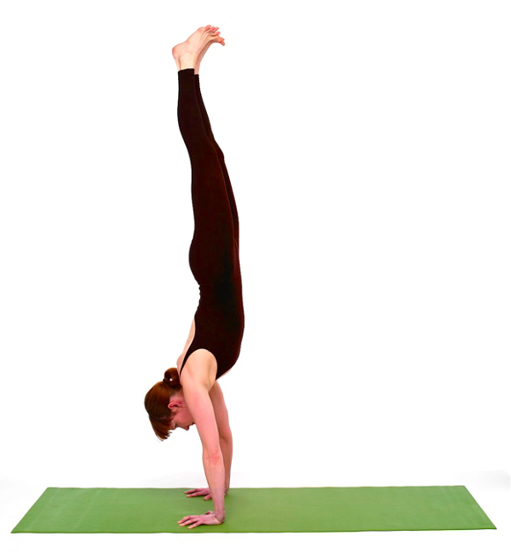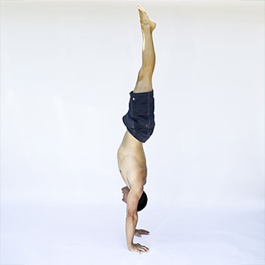
Describe 2 improvements the other performer could make to improve their performance:
- ……………………………………………………………………………………..
- .…………………………………………………………………………………….
In gymnastics you have planned and performed a routine. Explain two considerations you made when planning this routine? (Give reasons why you included/did not include certain skills)
- …………………………………………………………………………………………
- …………………………………………………………………………………………
Is gymnastics scored objectively or subjectively, please circle.
Describe what you could do to achieve a high score:
……………………………………………………………………………………………………………………………………………………………………………………………………

Fourth level Gymnastics targets | Pupil  Check | Teacher check | Date
I can demonstrate a clear starting & finishing position
I can perform a complex rotation (backward roll, dive forward roll, cartwheel &/or round-off)
I can perform a complex balance (handstand, head stand with support)
I can use different body shapes and rotations during flight
I can demonstrate with some control & fluency an inversion skill
I can demonstrate control & fluency on the floor or using apparatus
I can demonstrate one change of pace & one change in direction
I can identify two strengths & one area of development for self & partner
I can perform an individual or cooperative routine linking three skills
I can use this information to effectively improve performance
Fourth level Gymnastics Achieved
(Signed and dated)
Self-reflection:  Strengths within performance | Self-reflection:  Areas for development within performance
Teacher feedback:  Strengths within performance | Teacher feedback:  Areas for development within performance

Indoor Invasion Games - Learning Intentions

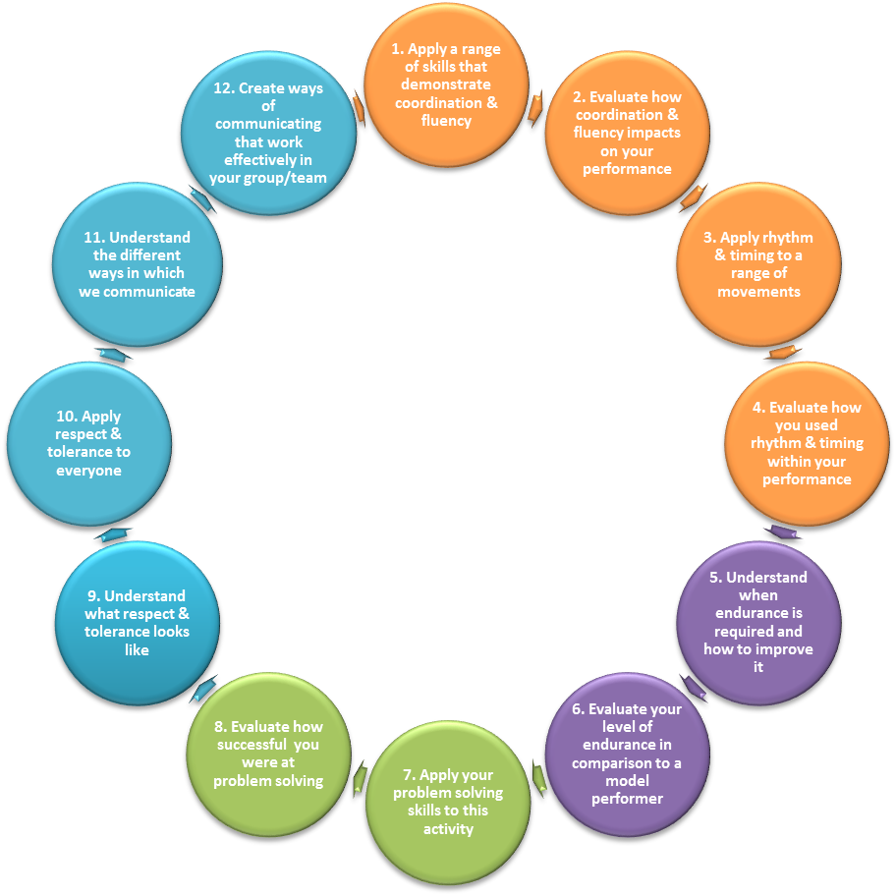

These are the learning intentions that your teacher will share with you during your activity.

These will help you develop and progress through this activity.

NUMERACY – Number Processes:

Organise groups of people into teams.

Keep scores using a variety of different scoring systems.

LITERACY – Listening and Talking:

Contribute and allow others to contribute in discussions.

Using suitable vocabulary to communicate effectively.

Show understanding of what I watch & listen to.

Basketball – Third Level

How many points do you get for scoring a basket inside the ‘D’? …………………………………….

State two rules from the game of basketball?
Rule 1: …………………………………………………………..............................
Rule 2: …………………………………………………………..............................

On the diagram below label the following areas:
- The key
- The free throw line
- The basket
- The centre circle
- The end line
- The side line
- The 3 point line
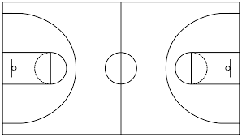

There are three main ways to pass the ball in basketball. Name two?
- …………………………………………………………………………………………
- …………………………………………………………………………………………

Name a type of shot you could use to score a basket? …………….
Third level Basketball targets | Pupil  Check | Teacher check | Date
I can dribble the ball with control and fluency
I can shoot close to the basket

I can pass using chest/bounce techniques

I can use my CRE to work to the best of my ability throughout the lesson
I can sometimes make good decisions in games
I can find space during games

I can sometimes use man to man marking
I can work co-operatively with others

I can play within the rules of the game

I can take responsibility for leading others
Third Level Basketball Achieved
(Signed and dated)
Self-reflection:  Strengths within performance | Self-reflection:  Areas for development within performance
Teacher feedback:  Strengths within performance | Teacher feedback:  Areas for development within performance

Basketball – Fourth Level
Describe three positives about this model performer’s lay-up?
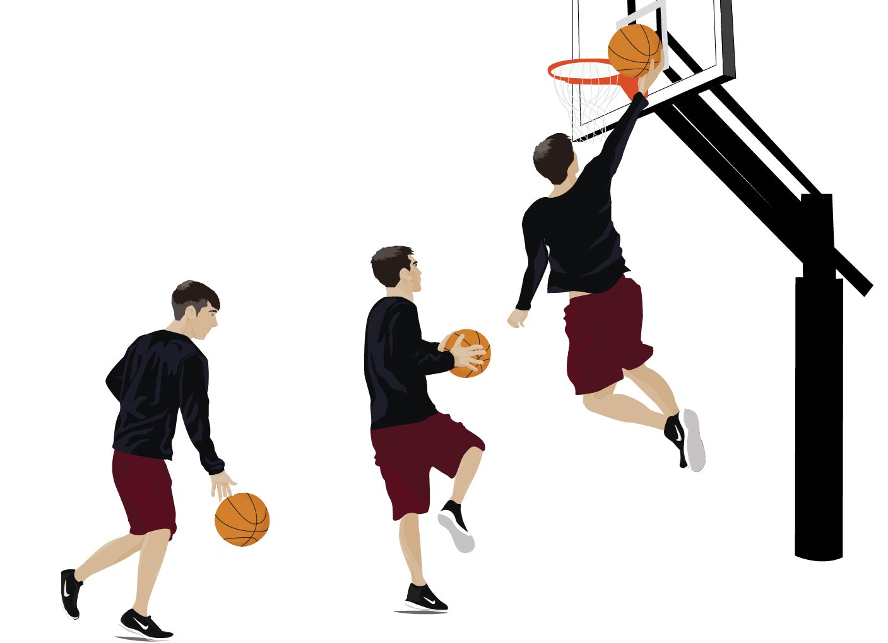
- ……………………………………………….
- ……………………………………………….
- ……………………………………………….

What position would the following players play?
I am one of the tallest in my team. I can move down the court quickly. I can perform a successful lay-up.
……………………………………………………………………………………………….
I am agile. I can make good passes to my team mates. I can dribble the ball up the court successfully.
……………………………………………………………………………………………….
I am usually the tallest in the team. I am strong and good at rebounds. I perform the tip-off at the start of games.
……………………………………………………………………………………………….

Describe a double dribble? …………………………………………………….
……………………………………………………………………………………………….
Fourth level Basketball targets | Pupil  Check | Teacher check | Date
I can dribble the ball consistently under pressure
I can shoot using different techniques (jump/set/lay-up)
I can pass consistently under pressure (chest/bounce/javelin)
I can regain possession in defence (rebound/intercept/steal)
I can identify attackers movement and close space effectively
I can sometimes use the half court man to man marking tactic
I can use a triple threat in attack (shoot > pass > dribble)
I can create & identify space in attack

I can fulfil the duties of one of the three main roles (G, C, F)
I can follow the basic rules as a player & implement as a referee
Fourth level Basketball Achieved
(Signed and dated)
Self-reflection:  Strengths within performance | Self-reflection:  Areas for development within performance
Teacher feedback:  Strengths within performance | Teacher feedback:  Areas for development within performance

Outdoor Invasion Games – Learning Intentions
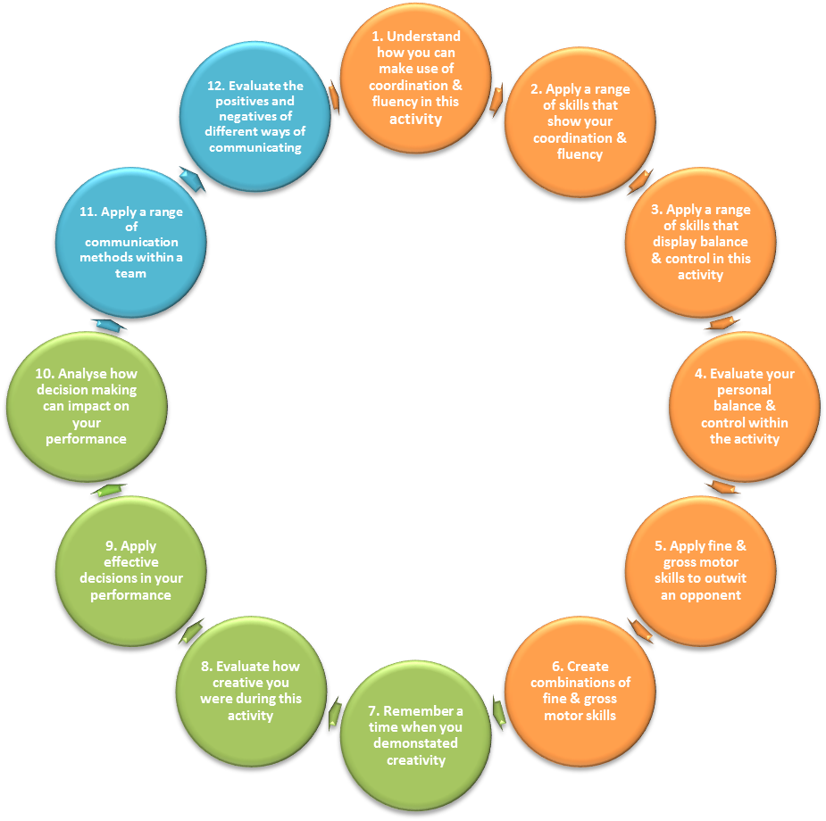
These are the learning intentions that your teacher will share with you during your activity.

These will help you develop and progress through this activity.
NUMERACY – Number Processes:

Organise groups of people into teams.

Keep scores using a variety of different scoring systems.

LITERACY – Listening and Talking:

Contribute and allow others to contribute in discussions.

Using suitable vocabulary to communicate effectively.

Show understanding of what I watch & listen to.

Football – Third Level

What part of your foot should you use to make an accurate pass? …………………………………………………………………………………………

If you want to receive a pass describe what you could do to help your team-mate? ……………………………………………………………...
………………………………………………………………………………………………….
Explain 2 rules of football
Rule 1: ……………………………………………………………………………………..
………………………………………………………………………………………………….Rule 2: ………………………………………………………………………………………
………………………………………………………………………………………………….

During the football course you practiced skills. Why is it important to practice skills and not just play games?
………………………………………………………………………………………………….………………………………………………………………………………………………….

In football you win by scoring more goals than the opposition. State two other sporting activities and how you would win?
 | Activity | How do you win?
Individual
Team
Third level Football targets |  |  | Pupil  Check | Teacher check | Date
I can dribble the ball with different parts of my foot
I can shoot towards the goal

I can pass using inside foot technique

I can sometimes tackle to get the ball

I can sometimes apply speed in my performance
I can find space during games

I can sometimes use man to man marking

I can sometimes make good decisions in games
I can work co-operatively with others

I can include and encourage others

I can play within the rules of the game

Third Level Football Achieved
(Signed and dated)
Self-reflection:  Strengths within performance |  |  | Self-reflection:  Areas for development within performance
Teacher feedback:  Strengths within performance |  |  | Teacher feedback:  Areas for development within performance
Football – Fourth Level

In football your team may adopt tactics. Describe one of the following tactical decisions? Possession, Long Ball, Using a Sweeper, Wing Backs, Lone attacker. ………………………………………………………………………..…………..……….. .………………………..……………………………………………………………….…..
……………………………………………………………………………………………….

What is meant by the term Etiquette? ……………………………………………………………………………………………………………………………………………………………………………………………………
How would you demonstrate this in football?
1……………………………………………………………………………………………….
2……………………………………………………………………………………………….

Mark on the pitch below a basic formation showing 1 team of 11 players?
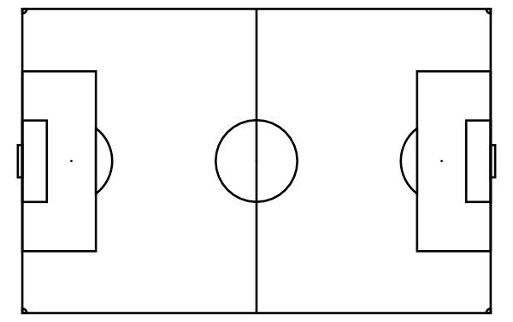
GK = Goal Keeper
D = Defender
M = Midfield
F = Forward

- You can use more specific terminology LB/RB/CAM/ST
Fourth level Football targets | Pupil  Check | Teacher check | Date
I can dribble the ball under pressure with control
I can shoot to challenge the goal keeper

I can pass using a range of short and long passes
I can tackle safely at the right time

I can find space when attacking

I can close down space in defence

I can use effective decision making during the game
I can demonstrate effective positioning (GK, D, M, A)
I can take responsibility for leading

I can follow the basic rules as a player & implement as a referee
Fourth Level Football Achieved
(Signed and dated)
Self-reflection:  Strengths within performance | Self-reflection:  Areas for development within performance
Teacher feedback:  Strengths within performance | Teacher feedback:  Areas for development within performance

Hockey – Third Level

State 3 things that are good about this model performer receiving a pass in hockey
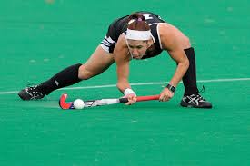
- ……………………...

- ……………………...

- ……………………...

Describe the correct grip for dribbling? …………………………………….
………………………………………………………………………………………………….………………………………………………………………………………………………….

State three rules in hockey?
1……………………………………………………………………………………………….
2……………………………………………………………………………………………….
3……………………………………………………………………………………………….

In hockey you win by scoring more goals than the opposition. State two other activities that is scored the same way
1 ……………………………………………………............................................
2 ………………………………………..........................................................
Third level Hockey targets | Pupil  Check | Teacher check | Date
I can stop the ball with control

I can play a push pass

I can dribble with control

I can tackle safely and within the rules

I can hit the ball hard towards the target

I can Indian dribble the ball

I can play small sided games

I can sometimes make quick and effective decisions during a game
I can see space and move off the ball into it

I can use different methods of communication
I know and can follow the basic rules during a game
Third Level Hockey Achieved
(Signed and dated)
Self-reflection:  Strengths within performance | Self-reflection:  Areas for development within performance
Teacher feedback:  Strengths within performance | Teacher feedback:  Areas for development within performance
Hockey – Fourth level

Who is in the best position to shoot - A, B or C? Explain your answer.
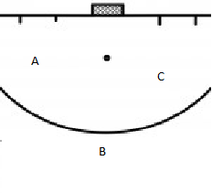
…………………………………………………………………………………………………………………………………………………………………………………………………..

Why do you want to have width on your attack in hockey?
………………………………………………………………………………………………………………………………….....................................................................

Hockey is played using a stick and a ball. Can you name two other sports that use similar equipment?
- ………………………………………………………………………………………
- ………………………………………………………………………………………

If you were to have one aspect of fitness for hockey what would it be and why? ………………………………………………………………………………………………………………………………….....................................................................
Fourth level Hockey targets | Pupil  Check | Teacher check | Date
I can stop the ball with control using front and reverse stick
I can play a push pass with control to a team mate
I can dribble with control under pressure

I can lift the ball with control in a safe manner
I can Indian dribble the ball within a game

I can hit the ball hard on target

I can choose the correct tackle and perform it safely
I can find and create space on and off the ball
I can play a position within a game

I know and can follow the rules during a game
Fourth Level Hockey Achieved
(Signed and dated)
Self-reflection:  Strengths within performance | Self-reflection:  Areas for development within performance
Teacher feedback:  Strengths within performance | Teacher feedback:  Areas for development within performance

Rugby – Third Level

How do you score in rugby? ……………………………………………………..

What direction are you not allowed to pass in rugby? ………………………………………………………………………………………………….

Rugby is an invasion sport. State two other sports that are invasion sports.
- ………………………………………………………………………………………..
- ………………………………………………………………………………………..

What shape should your hands form to catch the ball? ………………………………………………………………………………………………….

To complete a successful tackle safely you should follow four basic steps. What are they?
- ………………..in the hoop
- Eye to ……………………
- ……………… to cheek
- Bands of …………………

Third level Rugby targets | Pupil  Check | Teacher check | Date
I can use the tackle safely (eye to thigh, cheek to cheek, band of steel)
I can pass and receive the ball

I can run forward and pass backwards

I can present the ball effectively while on the ground to team mates
I can protect the ball when on the ground

I know how to score a try

I can run a support line to receive an offload

I can carry out an offload to a team mate

I can stay in a defensive line

I can effective communicate with my teammates
I know and can follow the basic rules during a game
Third Level Rugby Achieved
(Signed and dated)
Self-reflection:  Strengths within performance | Self-reflection:  Areas for development within performance
Teacher feedback:  Strengths within performance | Teacher feedback:  Areas for development within performance
Rugby – Fourth Level

State three ways to restart a passage of play in rugby?
- ……………………………………………………………………………………..
- ……………………………………………………………………………………..
- ……………………………………………………………………………………..

Name a skill you have developed during the rugby block. Describe a practice or game you have completed to improve this skill. You may want to include a diagram.
Skill…………………………………. Diagram
Practice Description
……………………………………….
……………………………………….
……………………………………….
…………………………...............
...........................................

What can you do to promote Respect in rugby?
……………………………………………………………………………………………………………………………………………………………………………………………………

What is the minimum time you must wait until you return to play after a concussion? ……………………………..days
Fourth level Rugby targets | Pupil  Check | Teacher check | Date
I can pass of both hands

I can offload during a full tackle situation

I can present the ball effectively with competition from defence
I can tackle in a game

I can identify space, communicate with team mates & exploit weaknesses
I can consistently make the correct decision in attack (run > pass > kick)
I can effectively use the offload to keep the ball moving
I can successfully carryout different roles within the team
I can provide feedback to encourage others

I can follow the basic rules as a player & implement as a referee
Fourth Level Rugby Achieved
(Signed and dated)
Self-reflection:  Strengths within performance | Self-reflection:  Areas for development within performance
Teacher feedback:  Strengths within performance | Teacher feedback:  Areas for development within performance

Notes
……………………………………………………………………………………………………………………………………………………………………………………………………………………………………………………………………………………………………………………………………………………………………………………………………………………………………………………………………………………………………………
……………………………………………………………………………………………………………………………………………………………………………………………………………………………………………………………………………………………………………………………………………………………………………………………………………………………………………………………………………………………………………
……………………………………………………………………………………………………………………………………………………………………………………………………………………………………………………………………………………………………………………………………………………………………………………………………………………………………………………………………………………………………………
……………………………………………………………………………………………………………………………………………………………………………………………………………………………………………………………………………………………………………………………………………………………………………………………………………………………………………………………………………………………………………
……………………………………………………………………………………………………………………………………………………………………………………………………
Notes
……………………………………………………………………………………………………………………………………………………………………………………………………………………………………………………………………………………………………………………………………………………………………………………………………………………………………………………………………………………………………………
……………………………………………………………………………………………………………………………………………………………………………………………………………………………………………………………………………………………………………………………………………………………………………………………………………………………………………………………………………………………………………
……………………………………………………………………………………………………………………………………………………………………………………………………………………………………………………………………………………………………………………………………………………………………………………………………………………………………………………………………………………………………………
……………………………………………………………………………………………………………………………………………………………………………………………………………………………………………………………………………………………………………………………………………………………………………………………………………………………………………………………………………………………………………
……………………………………………………………………………………………………………………………………………………………………………………………………

Integrity
Equality
Respect
Responsibility
Ambition

@IrvineRoyalPE
https://blogs.glowscotland.org.uk/na/irvineroyalacademype/

