Integrity, Equality, Respect, Responsibility, Ambition
Responsibility, Ambition, Integrity, Equality, Respect
Ambition, Integrity, Equality, Respect, Responsibility


Irvine Royal Academy

S3 PE Studies

Gymnastics – The Social Factor

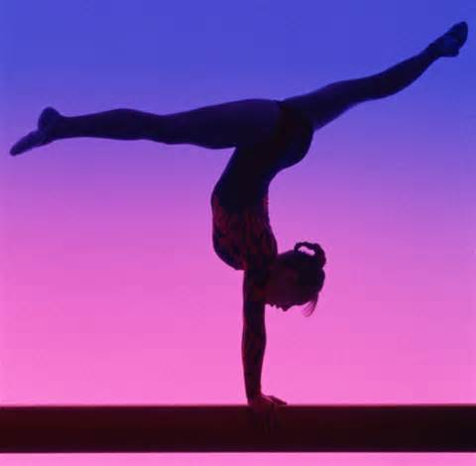

Name………………………………..

Class…………………………………
The Cycle of Analysis
The method(s) you use to identify factors (which are strengths and weaknesses) in your performance is the first stage of the cycle of analysis. Once you collect this information you can plan a programme to try and improve upon your weaknesses.
To develop your performance effectively you must understand and follow the ‘Cycle of Analysis’.

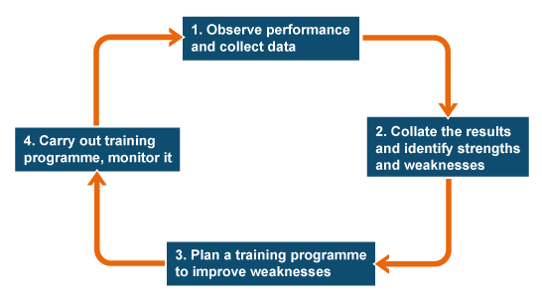

Features & Impact

CO-OPERATING & COMPETING

Co-operating is where you work together with others to achieve a common goal. In any activity, where you work with at least one other person, you will be a member of a group or team. In this group/team you will have to give (contribute) something that helps. Each member of the team or group is expected to contribute. You can compete individually or as a part of a team. Competing is where the emphasis changes from supporting a team mate/opponent to trying to win.

Question:
During gymnastics, can you remember a time when you had to co-operate with team mates in your class? Describe this situation below.

………………………………………………………………………………………………………………………………………………………………………………………………………………………………………………………………………………………………………

Positive Impact

Co-operating effectively within gymnastics provides a greater opportunity for classmates to work together effectively to arrange the equipment safely at the start of the lesson and maintain this throughout lesson. In addition, by cooperating with classmates it enables pupils to fully participate in lesson as they are able to offer support during complex skills allowing classmates to develop confidence in safe and controlled environment. This can be done by helping each other by supporting your partner and giving constructive feedback. Positively contributing to your team will have a positive effect on their performance. This can be achieved by motivating your classmates and offering encouragement. For example a dancer may have an idea and suggest how the dance could be developed making the dance look better. In a team if your teammates see that you are fulfilling your role, marking an opposition player for example, then they will work hard to ensure they fulfil their roles. It is important to ensure each member of a team contributes for their overall success.

Question

Explain a time when cooperation had a positive impact on your performance. Give reasons to why this was.

………………………………………………………………………………………………………………………………………………………………………………………………………………………………………………………………………………………………………

Negative Impact

A negative contribution to your team and not fulfilling your role can result in a poor performance from you and your group. If you do not fulfil your role of supporting a classmate or ensuring equipment is safe this may result in an accident. Having a classmate perform poorly or become negative has impact on the rest of the group which could result in a loss of confidence or arguments within the group.

Question

Explain a time when cooperation had a negative impact on your performance. Give reasons to why this was.

………………………………………………………………………………………………………………………………………………………………………………………………………………………………………………………………………………………………………

ETIQUETTE

Etiquette is a code and set of expectations for the conduct of the performer and is based on following the written rules but also covers many unwritten rules and protocols that are expected within the particular activity. Etiquette tends to be based on traditions and social conventions within the activity.

Positive Impact

Showing appropriate etiquette means a performance is likely to be good tempered and fair. During gymnastics vault, classmates would allow each other to perform their vault without any distractions allowing them to focus without any distractions.

Negative impact

Poor etiquette means that the performance is disrupted. Team mates using bad language and taking their frustration out on equipment will result in a poor performance but will also impact on their classmates.

Question

State 3 ways that you can show good etiquette in gymnastics

………………………………………………………………………………………………………………………………………………………………………………………………………………………………………………………………………………………………………

ROLE MODELS

These are people who serve as a good example and whose performance, attitude, fitness, behaviour and skills we would want to emulate. Role models have the ability to inspire others. Role models themselves can have a lot of pressure put onto them to be the perfect professional. Model performers can be used for comparison with our own and others performances. This can be used to identify strengths and weaknesses in the performance in any of the 4 factors.

Positive Impact

Role models can encourage good sportsmanship and honesty and can have a positive impact on those taking part in sport as they can also be used to promote good etiquette and high skill level and discourage any negative behaviour.

Negative Impact

If the role model does not ‘model’ this behaviour all of the time then other team members could copy this behaviour resulting in negative behaviours been used by all team members.

Methods of Gathering Information

Cooperation self-reflection
This method allows you to collect initial data on your current level of cooperation in your activity. It can be completed at the start and end of the block and results can be compared. There are statements on cooperation and you have to select one of four criteria – always, usually, sometimes and never. You should reflect on your performance and tick the box which best describes how you cooperate in different situations.

 | Always | Usually | Sometimes | Never
Social Factor
I have confidence in my team mates
I have trust in my team mates
I understand my role / responsibility during games
I work hard for my team at all times
I always give 100% regardless of performance / score
I cover for my team mates and offer support
I stay positive and don’t argue when things go wrong
I blame my team mates for mistakes
I support my team mates whatever their decision
Group Cohesion Questionnaire

This is a questionnaire which allows you to collect information on how you are contributing to the team individually and how the team bonds together. You should read each statement and circle one number (1-9) to show much you agree/disagree with the statement.

- We all share the same commitment to our teams goals
1 2 3 4 5 6 7 8 9
Strongly disagree Strongly agree
- I invite my team mates to do things with me
1 2 3 4 5 6 7 8 9
Strongly disagree Strongly agree
- As a team, we are all on the same page
1 2 3 4 5 6 7 8 9
Strongly disagree Strongly agree
- Some of my best friends are on this team
1 2 3 4 5 6 7 8 9
Strongly disagree Strongly agree
- I like the way we work together as a team
1 2 3 4 5 6 7 8 9
Strongly disagree Strongly agree
- I do not get along with the members of my team
1 2 3 4 5 6 7 8 9
Strongly disagree Strongly agree
- We socialise with each other whenever possible
1 2 3 4 5 6 7 8 9
Strongly disagree Strongly agree
- As a team, we are united
1 2 3 4 5 6 7 8 9
Strongly disagree Strongly agree

Approaches to Develop Performance

The following approaches can be used to develop the social factor. You will need to identify which social feature is having an impact on your activity and set out goals in order to develop your performance.

Team building approach

This approach is used to improve relationships within the group. It can start with fun, easy activities intended to get everyone in the group relaxed and open to communicate with each other.

From here the group would be set a task which they must achieve together as a group. By working through a problem together, positive relationships can be established. This new positivity should be carried back into the performance. This team building should become a strong feature of your training. The aim is to ensure negative behaviour, which might exclude certain team members, is minimised and positive behaviour is maximised.

Praise sandwich

Team building tasks build in positive reinforcement to foster good, strong and positive relationships within the group. The praise sandwich is a feedback given in 3 parts.

- Highlight positive statement about something done well in performance
- Constructive statement about something they need to work on
- Final positive statement highlighting something else performed well

By using praise effectively this will result in building team morale and group members feeling valued and confident in trying to develop their performance.

Question

Look at the picture below and give some constructive feedback on what one of the performers can do to improve their handstand. State which performer you are answering on.

Performer A Performer B

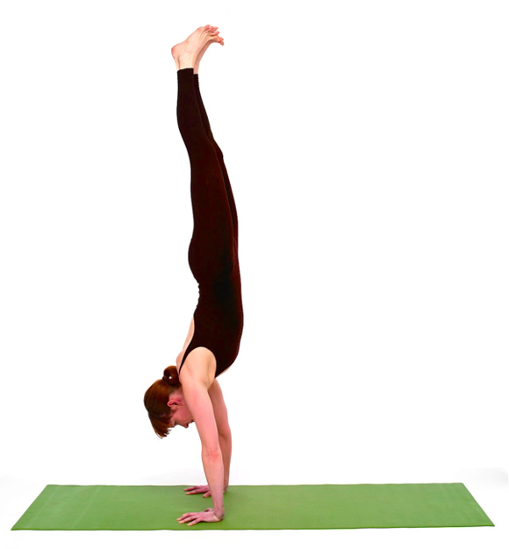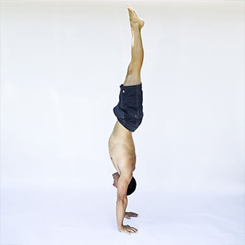

………………………………………………………………………………………………………………………………………………………………………………………………………………………………………………………………………………………………………
………………………………………………………………………………………………………………………………………………………………………………………………………………………………………………………………………………………………………

Monitoring & Evaluating

While developing the approaches to help manage your emotions, you want to monitor your training to ensure the approaches are working. This will allow you to track any changes you may need to make. When monitoring you want to look for evidence that the approaches are working. This can be done through feedback. You will be able to give yourself feedback and gain feedback from others.

At the end of a training programme you can evaluate your performance by re-testing using the same methods of gathering information to assess how successful you now are at managing your emotions. This will allow you to compare your results, re-assess your current emotional state and help you identify any future development needs.

