Integrity, Equality, Respect, Responsibility, Ambition
Responsibility, Ambition, Integrity, Equality, Respect
Ambition, Integrity, Equality, Respect, Responsibility


Irvine Royal Academy

S3 PE Studies

Fitness – The Physical Factor - Fitness
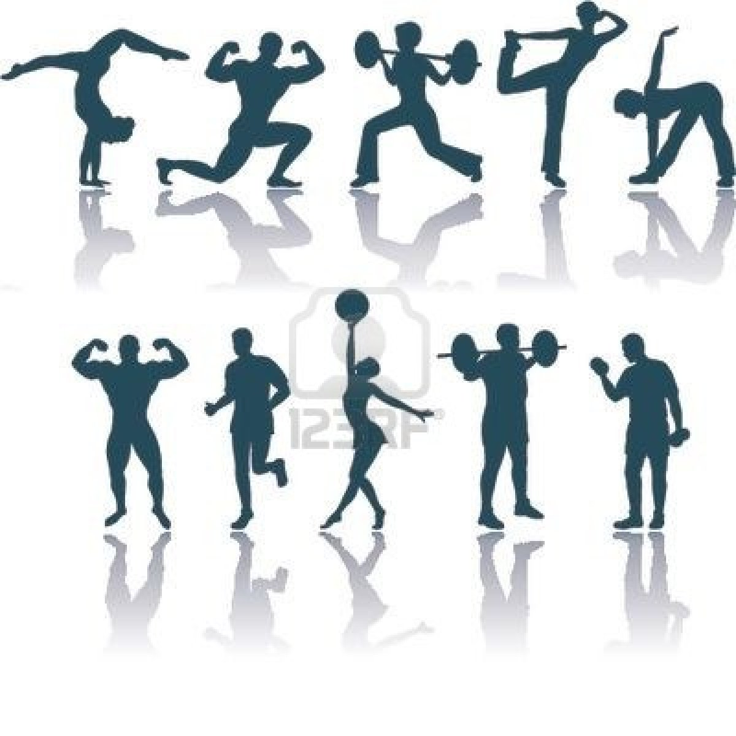

Name………………………………..

Class…………………………………

The Cycle of Analysis
The method(s) you use to identify factors (which are strengths and weaknesses) in your performance is the first stage of the cycle of analysis. Once you collect this information you can plan a programme to try and improve upon your weaknesses.
To develop your performance effectively you must understand and follow the ‘Cycle of Analysis’.

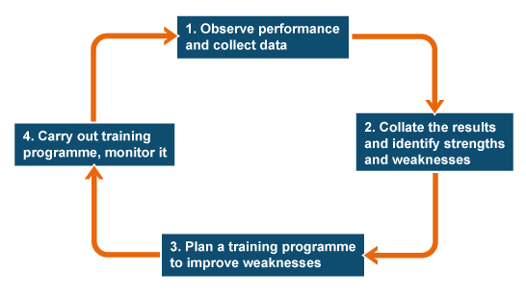

Features & Impact

Power

Agility
Local muscular endurance

Flexibility

Strength

Speed
Cardio-respiratory endurance CRE
Aspects of Fitness
Principles of Training
Specific – Is your training specific to the activity you are doing?

Progression – Are you getting better at what you are training?

Overload – Are we making our programme gradually more challenging?

Reversibility – If you stop training you start to lose the level of fitness you have gained

Tedium – Are you making your programme interesting enough that you don’t become bored?

Application of principles of training

Frequency | This is how often you are training. You can overload your training by training more often
Intensity | This is how hard you are pushing yourself during training
Duration | This is how long you train for

CRE
The ability of the heart and lungs to provide the working muscles with oxygenated blood for a prolonged period of time.

Impact on Performance
Poor CRE will result in the performer becoming breathless more quickly and unable to keep up with play or maintain a high skill level. Decision making may also be affected and longer rest periods will be needed to aid recovery. A high level of CRE delays the onset of fatigue. This means that your work rate stays high so you can fulfil your role in the team and maintain a high skill level (as fatigue can also affect your control, touch, concentration and decision making).

Method of Gathering Data – CRE

Cooper 12 Minute Run Test

The 12 Minute Cooper Run Test is a standardised test which measures which measures a performers level of Cardio-respiratory endurance (CRE).

Task: Use the recording sheet on the following page to complete the 12 Minute Cooper Run Test.
Cooper 12 Minute Run Test

Name: _______________________ Age: ______ Date: _____________

Each full lap is 100m

Make sure you are concentrating and focussed and put a tick beside the distance each time your partner passes your cone.
Distance Covered (m)
100 | 200 | 300 | 400 | 500 | 600 | 700 | 800 | 900 | 1000
1100 | 1200 | 1300 | 1400 | 1500 | 1600 | 1700 | 1800 | 1900 | 2000
2100 | 2200 | 2300 | 2400 | 2500 | 2600 | 2700 | 2800 | 2900 | 3000

When the whistle goes at the end of the test your partner will stop at the next cone. Each cone is 5 extra meters. Put a tick beside each extra 5m run.

5 | 10 | 15 | 20 | 25 | 30 | 35 | 40 | 45 | 50 | 55 | 60 | 65 | 70 | 75 | 80 | 85 | 90 | 95 | 100

Add the scores together to give you the total distance run in 12 minutes:

Total distance covered___________________________ (m)

Now compare your performance to the National Norms and note your current level of CRE fitness.

Male

Age | Excellent | Above Average | Average | Below Average | Poor
13-14 | >2700m | 2400-2700m | 2200-2399m | 2100-2199m | <2100m
15-16 | >2800m | 2500-2800m | 2300-2499m | 2200-2299m | <2200m

Female

Age | Excellent | Above Average | Average | Below Average | Poor
13-14 | >2000m | 1900-2000m | 1600-1899m | 1500-1599m | <1500m
15-16 | >2100m | 2000-2100m | 1700-1999m | 1600-1699m | <1600m

My level of CRE is: ___________________________

Describe a method of gathering information for Cardio Respiratory Endurance?

…………………………………………………………………………………………………………………………………………………………………………………………………………………………………………………………………………………………………………………………………………………………………………………………………………………………………………………………………………………………………………………………………………………………………………………………………………………………………………………………………………………………………………………………………………………………………………………………………………………………………………………………………………………………………………………………………………………………………………………………………………………………

What was it measuring
What activity is it linked to
Where it took place
What did it look like
What resources did you use
How you carried it out / what it looked like

What are the benefits of carrying out this method?

………………………………………………………………………………………………………………………………………………………………………………………………………………………………………………………………………………………………………………………………………………………………………………………………………………………………………………………………
………………………………………………………………………………………………………………

What are the limitations of carrying out this method?

………………………………………………………………………………………………………………………………………………………………………………………………………………………………………………………………………………………………………………………………………………………………………………………………………………………………………………………………………………………………………………………………………………………………………………

Development Approaches – CRE

There are a number of different approaches to develop CRE. They include:

- Continuous running/ swimming/ cycling
- Interval training
- Conditioning Training
- Fartlek Training

The approach that you are going to use is Fartlek Training. The grid you will use is shown below.

Task: Complete each section by writing what you did between each section.

Speed

Speed is the body’s ability to perform an action in a short time. Speed can be split into two categories whole body speed and part body/limb speed. Whole body speed is where whole body performs an action quickly. Part body/Limb speed is when a particular part of your body performs an action quickly. Speed Endurance is the ability to continually make fast runs over a long period time.

Impact on Performance
Speed is required in football when trying to beat an opponent to a 50/50 ball, to lose a defender, to get into space, to support an attack, to dribble round an opponent or to chase back and close down an attack. If you lack speed then you will be unable to maintain possession of the ball, win it back, or take on your opposite player effectively. This happens continually throughout the game as you repeatedly sprint over varied distances. Therefore speed endurance is also important because if it is poor you will be unable to maintain sprinting throughout the duration of the game.

Strength

The maximum force a muscle or group of muscles can exert at any one time. Strength can be further divided into Static Strength (muscles contract and hold one position), Dynamic Strength (muscles repeatedly apply force over a short period of time) and Explosive Strength or Power (muscles exert force in a short, fast burst).

Impact on Performance
Performing a scrum in Rugby would be an example of where Static Strength is required. Rugby Players are required to use Static Strength to stop the opposition from pushing the scrum and gaining an advantage. Dynamic Strength would be required when swimming short distances. Swimmers would require strong chest, arm and shoulder muscles when performing strokes like the freestyle, backstroke and breast stroke in order gain propulsion. Explosive Strength would be required for activities such as throwing a Javelin. Explosive Strength is used in single actions when maximum energy is needed.

Local Muscular Endurance (LME)

Local Muscular Endurance is the ability of muscles/ groups of muscles to continuously perform during exercise.
Good LME in physical activity allows a performer to maintain a high level of performance/skill throughout an activity.

Impact on Performance

A footballer with good levels of LME in his legs would be able to consistency tackle and win the ball and keep possession from the opposition all the way to the end of the match.

A volleyball player with poor levels of LME in their legs mean that they cannot jump as high as the game goes on. This mean that they cannot get enough height to spike a ball which means that the opposition do not need to block against the attack. This would mean that the opposition can conserve their energy, making it easier for them to build their own attacks leading to more opportunities for the opposition.

Method of Gathering Data – LME

Standardised Tests

To measure LME performers can use the 1 Minute LME tests shown in the table below.

Task: Complete the table below identifying the muscle groups that each test is measuring the LME for. Performers must do as many of the exercises shown below in 1 minute and record their results.

Exercise | Muscle Group | No. of Repetitions
Step-ups
Sit-ups
Press-ups
Dips

Development Approach – LME
Circuit Training
Circuit training is an effective way of improve your levels of LME. Stations can be set up to work individual or groups of muscles for a set period of time e.g. 1 minute.

Task: Design your own LME Circuit using the diagram below. You must write down what equipment you require for each station and how long the performers will be working for.

Station | Exercise | Equipment | Muscles Worked
1
2
3
4
5
6
7

Performers will work for ___ minutes at each station.
Agility
Agility is the ability to change direction or the body’s position at speed.

Impact on performance
In rugby if I have good agility I can weave through defender’s challenges more often during a match. This makes it more difficult to tackle me which allows me to gain more ground on the opposition or even results in me scoring a try. By doing this I put the opposition under pressure and create more opportunities for my team closer to the opposition’s goal line.

Method of Gathering Data – Agility
Illinois Agility Test

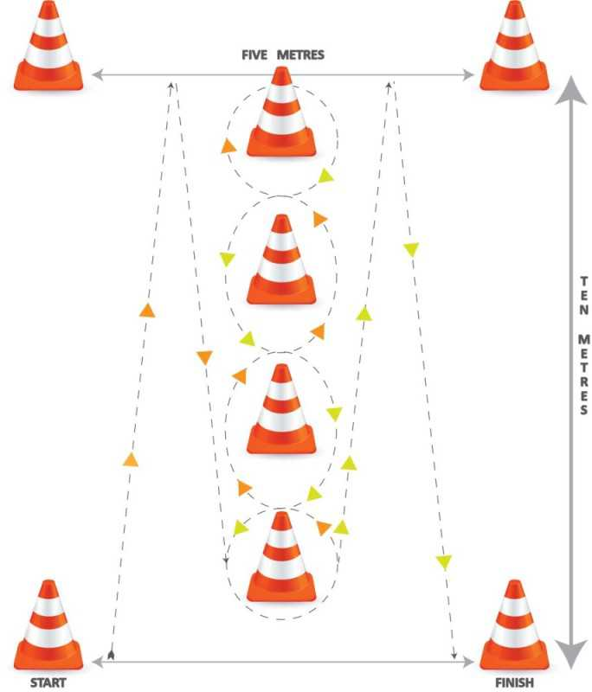
Gender | Excellent | Above Average | Average | Below Average | Poor
Male | <15.2 secs | 15.2 - 16.1 secs | 16.2 - 18.1 secs | 18.2 - 19.3 secs | >19.3 secs
Female | <17.0 secs | 17.0 - 17.9 secs | 18.0 - 21.7 secs | 21.8 - 23.0 secs | >23.0 secs
Describe a method of gathering information for measuring Agility?

………………………………………………………………………………………………………………………………………………………………………………………………………………………………………………………………………………………………………………………………………………………………………………………………………………………………………………………………………………………………………………………………………………………………………………………………………………………………………………………………………………………………………………………………………………………………………………………………………………………………………………………………………………………………………………………………………………………………………………………………………………………………………………

What was it measuring
What activity is it linked to
Where it took place
What did it look like
What resources did you use
How you carried it out / what it looked like

What are the benefits of carrying out this method?

………………………………………………………………………………………………………………………………………………………………………………………………………………………………………………………………………………………………………………………………………………………………………………………………………………………………………………………………………………………………………………………………………………………………………………

What are the limitations of carrying out this method?

………………………………………………………………………………………………………………………………………………………………………………………………………………………………………………………………………………………………………………………………………………………………………………………………………………………………………………………………………………………………………………………………………………………………………………

Development Approach – Agility
Speed/ Agility/ Quickness Circuit
To improve your level of agility you can use a speed, agility quickness (SAQ) circuit. This is a circuit which has a number of stations that force the performer to perform quick movements that force the body to change direction quickly. There must be significant rest periods between performers going through each station to avoid performers developing CRE or LME instead of agility.

Task: Complete the table below listing six different SAQ stations you have completed giving a description of what you done at each station.

Station | Description
1.
2.
3.
4.
5.
6.

Flexibility

Flexibility is the range of movement around a joint.

Impact on Performance

Good flexibility allows a tennis player to stretch without fear of injury during a game. This can be in the form of a player serving. Their good flexibility at the shoulders allows them to move their arm further backwards. This allows the player to swing their arm over a greater distance with pace which results in them serving the ball with a maximum speed.

Poor flexibility can have a negative impact on performance in gymnastics. If a gymnast can stretch their arms or legs into the correct position their performance will look messy and not smooth. They will also not be able to complete advanced moves required to get high scores during a gymnastics routine which will result in them getting a poor score.
Monitoring & Evaluating

While developing the approaches to develop your skills, you want to monitor your training to ensure the approaches are working. This will allow you to track any changes you may need to make. When monitoring you want to look for evidence that the approaches are working. This can be done through feedback. You will be able to give yourself feedback and gain feedback from others.

At the end of a training programme you can evaluate your performance by re-testing using the same methods of gathering information to assess how successful you now are at managing your emotions. This will allow you to compare your results, re-assess your current emotional state and help you identify any future development needs.

