Integrity, Equality, Respect, Responsibility, Ambition
Responsibility, Ambition, Integrity, Equality, Respect
Ambition, Integrity, Equality, Respect, Responsibility


Irvine Royal Academy

S3 PE Studies

Volleyball – The Physical Factor - Skills
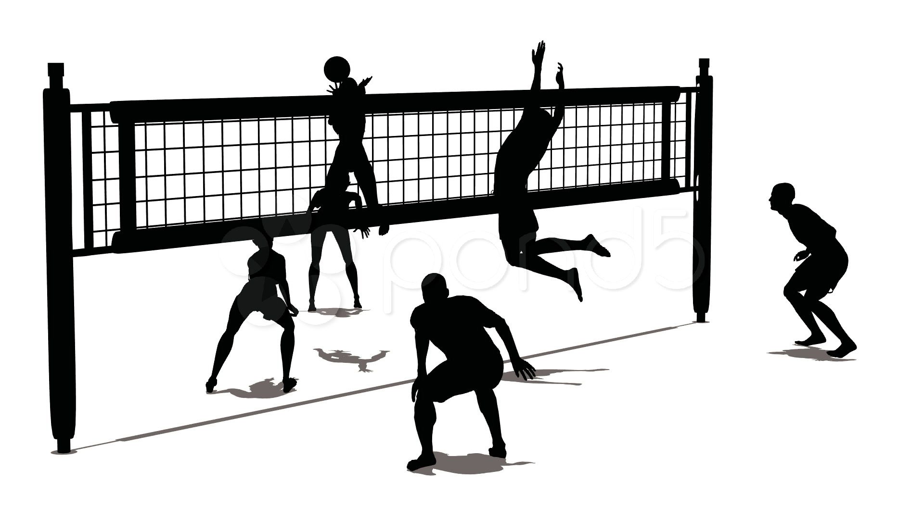

Name………………………………..

Class…………………………………

The Cycle of Analysis
The method(s) you use to identify factors (which are strengths and weaknesses) in your performance is the first stage of the cycle of analysis. Once you collect this information you can plan a programme to try and improve upon your weaknesses.
To develop your performance effectively you must understand and follow the ‘Cycle of Analysis’.

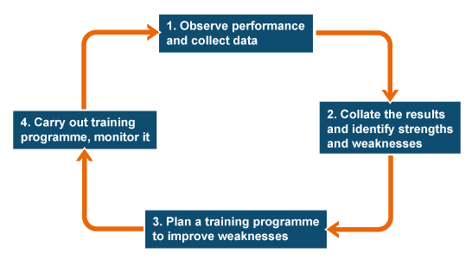

Features & Impact

Technical Qualities
Technical qualities are the features that allow you to execute skills. The table below shows a list of the technical qualities you will apply across all activities

Quality | Definition | Example
Timing | The choice, judgement, or control of when something should be done | A tennis player timing their jump so that they connect with the ball at its highest point when serving
Consistency | Actions or movements performed the same way regularly | A boxer continually landing jabs in the same area on their opponent

Question:
Give an example of when each of the above technical qualities are used in a different activity? Give different examples from the ones that are already provided above

Activity: ……………………………………

Timing
Consistency

Positive Impacts

If your timing is good when playing badminton then you can time the swing of your racquet to connect with the shuttle at its highest point. This will generate power which will make it difficult for your opponent to return the shuttle.

Negative Impact

If my consistency when playing a long pass in football is poor then I may not use that skill as I know I cannot play it well that often. This limits my options and may cause me to make the wrong pass due to this. This will result in me losing the ball more often which will give the opposition more opportunities to score.

Question:

Select a technical quality and write one positive and negative impact this can have on your performance in an activity. It does not need to be the same technical quality for the positive and negative impact.

Positive Impact ………………………………………………………………………………………
……………………………………………………………………………………………………………….……………………………………………………………………………………………………………….……………………………………………………………………………………………………………….

Negative Impact ………………………………………………………………………………………
……………………………………………………………………………………………………………….……………………………………………………………………………………………………………….……………………………………………………………………………………………………………….

Special Qualities

Special qualities are a combination of cognitive (thinking) skills and physical skills. The features we are going to examine are both creativity and imagination.

To be creative and imaginative during an activity is to develop new ideas and original ways of performing. This can be achieved in a number of different ways in sport from using a skill differently or by a team using a new tactic or movement.

An example of this maybe a football team using a set play routine they have created in training during a competitive match.

Question

Give an example of how you have been or could be creative during a volleyball match.

Positive Impact

A positive impact of being creative is that your opponents cannot predict what you are going to do in a match. This will make them uncertain on the best way to defend against you. Your opponent’s indecision will give you more time and space to play which will allow you to create more opportunities to score points.

Negative Impact

If you have a lack of creativity then you will become predictable to your opponent. If they know what you will do it is far easier for them to counteract your actions. This may result in them blocking your spikes during a match which will result in you scoring fewer points.
Quality of Performance

The quality of you performance is determined by how well you perform skills with quality and control. Two features that have a major impact on your volleyball performance are accuracy and control.

Accuracy

The importance of being able to play a skill with accuracy is vital in volleyball both to build attacks and score points.

Discuss with a partner how accuracy can positively impact on your performance and write the answer below.

Control

The ability to play skills with control is necessary to improve your ability in any activity. Give an example of what control looks like for each of these skills in volleyball:
Skill | Explanation
Setting

Dig

Serving

Spiking

Methods of Gathering Information

General Observation Schedule (GOS)

Observe your partner in a volleyball match and complete a GOS on their performance. Every time your partner performs a skill successfully you should put a (√) in the successful column next to that skill and every time they do not perform a skill well you will put the (√) in the unsuccessful column. After your partner has completed their match calculate the % of success they have by adding the total number of (√)’s and divide by 100. Times that number by the amount of successful (√) and that will give you the percentage.

Skill/technique | Successful | Unsuccessful | % of success
Serving
Tip
Spike
Attack volley
Dig pass
Volley pass
Set
Scatter Diagram

A scatter diagram focuses on accuracy and success of different types of shots used within a practice or game. Every time a performer plays a shot the observer marks on the court were the shot went and if it was successful (√) or unsuccessful (X). This highlights if the shot is being played with accuracy towards a specific area and if they shot is successful or not.

Select a skill that you will be focusing on and circle and area/s on the court where the performer should be aiming for with that shot.

Skill...................................
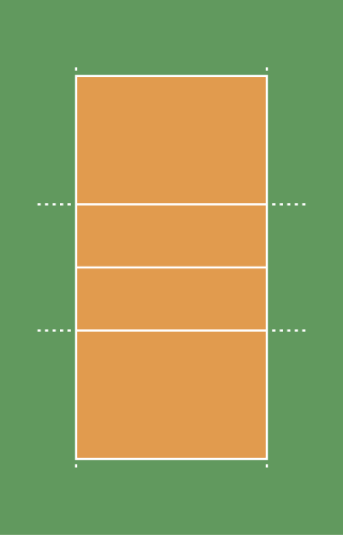

Focused Observation Schedule (FOS)

A FOS breaks down a specific skill into subroutines for the three different phases of the skill. These are preparation (P), action (A) and recovery (R) phases of a skill. This can also be referred to as a PAR Analysis Sheet.

Preparation → What you do to get ready to play the skill

Action → What you do when you perform the skill

Recovery → What you do after you perform the skill

Subroutines
A subroutine is all the small actions that make up playing a skill. When the skill is broken down into these subroutines each small action can be analysed. This allows the performer to see which part of the skill they are performing well and which part needs further development.

The observer will watch the performer play the skill 5 times and tick each time the subroutine is performed correctly and put an (X) every time it is not. Below is a FOS for Setting. Complete with a partner.

Subroutine | 1 | 2 | 3 | 4 | 5 | % of Success
Preparation
Move to the ball and square shoulder to the target
Feet shoulder width apart with arms and legs bent
Action
Contact the ball at its lower back
Receive the ball onto fingers and thumbs
Extend arms and legs towards the target
Push through the ball in one movement
Recovery
Hands finish pointing towards the target

The Benefits of Methods of Gathering Data – Skills

Each method of gathering data provides benefits when used to gather data and monitor progress. The table below shows a list of the benefits of the methods of gathering data already discussed in this booklet.

Method of Gathering Data | Benefits
General Observation Schedule | - This is a permanent record which can be later referred back to  - It highlights strengths and development needs in a performance  - It is easy to use  - It can be used for comparison when used to retest at the end of a training programme
Scatter Diagram | - It is easy to use  - It clearly shows a performer’s accuracy  - It is a permanent record which can later referred back to  - It can be used for comparison when used to retest at the end of a training programme
Focus Observation Schedule | - It highlights which subroutines within a skill a performer needs to further develop  - By isolating these subroutines a performer can use practices during their training programme that can develop the specific subroutines or phase of the skill  - It is a permanent record which can later referred back to  - It can be used for comparison when used to retest at the end of a training programme

Development Approaches - Skills

Gradual Build Up

A performer can use the gradual build up training approach to develop their ability to perform a skill. This approach breaks the skill down into smaller chunks, isolating aspects of the skill. As the performer becomes more able to perform each aspect of the skill the practices become more challenging and game like.

A number of training approaches can be used within the overall title of gradual build up. Below is a table giving a description of each and also the benefits of using each approach. Each of the types of development approach become more challenging as you continue through the table.

Development Approach | Description | Benefit
Shadow Practice | This is where a performer shadows the movement of the skill without the use of equipment | - You can learn the subroutines of the skill without having the pressure of a ball, shuttlecock etc.
Repetition Practices | This is where a performer repeats the same action over and over again during a practice | - You are able to practice parts of the skill that are causing you problems  - This development approach is highly adaptable  - Develop muscle memory by ‘grooving’ the technique
Pressure Drill | This practice involves a performer adding pressure to a practice e.g. increasing the speed, adding in timed challenges etc. | - You will be able to make practices more game-like  - You will learn to play the skill under pressure
Conditioned Games | A performer can introduce rules or conditions to a game to ensure a specific skill is used | - Your practice will reflect an actual performance  - You are able to focus on a specific part of your skill with a performance

Whole Part Whole

Whole part whole is a development approach that can be used by a performer to further improve a skill that they already have a level of competency in playing. An example of this may be a football who can play a long pass but is struggling to play it with the accuracy that they are needing during a game. Using whole part whole the performer can isolate the subroutine (part of the skill) that is causing the issue.

This allows the performer to work on this specific part of the skill without going through the process of working on the rest of the skill. This allows a competent performer to remain motivated as they only have to work on a single element of their technique. After the technique is corrected for that element of the skill then the performer would then go straight back to using the skill in a competitive scenario.
Monitoring & Evaluating

While developing the approaches to develop your skills, you want to monitor your training to ensure the approaches are working. This will allow you to track any changes you may need to make. When monitoring you want to look for evidence that the approaches are working. This can be done through feedback. You will be able to give yourself feedback and gain feedback from others.

At the end of a training programme you can evaluate your performance by re-testing using the same methods of gathering information to assess how successful you now are at managing your emotions. This will allow you to compare your results, re-assess your current emotional state and help you identify any future development needs.

