**Responsibility, Ambition, Integrity, Equality, Respect**

**Ambition, Integrity, Equality, Respect, Responsibility**

**Integrity, Equality, Respect, Responsibility, Ambition**

Irvine Royal Academy

Higher Physical Education

Badminton Block

Mental and Physical Factors Impacting Performance

Features Covered

Mental

* Level of Arousal
* Decision Making

Physical

* Skill Repertoire (Skills)

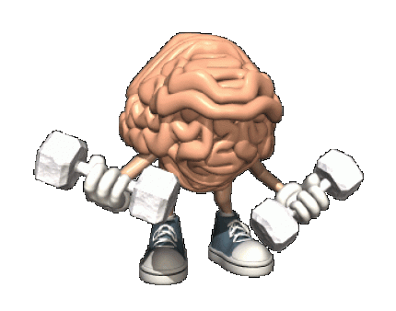[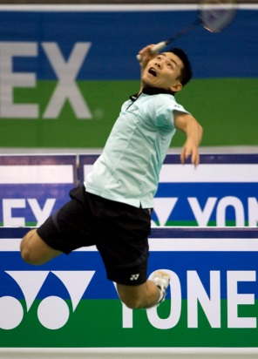](http://www.wired.com/playbook/wp-content/uploads/2012/08/AP09081106923.jpg)

Contents Page

|  |  |
| --- | --- |
| **Page** | **Content** |
| 1 | Front Cover |
| 2 | Contents Page |
| 3 | Introduction to the Course |
| 4 | Factors Impacting on Performance |
| 5 | Skill Repertoire |
| 6-8 | Level of Arousal |
| 9-10 | Decision Making |
| 11 | Mental and Physical Factors Checklist |
| 12 | Methods of collecting information |
| 13-16 | Stroke Repertoire and Technique Analysis Observation Schedule |
| 17 | Video Analysis |
| 18-24 | Decision Making Observation Schedule and Mental Toughness Questionnaire |
| 25 | Collecting Information Checklist |
| 26 | Approaches to developing performance |
| 27-28 | Stages of Learning |
| 29 | Shadow Practice |
| 30 | Repetition Drills |
| 31 | Pressure Drills |
| 32 | Combination Drills |
| 33 | Principles of effective practice |
| 34 | Goal Setting |
| 35-36 | Mental Imagery |
| 37 | Bensons Relaxation Response |
| 38 | Approaches Checklist |
| 39 | Recording, Monitoring and Evaluating |
| 40 | The purpose of monitoring and evaluating |
| 41-42 | Recording performance development - Training Diary |
| 42 | Monitoring performance development |
| 43 | Recording, Monitoring and Evaluating Checklist |

**Introduction to the course**

**Course content**

When studying Higher Physical Education you will learn about your own performance and how it can be improved. The process you go through will require you to reflect on what you already know from your study of PE and ask you to apply this knowledge further to unfamiliar situations.

You will learn about the factors that impact on performance and you will implement and evaluate approaches to develop performance further. This will be internally assessed. You will be required to demonstrate a broad and comprehensive range of complex movement and performance skills in TWO physical activities to pass the Performance Skills Unit.

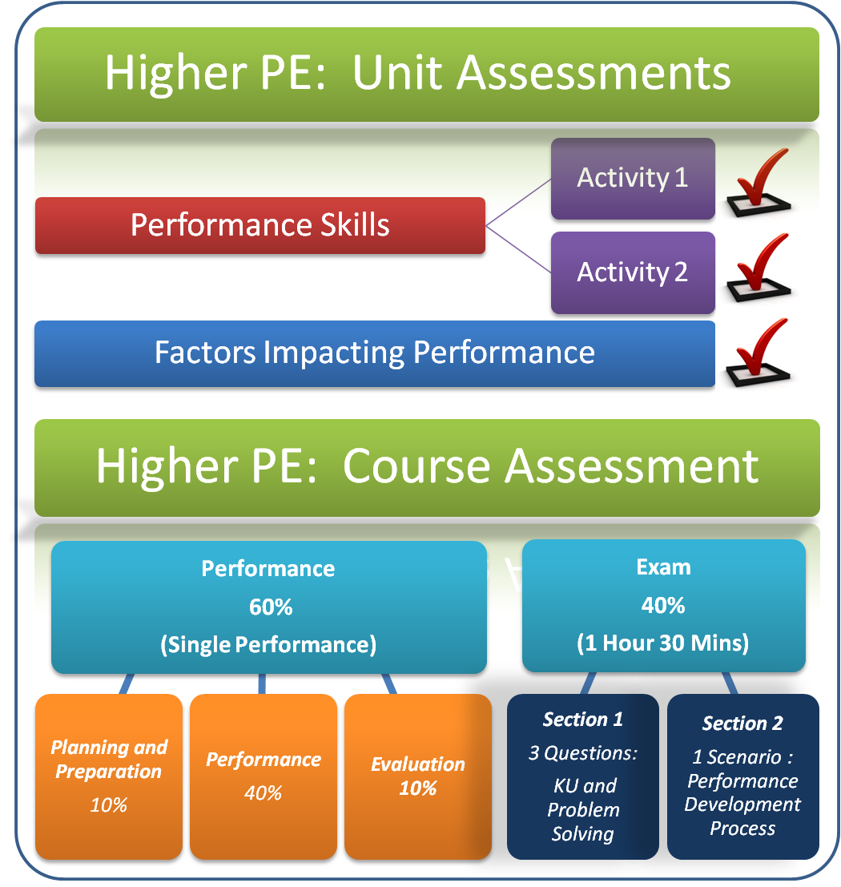

[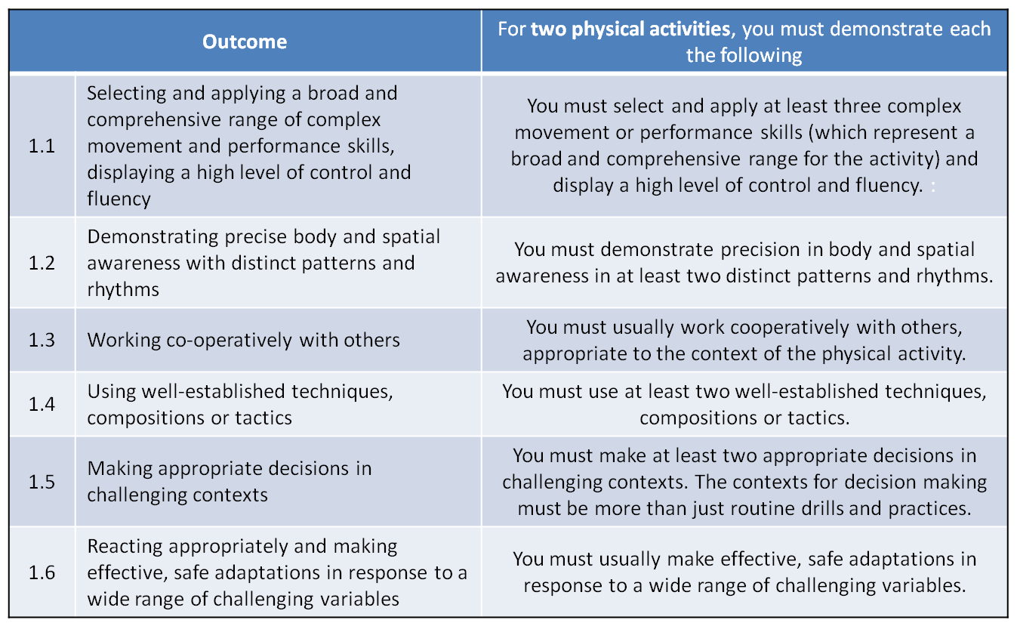](http://blogs.kincorth.aberdeen.sch.uk/higher/files/2013/12/HIGHER-PERFORMANCE2.png)

Factors Impacting on Performance

(Features)

|  |  |
| --- | --- |
| **Physical** | **Mental** |
| Skill Repertoire | Level of arousal |
|  | Decision Making |
|  |  |

The information in this section explains how different **factors** can have a **positive and negative impact on your performance** when competing in badminton

The two factors we will focus on are **mental and physical.** These factors are broken down into **features** and examples are provided explaining how these features will positively or negatively impact your performance.



**Physical Factor**

**Skill Repertoire *“All strokes have a purpose. As a performer you must understand what you can do with strokes you have in your repertoire”.***

**Skill is the body’s ability to master movement and co-ordinate the senses, brain and muscles efficiently and swiftly.**

Skill Repertoire is the range of skills that you have at your disposal during a badminton match which can be best utilised in **a variety of performance** situations. Your ability to perform skills and techniques within an activity will impact on your performance significantly. Your ability to both **develop your skill** level progressively and **perform a range** of skills within the activity will impact on your **whole performance**.

How does the ability to perform a range of skills and techniques **Impact Positively?**

In badminton the wider your shot repertoire the more able you will be to **apply the right shot at the right time** in the match. From any one point on the court you will have the potential to select a **number of shots** to send your opponent a problem. This will enable you to **vary the height, angle and speed** of your shots to **expose space** in the corners of the court and **dictate and control** the game. Also, the more varied your repertoire the **faster your decision-making abilities** as you have retained a bank of knowledge on the sport and have this experience of techniques and success to allow for a faster response and **confident performance**. Shots can be used to **place** the **shuttle in the corners** and build strong attacks. The quality of preparation for each shot allows for **economic and graceful movements.**

For example, in badminton, if you are able to perform an overhead clear to the back tramlines and accurately to the corners, this will impact on your performance positively as you can force the opponent back to create space at the front. You can prevent the main attacking shot the smash and can give yourself time to recover and build a strong attack when under pressure from a strong opponent.

How does a lack of skill repertoire **Impact** **negatively?**

If you are limited in your shot selection your play becomes very **predictable** and your **creativity, tactical** and **decision making potential** is massively **reduced**. Limited options prevent you from **creating space** on the court and **lack of timing, accuracy and technique reduces the movement required by the opposition**. Ultimately many points will be lost as you spend your time **constantly defending** and chasing the shuttle down. You will be limited in the way you can change the tempo of the game and limitation in the skills will impact your concentration, motivation and ability to cope under pressure.

For example, a badminton player who is unable to block the shuttle low over the net to the sides of the court will be forced to lift setting their opponent up for a possible smash.

**Mental Factor**

**Level of Arousal “*Arousal is defined as being an energised mental state of alertness and preparedness for an activity”.***

Arousal is the key factor in determining success in sport. Getting to, and then keeping, the right level of arousal is hard to achieve and is often the downfall of sports people. This is because both too little (Under arousal) and too much (Over arousal) can have catastrophic effects on performance.

[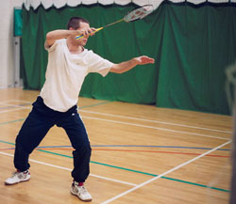](http://www.google.co.uk/url?sa=i&rct=j&q=&esrc=s&frm=1&source=images&cd=&cad=rja&uact=8&docid=pGCPkxnT0zLgEM&tbnid=5H9XAo9lH0kiUM:&ved=0CAUQjRw&url=http://www.badmintonbible.com/articles/grips-guide/which-grip/serve-return.php&ei=RPd5U9HeHeOv7Qa8o4DQDA&bvm=bv.66917471,d.ZGU&psig=AFQjCNHtaab-WywHkfYmnR2Nde4z4D9GrA&ust=1400588408647587)**Level of Arousal is impacted by**

* Criticism
* Recovery from injury
* Mistakes
* Crowd Pressure
* Anxiety
* Excitement
* Dips in form
* Intimidation by opponents

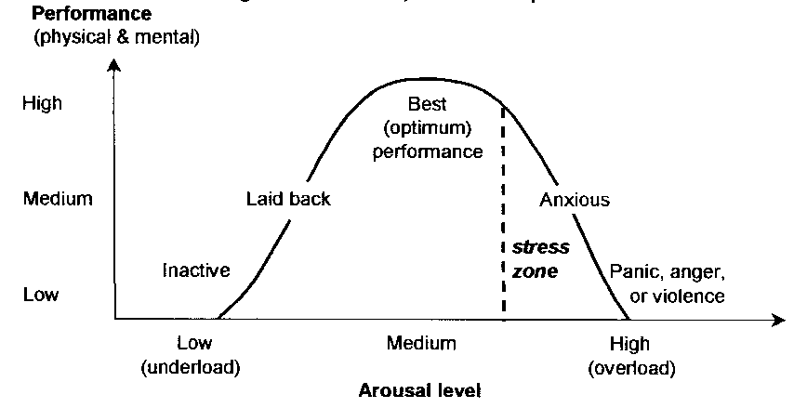

The key is to get “in the zone” and create a “performance Bubble” as a positive mind = 100% success

Optimum level of arousal

The level of arousal required for different sports significantly varies along with how athletes get themselves to this mental state. Think of Usain Bolt as he embraces the crowd and jokes about on the start line and the New Zealand rugby team as they perform the Hakka. If you took this high level of arousal to another sport such as the gymnastics beam or rifle shooting you can see the problems that this will cause to the performer where a calm mind, relaxed muscles and steady breathing are required.

[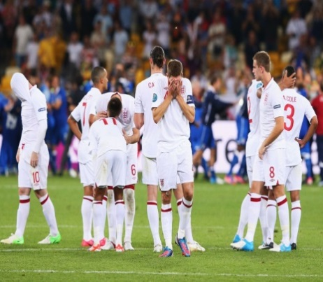](http://www.google.co.uk/url?sa=i&rct=j&q=&esrc=s&frm=1&source=images&cd=&cad=rja&uact=8&docid=acs4Lv-OC4-k5M&tbnid=QklnI0yE2QGx7M:&ved=0CAUQjRw&url=http://www.mirror.co.uk/sport/football/news/steven-gerrard-on-englands-euro-exit-939025&ei=6u15U7jkEY2M7Aa2hYG4Ag&psig=AFQjCNHaOE2VIuzaHf2kP7z6yAd7UFJd9Q&ust=1400585908887560)[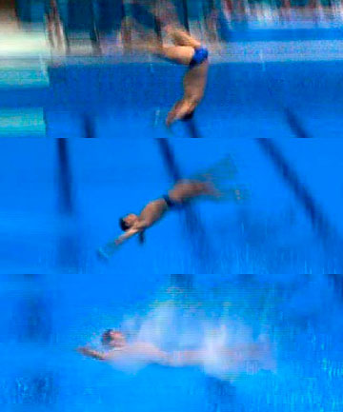](http://www.google.co.uk/url?sa=i&rct=j&q=&esrc=s&frm=1&source=images&cd=&cad=rja&uact=8&docid=2adH1V56o6pioM&tbnid=9ZXN770udBzwSM:&ved=0CAUQjRw&url=http://www.stuff.co.nz/sport/olympics/other-sports/7429660/Oh-Feck-German-diver-bombs-in-London&ei=jOx5U4yDLK-S7Ab49YDICw&psig=AFQjCNEu16RR7LYOwjNw4se-nLDCuKUqkg&ust=1400585636340483)Think of the catastrophic effect of **over arousal.**

**[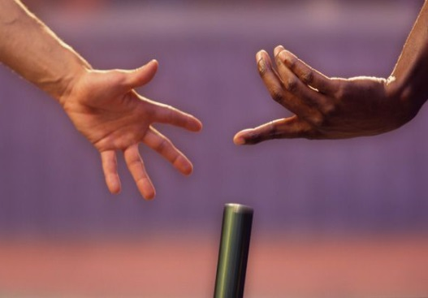](http://www.google.co.uk/url?sa=i&rct=j&q=&esrc=s&frm=1&source=images&cd=&cad=rja&uact=8&docid=0Q6G47U_ybsqaM&tbnid=6SL2wBICK90nPM:&ved=0CAUQjRw&url=http://caracaschronicles.com/2010/05/18/dropping-the-exchange-market-baton/&ei=2-55U5u6CMbA7AaN_4CADA&psig=AFQjCNGpZcz1MjZcvixZTro3RE8AmUvzbg&ust=1400586285082934)**

**German diver, London Olympics England football team and penalties Dropping the baton**

**RED ALERT**

[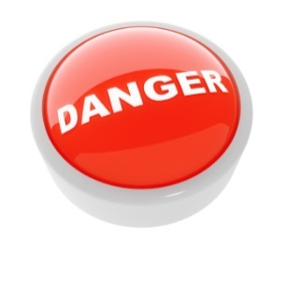](http://www.google.co.uk/url?sa=i&rct=j&q=&esrc=s&frm=1&source=images&cd=&cad=rja&uact=8&docid=m1ULHiVS9h5CBM&tbnid=UcE7dr865M0wQM:&ved=0CAUQjRw&url=http://www.hotforsecurity.com/blog/users-more-aware-of-browser-security-warnings-study-finds-6574.html&ei=lvF5U-q-Gc_07AbLtQE&psig=AFQjCNG-1-4CFuUzVmT96rOlyW8-wjBygQ&ust=1400586998968383)**Watch the Cracks appear!!!!!**

* **Errors due to nerves getting the better of you.**
* **Lack of drive to succeed**
* **Blame culture rather than reflect on self**
* **Dwell on the past and errors rather than the future**
* **Anger (Focus on mistakes)**
* **Impossible to goal set**
* **Anxiety dominates play (observed in mannerisms and body language)**
* **Concentration deteriorates**
* **Fatigue (Negative thoughts)**
* **Psychological barriers (Roger Bannister Example)**

How does being able to control your level of arousal **impact positively** on your performance?

In badminton being able to control your level of arousal and get it to the right level gets you prepared to do your best. The performer can shut out distractions and make the right decisions throughout the match on shot selection and movement. They have confidence in their performance and are less likely to choke under pressure. They can control the match and react to the cues of the opposition to prepare early and counter attack. They use their experience to shake off any issues in their performance to regroup very quickly. For example if a player serves twice out of the court they quickly focus on past performances and maintain concentration and correct the issue immediately and never dwell on the fault.

**Mental Factor**

**Decision Making “*Decision making is an action or process of choosing a preferred option or course of action from a set of alternatives. It forms the basis of all deliberate and voluntary behaviour”.***

Quality decision making is a critical skill in sports. The quality of your decisions has a massive impact on your

results. Experience plays a significant part in the decision making process such as your skill repertoire as do many other features.

**For example** Concentration Level of Arousal Decision making capabilities

The more developed a performer’s information processing system the better adept they are at responding to cues, sorting information, and drawing on past experiences which results in instant decisions. Anticipation is linked to the decision making process and players must learn to “read” a situation early to establish what things are unimportant, less important and very important. This helps an athlete to predict what might happen next and think one step ahead of their opponent and the game. This means they can plan ahead.

**For Effective decisions we make use of**

[](http://lizlovesbooks.com/lizlovesbooks/wp-content/uploads/2013/09/book_open-31.jpg)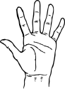SENSES PAST EXPERIENCE OUR ABILITY TO “READ” WHAT NEXT

[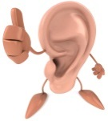](http://www.google.co.uk/url?sa=i&source=images&cd=&cad=rja&uact=8&docid=Plk1gDr_npSusM&tbnid=PFeS1SdWX6rXfM:&ved=0CAgQjRw&url=http://sixstringobsession.blogspot.com/2012/07/ear-training-101-figuring-out-chords-by.html&ei=eAh6U5aeBYGw7Qb954DABQ&psig=AFQjCNHfDtyulf-sbR2nloHa9RPfKw-0wQ&ust=1400592888180055)[](http://www.google.co.uk/url?sa=i&source=images&cd=&cad=rja&uact=8&docid=jf26Na3tcN_r-M&tbnid=3bUv94nJYfsbcM:&ved=0CAgQjRw4pQE&url=http://www.123rf.com/clipart-vector/blue_eyes.html&ei=Fgh6U7q_JO7o7AaSpIGgAQ&psig=AFQjCNEdvQdD2YeezfJxvAroDq-V0bsb3Q&ust=1400592790678188)

How does good decision making **impact positively** on performance?

Good strategic play (Decisions) is rooted in a solid skill and fitness base. Effective badminton players have good perception, good decision making skills and the ability to produce the required shot at the precise moment it is need. Fast decision making allows a varied stroke repertoire to be applied to manoeuvre and outmanoeuvre opponents. It allows a player to mix power and touch shots to get the opponent on the run giving them less time to react and think. Badminton is a problem solving game and the objective is to send difficulties over the net. Swift decisions results in a higher success rate, good timing, and fluidity in movements. (Right place, right time) It reduces errors in play as players respond effectively to cues in the game to make the correct judgements and they can ignore possible distractions. Decisions are more spontaneous without conscious thought as a player has strong belief in their ability.

How does poor decision making **impact negatively** on performance?

* Recall of past experiences limited impacting decisions and judgments in a "live performance"
* Poor attention selection (Focusing on what is not important)
* Inability to read the game and solve problems
* Miss vital cues in the game which would direct attention impacting anticipation.
* Frequent, repetitive mistakes
* Confusion from brain overload. Decision not instinctive, delayed as it takes longer to process info.

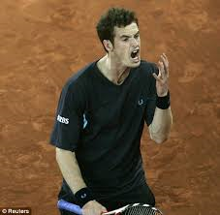

**What do I know checklist**

**Mental and Physical Factors**

***Check Your Progress***

Complete the following to check your understanding

***Help Getting Confident***

***Needed There***

***I can give a definition of all features***

***covered.***

***I have an increased understanding of***

***features***

***I can evaluate the impact of positive and***

***negative factors.***

***I can apply my knowledge of factors to an***

***unknown scenario.***

**Methods of Collecting Information**

The information in this section describes how you will **collect information** on the **factors impacting on your performance** in badminton.

It will also explain the **benefits** and **limitations** of using each method.

The methods of collecting information are as follows:

|  |  |  |
| --- | --- | --- |
| **Activity** | **Factor** | **Methods of collection** |
| **Badminton** | **Physical** | * Stroke Repertoire Observation Schedule * PAR Analysis Observation Schedule * Video Analysis |
| **Mental** | * Decision Making Observation Schedule * Mental Toughness Questionnaire |

[](http://www.privatelabelnutra.com/supplement-manufacturer-blog/wp-content/uploads/2012/08/shutterstock_102366094.jpg)

**PHYSICAL Feature – Skill Repertoire STROKE REPERTOIRE OBSERVATION SCHEDULE**

**Your partner will watch you in a game of badminton, 2 sets against an opponent of equal ability, and assess your**

|  |  |  |  |  |  |  |  |  |
| --- | --- | --- | --- | --- | --- | --- | --- | --- |
|  | **1st Analysis** | | | | **2nd Analysis** | | | |
| **Skills** | **Effective**  **(Skill played to a high level/**  **successful with outcome)** | **Fairly Effective**  **(Skill outcome achieved but could be improved. Skill nearly successful)** | **Ineffective**  **( Poorly executed/**  **Unsuccessful)** | **% Effective** | **Effective**  **(Skill played to a high level/successful with outcome)** | **Fairly Effective**  **(Skill outcome achieved but could be improved. Skill nearly successful)** | **Ineffective**  **( Poorly executed/**  **Unsuccessful)** | **%**  **Effective** |
| **Low Serve** |  |  |  |  |  |  |  |  |
| **High Serve** |  |  |  |  |  |  |  |  |
| **Overhead clear** |  |  |  |  |  |  |  |  |
| **Drop Shot** |  |  |  |  |  |  |  |  |
| **Smash** |  |  |  |  |  |  |  |  |
| **Net Play** |  |  |  |  |  |  |  |  |
| **Block** |  |  |  |  |  |  |  |  |

**performance using the table below. Place a tally mark in the appropriate area for each shot. Performance can also be videoed.**

**PAR ANALYSIS OBERVATION SCHEDULE**

**(MECHANICAL ANALYSIS)**

**THE OVERHEAD CLEAR**

**Watch a model performer on the iPad executing the skill (to paint a mental picture). The subroutines below can then be used as a comparison to your own performance.**

**Task: A feeder will hit as many feeds as necessary to gain appropriate information about performance. The performer will clear each feed whilst an observer records the effectiveness in each phase of the action.**

|  |  |  |  |
| --- | --- | --- | --- |
| **PHASE OF ACTION** | **MODEL PERFORMANCE** | **1ST PERFORMANCE** | **2ND PERFORMANCE** |
| Preparation | * Starts from base * Performer tracks path of shuttle and sidesteps quickly to the back of the court * Racket is taken up and back behind head * Rear shoulder drops * Front arm is up and extended to sight the shuttle |  |  |
| Action | * Shoulder arm and racket are brought forward at speed to generate power * Action resembles throwing action * Weight is transferred forward from back to front foot at impact with shuttle * Impact is with open racket face * Strike is through shuttle and weight transfer continues forward |  |  |
| Recovery | * Racket comes down and across body in recovery position * Forward momentum at the end of the action leads to return to base and recovery of ready position. |  |  |

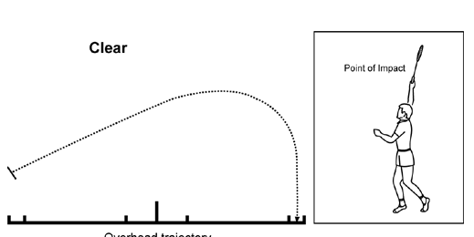

**Stroke Repertoire Observation Schedule**

To collect initial data on my performance in badminton a stroke repertoire observation schedule was used. This schedule listed the various shots of badminton. Whilst playing two sets against an opponent of equal ability an observer marked down each time I played one of these shots on a sliding scale from effective to ineffective.

**Technique Analysis Observation Schedule**

Having identified my weakness, the next stage was to obtain more focused data on this shot. Before looking at my own performance, I observed a model performer execute the skill as many times as necessary to gain the set criteria (P.A.R). This painted a picture of how the skill should be performed. (Mechanics and flightpath) Having written criteria in the form of a technique analysis observation schedule my shot was observed. An observer sat at the side of the court and observed me in a feeder practice whilst a partner racket fed to the back of the court as many shuttles as necessary. The observer put a tick or cross next to each criteria for the identified shot as I moved from base to the back of the court and recovered quickly back to base after striking the shuttle.

**Benefits of using an observation schedule**

* The written format provides a permanent record that allows for comparison at a later date.
* Having an observer it provides objective feedback which is non-bias providing more accurate results.
* By playing in a competitive match against someone of equal ability you are forced to play your full range of shots adding to the validity of the findings as the pressurised situation can highlight consistency.
* By completing the schedule over a sustained period of time patterns of play can be observed. It is also possible to see dips in form. The more information the more vivid the picture on performance. Occasionally, a player takes longer to get into the match. This duration provides them the opportunity to do this.
* All tally marks can be converted into statistics which are hard to argue with.
* Strengths and weaknesses can be identified from the schedule which future performance development programmes and goal setting can be based upon.
* Focussed observation schedules allow you to compare the mechanics to that of a model which motivates and inspires progress
* Objective feedback by a person with activity knowledge ensures validity and reliability of the results to create a detailed analysis of performance.
* Focussed observation schedules enable performers to identify faults and training priorities can then be built to support development of these flaws.

**Limitations with Observation Schedules**

1. When you have someone else recording information on performance the validity of the results are dependent on the observers focus and attention during the match and the importance they place on the process. Also, if they are lacking activity knowledge their perception of what equals an effective shot might be different from the reality.
2. Badminton is a very fast paced sport and there is likely to be a number of shots in every rally. This can make it impossible for one observer to record all shots played. When they take their eye of the match to complete the schedule shots are missed questioning the reliability of the findings.
3. If the opposition is not of a similar ability this will provide false results and a performer might not be forced to play their full range of shots if insufficient pressure is applied.
4. The content of the observation schedule has to be correct in the first place to focus on key elements of performance and allow for detailed observations.
5. The mental and emotional state of the performer is crucial if accurate results are to be collected. Lack of motivation, resilience, and anxiety etc will impact the quality of shots, decisions, concentration and technique. If a performer is over tired, hungry etc this will impact their play and ultimately the results.
6. Focussed observations completed in a closed environment although they provide lots of clear information it might not be realistic. For example in badminton often a player is coming from a different point on the court every time to play a clear in a game and with less time to prepare. In a feeder drill you have extra time and less pressure and it is therefore not replicating game situations.

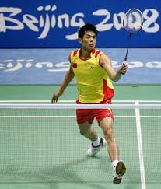

**Video Analysis**

Video analysis, a commonly used tool in modern sports, can provide a **training boost** for individual and team competitions. Coaches and trainers analyse video from **live competitive action** and **training exercises**, and the results of their careful analysis provide **helpful feedback** for the athletes. Thanks to video analysis, athletes can gain a **competitive edge, correct faults and maximize their strengths**.

**Advantages**

* Footage can be slowed down or paused to observe sub routines in more detail to highlight strengths and faults in performance.
* When recorded in an open, competitive environment you can find trends and patterns you can change. A basketball team may be vulnerable defensively on the outside, a golfer may hook his iron shots or a badminton player may lack power in their clears. Once the weak link is discovered, it can be modified and improved upon.
* It is a permanent record which allows you to compare at a later date to monitor progress.
* Vital source of visual feedback which paints a picture of stage of learning and provides motivation
* Badminton is such a fast paced sport and almost impossible for an observer to record all shots in a tally sheet (Observation schedule). Through utilizing video analysis at the same time it can increase the validity of results and ensure information is not omitted to provide a clear picture on performance.

**Limitations of Video Analysis**

[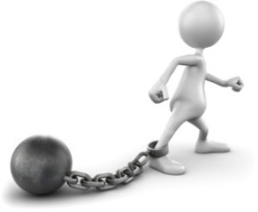](http://www.google.co.uk/url?sa=i&rct=j&q=&esrc=s&frm=1&source=images&cd=&cad=rja&uact=8&docid=BaDoXrnZdEshbM&tbnid=UeXJ-6GO8rvKKM:&ved=0CAUQjRw&url=http://www.mindmeister.com/326228381/wireless-technology&ei=VxCkU4eaE-2f7AaBzoCYBw&bvm=bv.69411363,d.ZGU&psig=AFQjCNHtclZOzliDDCDAWnoiIdwPoZXVsw&ust=1403347347505596)

**Collating the results and analysing what is in front of a performer can be difficult. Can they recognise and accept issues in their performance? This might be impacted by activity experience and knowledge.**

**It can take time to collate results.**

**Can you always guarantee that the ipad will be available?**

**Lighting might be poor which impacts the quality of your results. The space and angle of the Camera can be an issue to get all the action in.**

**Mental Sub Factor: Decision Making Decision Making Observation Schedule**

An Observer will record you playing a match against an opponent of equal ability. Get them to record the back court shots you play in the game. Record where they were played **from on the court.** **Code D= drop shot C = Clear and S = smash**

|  |  |  |  |  |
| --- | --- | --- | --- | --- |
| **1st Analysis** | | |  | |
|  |  |  |
|  |  |  |
|  |  |
|  |  |  |
| **2nd Analysis** | | |  |
|  |  |  |
|  |  |  |
|  |  |
|  |  |  |

**Mental Factor: Level of arousal Mental Toughness Questionnaire**

|  |  |  |
| --- | --- | --- |
| **Reboundability** | True | False |
| I) I frequently worry about mistakes. |  |  |
| 2) I get really down on myself during performance when I mess up. |  |  |
| 3) It’s easy for me to let go of my mistakes. |  |  |
| 4) If I start out badly, it’s hard for me to turn my performance around. |  |  |
| *5) I* get distracted by what the coach thinks whenever I screw up. |  |  |
| 6) I bounce back quickly from setbacks, bad breaks and mistakes. |  |  |
| **Handling Pressure** | True | False |
| 7) I do my best when there’s more pressure on me. |  |  |
| 8) I get too nervous to really perform to my potential. |  |  |
| 9) I do better in practice than I do when it really counts the most. |  |  |
| I0) I tend to get easily psyched out or intimidated. |  |  |
| II) I can keep myself calm and composed under pressure. |  |  |
| I2) I don’t want the ball, I dread competing at “crunch time.” (big game/race). |  |  |
| **Concentration** | True | False |
| I3) The coach’s yelling knocks me ***off*** my game. |  |  |
| I4) I tend to get easily distracted. |  |  |
| I5) Certain opponents can get into my head and throw me off my game. |  |  |
| I6) Lousy playing conditions (weather, field conditions, temperature, etc.) negatively  affect me. |  |  |
| I7) I have no trouble focusing on what’s important and blocking everything else out. |  |  |
| I8) Ithink too much about what could go wrong right before and during performance. |  |  |
| **Level of confidence** | True | False |
| I9) One or two failures do not shake my confidence. |  |  |
| 20) I tend to compare myself too much with teammates and opponents. |  |  |
| 2I) I’d rather compete against a better opponent and lose than go up against a weaker  opponent and win. |  |  |
| 22) I am a confident and self-assured athlete. |  |  |
| 23) I tend to be too negative. |  |  |
| 24) I have trouble dealing with negative self-talk (thoughts). |  |  |
| **Motivation** | True | False |
| *25)* I get more motivated after failures and setbacks. |  |  |
| 26) It’s easy for me to consistently train at a high level of intensity. |  |  |
| 27) I think about how today’s practice will help me get to my goals. |  |  |
| 28) I find myself just going through the motions a lot in practice. |  |  |
| 29) I have clear goals that are important for me to achieve. |  |  |
| 30)I am a highly motivated athlete. |  |  |
| **Level of Arousal** | True | False |
| 31) I have some anxiety, worry or excess tension prior to or during competition. |  |  |
| 32) Pre-game jitters stay with me well into the competition and don’t go away. |  |  |
| 33) I often feel too excited or amped up to perform to my best in a competition. |  |  |
| 34) I sometimes feel distracted or confused when I perform under pressure. |  |  |
| 35) I sometimes too laid back in training and competition |  |  |
| 36) I sometimes miss vital signals in the game |  |  |
| **Decision Making** | True | False |
| 37) I can ignore irrelevant information during my performance |  |  |
| 38) I can focus on more than one piece of information at a time |  |  |
| 39) I frequently become overloaded which results in errors |  |  |
| 40) My decisions are sometimes delayed, resulting in a slower response |  |  |
| 41) I can adapt my play in response to different problems |  |  |
| 42) I tend to make the same mistakes throughout a game |  |  |

**Section 1**, questions 1-6 deal with “Reboundability” or your skill at mentally bouncing back from setbacks and mistakes. Mental toughness depends on your ability to quickly leave your mistakes and failures behind you. Hanging onto your mistakes will get you into big trouble, performance-wise. Athletes who dwell on their mistakes while the competition continues, end up making more.

**Section 2**, questions 7-12 deal with the ability to handle pressure. Without the ability to stay calm in the clutch, an athlete will always underachieve. Peak performance demands that you are relaxed once the performance begins. While a little nervousness is critical for getting “up” for a game/match/race and performing at your best, (“good nervousness”) too much nerves (“bad nervousness”) will tighten your muscles and send your performance down the tubes.

**Section 3**, questions 13-18 deal with your concentration ability. In every sport, your ability to focus on what’s important and block out everything else is one of the primary keys to performance excellence. Poor concentration is the major reason why athletes choke and get stuck in performance slumps. Getting psyched out or intimidated is a direct result of concentrating on the wrong things.

**Section 4**, questions 19-24 deal with your level of confidence and the factors that affect confidence. One characteristic of the mentally tough athlete is he/she possesses a confidence level that seems to be unshaken by setbacks and failures. Under the pressure of competition, low confidence will neutralize natural ability, hard work and talent. Similarly, high confidence will enhance an athlete’s training and

God-given talents, lifting their performance to the next level.

**Section 5**, questions 25-30 deal with motivation. Motivation is the fuel that will drive your training to a successful completion and the accomplishment of your goals. Without adequate motivation athletes get stuck having “permanent potential.” Without motivation you won’t put in the work necessary to become a winner. Your motivation allows you to pick yourself up after a setback and keep going.

**Section 6**, questions 31 – 36, deal with ***Level of Arousal.*** This is the ability to control your state of alertness in order to perform at your optimum level. An athlete who is under-aroused will be over relaxed and may miss vital signals in the game. In contrast, an athlete who is over-aroused will have an adrenaline surge which will result in them over-anticipating cues and making mistakes and panicking.

**Section 7**, questions 37 – 42, deal with ***decision making*** This is the ability to process information and respond to cues in the game, resulting in an appropriate motor response from a number of options. An athlete who can make decisions quickly and effectively will experience positive outcomes, however poor decisions can lead to loss of points, loss of concentration and frequent errors.

[](http://www.upmcmyhealthmatters.com/wp-content/uploads/2013/06/MentallyToughMeme.png)

**MENTAL TOUGHNESS QUESTIONNAIRE**

|  |  |  |
| --- | --- | --- |
| **Question** | **True** | **False** |
| Section 1: Reboundability | | |
| 1 | 0 | 1 |
| 2 | 0 | 1 |
| 3 | 1 | 0 |
| 4 | 0 | 1 |
| 5 | 0 | 1 |
| 6 | 1 | 0 |
| Section 2: Handling Pressure | | |
| 7 | 1 | 0 |
| 8 | 0 | 1 |
| 9 | 0 | 1 |
| 10 | 0 | 1 |
| 11 | 1 | 0 |
| 12 | 0 | 1 |
| Section 3: Concentration | | |
| 13 | 0 | 1 |
| 14 | 0 | 1 |
| 15 | 0 | 1 |
| 16 | 0 | 1 |
| 17 | 1 | 0 |
| 18 | 0 | 1 |
| Section 4: Confidence | | |
| 19 | 1 | 0 |
| 20 | 0 | 1 |
| 21 | 1 | 0 |
| 22 | 1 | 0 |
| 23 | 0 | 1 |
| 24 | 0 | 1 |
| Section 5: Motivation | | |
| 25 | 1 | 0 |
| 26 | 1 | 0 |
| 27 | 1 | 0 |
| 28 | 0 | 1 |
| 29 | 1 | 0 |
| 30 | 1 | 0 |
| Section 6: Level of Arousal | | |
| 31 | 0 | 1 |
| 32 | 0 | 1 |
| 33 | 0 | 1 |
| 34 | 0 | 1 |
| 35 | 0 | 1 |
| 36 | 0 | 1 |
| Section 7: Decision Making | | |
| 37 | 1 | 0 |
| 38 | 1 | 0 |
| 39 | 0 | 1 |
| 40 | 0 | 1 |
| 41 | 1 | 0 |
| 42 | 0 | 1 |

**Marking scheme**

|  |  |
| --- | --- |
| **Section** | **Score**  A score of 6 in any category means this is a mental strength for you |
| Reboundability |  |
| Handling Pressure |  |
| Concentration |  |
| Confidence |  |
| Motivation |  |
| Level of Arousal |  |
| Decision Making |  |

**OVERALL SCORE**

[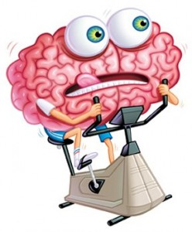](http://www.google.co.uk/url?sa=i&rct=j&q=&esrc=s&frm=1&source=images&cd=&cad=rja&uact=8&docid=-qg-YXO-xpVw4M&tbnid=UxQgP_TLgVYHtM:&ved=0CAUQjRw&url=http://steveleurquinintentionalliving.com/2012/03/01/the-challenge-of-mental-fitness/&ei=GrZwU8-BG5Dy7AaUxICADg&bvm=bv.66330100,d.ZGU&psig=AFQjCNFk6cFWHqaCYZqOr7CUzljiVpE-WQ&ust=1399981973821302)A score of 36 - 42 indicates strength in overall mental toughness. Scores of 32 - 35 indicates average to moderate skill in mental toughness. Scores of 31 or below mean that you need to start putting more time into the mental training area.

**Decision Making Observation Schedule**

To gain information on my decision making a decision making observation schedule was completed whilst I played against an opponent of equal ability to 21 points. Every time I played an overhead shot (Clear, Smash, Drop Shot) an observer marked down where I had played the shot from on the court. The observer used the following code: D=Drop Shot, C = Clear, S = Smash. Two analyses were completed, one at the beginning of the block and the other at the end.

**Benefits and Limitations of a Decision Making Observation Schedule**

**Benefits**

* Decision making strengths and weaknesses can be identified from shot selection and court position .This will inform future performance development programmes and goal setting.
* By playing in a competitive match against someone of equal ability you are forced to play your full range of shots adding to the validity of the findings as the pressurised situation can highlight consistency.
* By completing the schedule over a sustained period of time patterns of decision making can be observed. Occasionally, a player takes longer to get into the match. This duration provides them the opportunity to do this.
* Having an observer it provides objective feedback which is non-bias providing more accurate results.
* Objective feedback by a person with activity knowledge ensures validity and reliability of the results to create a detailed analysis of performance.
* The written format provides a permanent record that allows for comparison at a later date.

**Limitations**

* When you have someone else recording information on performance the validity of the results are dependent on the observers focus and attention during the match and the importance they place on the process.
* Badminton is a very fast paced sport and there is likely to be a number of shots in every rally. This can make it impossible for one observer to record all shots played. When they take their eye of the match to complete the schedule shots are missed questioning the reliability of the findings.
* If the opposition is not of a similar ability this will provide false results and a performer might not be forced to play their full range of shots if insufficient pressure is applied.
* Lack of motivation, resilience, and anxiety from a performer will impact decision making. If a performer is over tired, hungry etc this will impact their play and ultimately the results.

**Mental Toughness Questionnaire**

The mental toughness questionnaire is used to collect information on the mental factors that impact on my performance in badminton. It is completed at the beginning and the end of the badminton block. The questionnaire is in a paper format and has 42 questions which are split into the following sections:

* **Reboundability**
* **Handling Pressure**
* **Concentration**
* **Confidence**
* **Motivation**
* **Level of Arousal**
* **Decision Making**

For each section I answer the questions as either true or false in relation to my mental toughness. After completing the questionnaire I use the marking scheme to calculate my overall score. A score of 36 - 42 indicates strength in overall mental toughness. Scores of 32 - 35 indicates average to moderate skill in mental toughness. Scores of 31 or below mean that you need to start putting more time into the mental training area.

**Benefits and Limitations of the Mental Toughness Questionnaire**

**Benefits**

* The written format provides a permanent record that allows for comparison at a later date.
* Strengths and weaknesses can be identified from the questionnaire which future performance development programmes and goal setting can be based upon.
* The performer is gaining lots of information on their mental state. The more information they have on their performance the more accurate and valid the results.
* A coach/teacher/performer can get large quantities of information about Mental factors in a relatively short period of time. Subsequently, strengths and more importantly weaknesses can be identified quickly and addressed through an appropriate development programme and monitoring process.
* Everyone in the class is answering the same questions This reduces bias and increases the validity and reliability of the results because the performers are not being influenced by an interviewer.

**Limitations**

* The information which is being collected is based on a performers perception of their mental performance. Subsequently, this could impact on the validity of the results as it could be a bias assessment.
* It depends on the importance a performer places on the process. If a performer doesn't take the process seriously this will impact of the validity of the results.
* Results could be inaccurate if a performer misinterprets the questions.
* It can take a long period of time to collect and analyse the results.
* The questions being asked are only closed questions. A lack of open questioning means that the performers answers lack explanation, which could impact on the accuracy of the results.

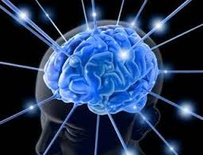

**What do I know checklist**

**Data Collection**

***Check Your Progress***

Complete the following to check your understanding

***Help Getting Confident***

***Needed There***

***I can describe at least two methods***

***of data collection for the Physical***

***and Mental Factors***

***I can explain why each method is***

***Appropriate. 2 Reasons minimum***

***I can evaluate the limitations of each***

***method.***

***I can analyse results to reflect on strengths***

***and weaknesses.***

***I understand the importance of model***

***performers.***

Approaches to Developing Performance

The information in this section provides you with **approaches** to developing **Mental** and **Physical** Factors.

Each approach will be **explained** and the **benefits** and **limitations** will be **evaluated**.

The section will also incorporate **Mandatory Knowledge** which will have to be applied within your answers for homework tasks, the FIP unit and final exam.

For **Badminton** several approaches will be explained and evaluated.

|  |  |  |  |
| --- | --- | --- | --- |
| **Physical** | **Approach** | **Mental** | **Approach** |
| Skill Repertoire | * Shadow Practice * Repetition Drill * Pressure Drill * Combination Drill | Level of arousal  &  Decision Making | * Mental Imagery * Relaxation Techniques **(Bensons Relaxation Response)** |

**Stages of Learning *Mandatory Knowledge***

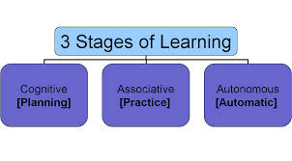

**Cognitive Stage**

The performer is gathering information on what to do and how to do it. During this stage the performer will have **many faults and the action will appear crude and lack control and refinement**. A **great deal of thought** goes into carrying out every movement pattern or skill which they are unfamiliar with. A badminton player at this stage will have **a limited stroke repertoire and will lack accuracy and control** in each action. Movement round the court looks uncoordinated and **energy consuming** with many errors taking place due to lack of control and timing, (missing the shuttle or being off balance). A novice badminton player at this stage of learning would be expected to have **slower reactions**. They have a great deal of information to process, which is new to them. Therefore, **decisions** they make during practice or game situations **take longer** to judge and evaluate.

Cognitive stage performers will use the following approaches:

* **Shadow Practices**
* **Repetition Drills (Simple)**

**External and Internal Feedback are critical** at this stage to correct faults before they become learned. Feedback has to be very accurate and precise to improve its effectiveness. Providing feedback immediately will enable an individual to act on it instantly. Positive feedback also provides encouragement.

Practice sessions will be **short** in duration to **avoid boredom** but long enough for **meaningful**

progress.

**Associative Stage**

At this stage performers are **putting the movements together**. This practice will allow them to become familiar with the sequence and timing of the various parts (sub-routines) involved. This is where **they detect and correct small faults**, then repeat the corrected movement over and over again (repetition). **They still have to think about the execution of the skill but some parts will be automatic** (the skill is starting to become grooved in your muscle memory). They can execute the skill in more demanding performance situations and practices, but **the skill can still break down under moderate pressure.**

Associative stage performers will use the following approaches:

* **Pressure Drills**
* **Repetition Drills (More Complex)**

Feedback is still vital at this stage to **reinforce various subroutines** when perfecting the movement.

The amount of practice and length of practice will depend on:

* **How complex the skill is (backhand overhead clear).**
* **The level of your desire to do well (motivation).**
* **Past experience.**

**Automatic Stage**

Automatic performer skills are so well learnt that they require **no thought**. An efficient badminton player when returning a shot from the back of the court knows that he/she can **execute a range of skills** from this point. This gives them more time to consider other points of performance such as **their opponents likely response or the pace and direction of the shot**. An automatic badminton player requires **no feedback** in the execution of a skill as they can feel when shots are efficient themselves. This player **moves effortlessly** round the court and can perform all skills quickly and efficiently. They are very perceptive and can respond to a problem an opponent delivers instantaneously.

Automatic stage performers will use the following approaches:

* **Pressure Drills**
* **Combination Drills**

**Physical Factor: Skill Repertoire**

**Shadow Practice**

A shadow practice is when you practice the movements of the shot without actually hitting the shuttle. This means you get a feel for the action and become comfortable with the movements of the shot. Practicing in isolation means you get fluency and timing in your action and movement. Players will visualise the skill through demonstrations by a model performer or viewing footage to build up a mental picture of the skill. Practice sessions will be short in duration to avoid boredom, but long enough for meaningful progress e.g. 3 x 30 seconds. Shadow practices are commonly used when learning a new skill where the performer has limited or no experience (**Cognitive Stage of Learning**).

**Examples of using it:**

A common use of shadowing to improve technique is when performing the Overhead Clear in Badminton (OHC). A performer would mimic the movement patterns of the preparation, action and recovery without contacting a shuttle. Think of the number of times a golfer will shadow a putt before taking the shot.

Advantages

* You can break the skill down into a series of subroutines which only involve part of the skill/technique, which make the skill/technique easier to learn.
* Since there is no external factors or hitting of the shuttle there is a greater chance of success.
* You are practicing the skill in a closed situation which means you can receive immediate feedback from a coach, teacher or partner. This allows you to make immediate corrections to your technique.

Disadvantages

* Performers can find this particular type of practice boring which can result in lack of focus and attention. This lack of challenge could lead to a decrease in overall performance.
* Since there are no external pressures the athlete will not get the opportunity to work on other parts of their game e.g. fitness, tactics, mental pressures. Since it is not related to game type pressures the athlete will not have to use complex movement patterns or make decisions and solve problems quickly.
* If quality external feedback is not provided at this early stage of practice it can result in bad habits which are more difficult to remove at a later stage.

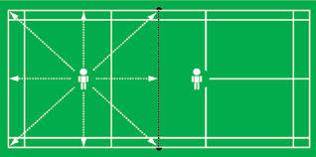

**Repetition Drill**

Repetition drills as the name suggests involves performing a skill repeatedly. The full skill can be repeated over and over again to develop muscle memory making the skill more natural and automatic. Repetition drills can also be used to focus on and practice certain parts (subroutines) of a skill. Focussing on the skill through repetition also eliminates the distraction of the game and other skills and helps to 'groove' the correct technique. Varying the practices and including rest periods are required when completing repetition drills to avoid boredom and fatigue.

Example: **High Serve-Overhead Clear return x 20**.

Advantages

* For a coach, teacher or partner is easy to spot faulty technique and correct immediately.
* Repeating a skill many times will eliminate faults and develop muscle memory. Focussing on the skill or part of the skill through repetition drills also eliminates the distraction of the game and other skills, and helps to ‘groove’ the correct technique through concentration.
* Varying the practice conditions and including appropriate rest periods when completing repetition drills avoids boredom and fatigue and ensure quality practice.
* You can receive various methods of feedback through a controlled situation e.g. video footage, coach's feedback, observation schedule.
* As a performer develops consistency other skills can be gradually introduced to make more game-like.
* Motivation can be sustained through targets set, i.e. straight and cross court clears played to 2 hoops at alternate corners as a target to aim for.

Disadvantages

* If a feeder is inconsistent and therefore ineffective all repetitive practice is counterproductive as a performer will not get to refine movement patterns.
* If the equipment, i.e. shuttles are of a poor quality it will impact the success and motivation of the performer.
* Repetitive practice is only effective if constructive feedback is given regularly to prevent bad habits and poor technique. Skills must be consolidated in this closed environment.
* If movement or other skills are introduced into the practice too early the skill could break down and learners may have their confidence destroyed.

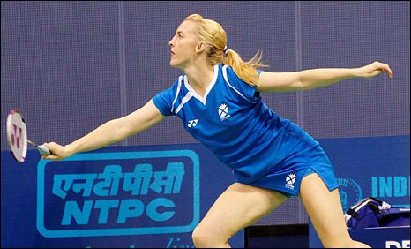

**Pressure Drills**

Pressure drills are an approach used which consists of deliberately creating intensive conditions for skill practice, much more difficult than those required in the actual game. Pressure training allows a performer to experience greater pressure during training to give them the chance to learn how to use and cope with pressure effectively during competitions. You must practise pressure situations in training, so they become normal and easy to handle. This will not only develop the physical factor but your emotional and mental strength to cope and perform under pressure. Decision making can only be developed in this context.

**An example in badminton would be to play 5 clear shots but after every shot the performer must flick a shuttle away from the service line. However, feeds are fast giving the performer less time to recover and prepare for the next shot.**

Advantages

* Allows you to make the practice more game-like when your anticipation and decision making needs to be faster.
* Allows you to perform under similar pressures to that you would experience in a game which can be unpredictable and open increasing performer motivation and challenge.
* Pressure training may improve the speed of executing skilled movements, and help performers retain the skills under the duress of competition.
* A number of complex movement patterns and skills can be combined.
* Develops consistency, timing and accuracy with the added bonus of preparing you mentally for similar situations during competition to enable you to remain calm and focussed.
* Fitness and tactics can be introduced to a pressure drill to work on the whole game.

Disadvantages

* If pressure training continues after the skill breaks down, learners may have their confidence destroyed and the training may be counterproductive.
* Performers under mental or physical stress could get muscle tension that leads to poor technique or movement during the activity.

**Combination Drills**

In a combination drill more than one skill is practiced. In badminton 2 players could perform the following combination: **High Serve, Overhead Clear, Drop Shot, Lift**. This drill could be increased in difficulty by making it continuous. This practice develops skills in more game like situations and allows the development of movement to play the shots. Variety is also brought into the practice to avoid boredom and to increase the quality and relevance of the practice. This approach is used during **the Associative (Practice) stage of learning leading towards the Automatic stage.**

Advantages

* Encourages players to link skills together and show fluency in ever changing movement patterns
* Lots of problem solving and quick decision making situations to use the correct shots at the correct time
* It places a developing skill into a situation with many external pressures and competition.
* Motivational practice for the experienced player.

Disadvantages

* It relies on both players being able to execute a range of shots and move fluently around the court. If one player is unable to do this the practice will continually break down and improvements in performance will not be made.
* If pressure-training continues after the skill breaks down, learners may have their confidence destroyed and the training may be counterproductive.
* Performers under mental or physical stress could get muscle tension that leads to poor technique or movement during the activity.

[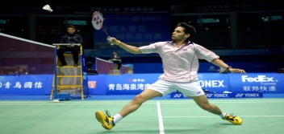](http://www.sportskeeda.com/tennis/team-india-at-london-2012-day-one-wrap/)

**PRINCIPLES OF EFFECTIVE PRACTICE *Mandatory Knowledge***

In order to ensure that practices are effective and that improvement will take place, performers need to consider the Principles of Effective Practice. By considering the list below, performers can plan and carry out an effective training programme that will enable them to achieve their goals.

**SPECIFIC**

Practice must be specific to your needs. This means the programme must take into account your strengths, weaknesses, stage of learning and demands of the activity.

**PROGRESSION**

It is important to monitor practices for improvements – if you are constantly playing an accurate shot it’s time to make the practice more demanding. Practices must show progression. As you improve, you can move on to slightly more demanding practices. You can add to the demands of practices by increasing competition, having to carry out skills quicker, performing longer sequences of work and being able to cope with the demands of performing under pressure.

**WORK/REST RATIO**

Practices must have intervals of rest to maintain quality. In all forms of training you need to calculate the ratio of work to rest. Working out this ratio is one of the key issues in making skill-training specific to your needs. The ratio varies according to:-

- Your previous experience in the activity

- Your level of practical ability.

- The complexity of the skill involved.

- The physical demands involved in the practice

This will avoid fatigue setting in and increase motivation. When you get tired, the quality of your practice deteriorates, rather than carry on, it is better to take a rest. Better still, organise the session so that you can take turns as player, observer and feeder. The points made above relating to duration are also relevant when considering fatigue.

**REGULARITY**

If there is too much time between practice sessions, little of what has been learned will be carried over to the next practice. Practising every day is ideal but this is not always possible. Two or three times a week is enough for good progress to be made.

**VARIETY**

Practices must be varied to avoid boredom and so you are motivated to improve and practise.

**EXCITING**

Practices must be exciting and challenging. This makes you want to practice and keeps high levels of concentration and motivation. A short, exciting, and interesting training session is better than an overlong one where you become bored and disinterested.

**GOAL SETTING**

Setting clear objectives and SMARTER goals as part of your training programme will motivate you to improve.

**Goal Setting**

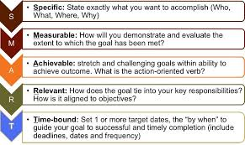

**Approaches to developing Mental Performance**

**Mental Features - Decision Making and Level of Arousal**

**Mental Imagery/Visualisation**

Mental imagery, or visualisation sometimes called mental rehearsal, involves the athlete imagining themselves in an environment performing a specific activity using all of their senses (sight, hear, feel and smell). The images should have the athlete performing successfully and feeling satisfied with their performance.

Visualisation is proving to be an understandably popular mechanism with elite athletes eager for marginal gains. The use of imagery primes their muscles to perform correct technique and to execute appropriate actions in competition, but it also conditions their mind to think clearly about how they will react to certain pressures, situations and problems. Consider it a ‘mental warm-up or walk through” of what you want to see happen. A vivid picture and strong feelings are like a magnetic attraction so be careful of what you picture with feeling, because you will be pulled in that direction. For the novice, Mental imagery may well improve confidence, relieve anxiety and help to control arousal levels.

[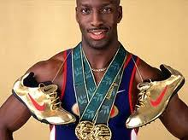](http://www.google.co.uk/imgres?q=michael+johnson&um=1&hl=en&biw=1366&bih=587&tbm=isch&tbnid=22NWtlKHj6NR8M:&imgrefurl=http://ukchoc.com/2011/10/24/top-10-black-sportsman-5-michael-johnson/&docid=NUopcXk3e_4f8M&imgurl=http://ukchoc.com/wp-content/uploads/2011/10/Michael-Johnson.jpg&w=275&h=206&ei=vw5BT-OJE4ej0QWXtLiPDw&z) ***“Throughout my career, any time I wasn’t doing something that required my full attention, my mind defaulted back to visualising races. Several times a day, I would automatically imagine the gun going off and myself contending with a different scenario each day. Running through my options in my mind before I ever hit the track was critical” (Michael Johnson, Olympic champion, athletics)***

**How it works?** 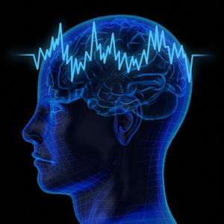

It is safe to assume that we all know our brain is a complex machine. It relies on Electrical transmissions through the neural pathways which fuel our senses. When we learn new skills our brain cells form new connections improving memory- therefore skills. Knowledge is stored in our brain and as we learn it changes and becomes upgraded- with thousands of hours of practice. Imagery/visualisation is a short cut which primes our mind for what it ultimately instructs our bodies to do. It is also like downloading new software and our brains upgrade quicker.

[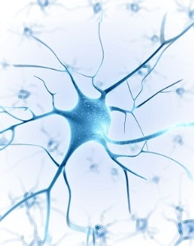](http://understandingcontext.com/wp-content/uploads/2013/12/Neuron-Branches-300.jpg)You rehearse entire sequences in your brain without moving a muscle. Every part of a skill or performance is repeated over and over again. The brain is activated when we imagine a movement. Rehearsal in your mind creates pathways in the brain cells as if executing the skill/performance, grooving the actions. Pathways are therefore already in place when a performer carries out the performance leading to confidence, self-belief and success.

**When should it be carried out?**

This approach is carried out daily and focuses on different elements of the performance. Targets are set for all mental training to replicate goals during practice. Every eventuality should be visualized so that the performer is fully prepared for unpredictable situations. **It is equally if not more important than the physical training**.

**How to apply mental imagery?**

* This method is used regularly by many of the world’s best tennis players. Novak Djokovic and Andy Murray both use imagery to prepare for games. Djokovic was taught to visualise his shots to the accompaniment of classical music by his first coach.
* Murray has even been known to [make several visits to a deserted Centre Court](http://www.theguardian.com/sport/2012/jun/24/wimbledon-2012-andy-murray-centre-court) in advance of Wimbledon in order to mentally acclimatise to the environment. “I have sat on Centre Court with no one there and thought a bit about the court, the matches I have played there,” Murray said. “I want to make sure I feel as good as possible so I have a good tournament.”
* A basketball player will use imagery in a free through situation and close their eyes visualizing successful execution. (mechanics, flight of the ball, sound of the swoosh etc)
* A cyclist will rehearse their race knowing where all the uphill sections of the course are, where he or she plans to overtake, where the tight more technical section are etc.
* A gymnast will rehearse set skills in their routine and gradually develop this visual picture so that the full routine is linked together and performed fluently in the performers mind with an audience.

Advantages

* It can motivate the athlete by recalling images of success in past competitions or beating a competitor in competition.
* It can reduce negative thoughts by focusing on positive outcomes.
* Refocus the athlete when the need arises e.g. if performance is feeling sluggish, imagery of a previous best performance can help get things back on track.
* Set the stage for performance with a complete mental run through of the key elements of their performance to set the athletes desired pre-competition feelings and focus.
* Having rehearsed any eventuality you will be able to cope with pressure allowing you to remain calm and stay in control.

Disadvantages

* Some athletes may imagine negative previous performances in past competitions or against a particular opponent, which can impact on performances and results.
* This type of approach takes a lot of practice for it to have a positive impact. Performers must use it every day in order to master the technique, especially with fast paced and complex sports like badminton.
* You must be physically able and proficient at badminton for this technique to be successful. If you are unable to perform the basic skills and movement patterns of the game, imagery will be ineffective.
* In the moment, this approach can be forgotten as distractions and external factors result in the performer missing the cue which identifies that fear, excitement could impact arousal level to refocus.

Relaxation Techniques - Benson's Relaxation Response

Benson's technique is a form of meditation that can be used to attain quite a deep sense of relaxation and can be ideal for staying calm in between rounds of a competition. Learning the relaxation response helps to counter ill effects of the fight or flight response and, over time, allows the development of a greater state of alertness. It can be mastered with just a few weeks practice and comprises 7 easy steps:

1. **Sit in a comfortable position and adopt a relaxed posture**
2. **Pick a short focus word that has significant meaning for you and that you associate with relaxation (e.g. relax, smooth, calm, easy, float, breath etc)**
3. **Slowly close your eyes**
4. **Relax all the muscles in your body**
5. **Breathe smoothly and naturally, repeating the focus word**
6. **Be passive so that if other thoughts enter your mind, dismiss them and return to the focus word – do not concern yourself with how long the process takes**
7. **Continue this for 10-15mins or as required.**

For this technique to work the following conditions must be in place:

* The athlete must believe the relaxation will help.
* A quiet, dimly lit and warm room which is free from interruption must be used.

Advantages

* This technique promotes rest, recovery and recuperation.
* It removes stress related reactions e.g. increased muscular tension
* The establishing of a physical and mental state which has increased receptivity to positive mental imagery
* It establishes a set level of physical and mental arousal prior to warming up for competition.

Disadvantages

* If the athlete is not relaxed or doesn't fully commit themselves to the process then this technique will be ineffective.
* If an athlete doesn't perform this technique in a quiet environment then it will be ineffective as he/she will be unable to fully relax and focus on the 7 steps.
* This type of approach takes a lot of practice for it to have a positive impact. Performers must use it every day in order to master the technique, especially with fast paced and complex sports like badminton.
* You must be physically able and proficient at badminton for this technique to be successful. If you are unable to perform the basic skills and movement patterns of the game, imagery will be ineffective.

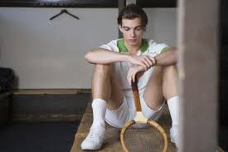

**What do I know checklist**

**Approaches**

***Check Your Progress***

Complete the following to check your understanding

***Help Getting Confident***

***Needed There***

***I understand the stages of learning***

***I can produce a relevant programme of work.***

***I can describe and justify at least 2 approaches***

***for a mental and physical factor***

***I understand and can apply the principles***

***of effective practice to develop a mental and***

***physical factor.***

**Recording, Monitoring and Evaluating**

**[](http://www.brindlemedia.net/wp-content/uploads/2012/11/Evaluate.jpg)**

The information in this section explains the purpose of monitoring and evaluating performance development in badminton.

It will explain different methods for recording and monitoring performance development for both Mental and Physical Factors.

**The Purpose of Monitoring and Evaluating Performance**

* Evaluating performance will allow you to see if performance has improved and also if the training programme has worked. You may have to make adaptations/progressions to your approaches.
* Re-testing using all methods of analysis is appropriate as the programme may have resulted in improved Technique but no improvement in Scatter Graph and Match Analysis sheet results.
* If results are positive then this can improve motivation to develop performance even further.
* New strengths and weaknesses can be identified and future development needs can be agreed.
* The information from the evaluation process can also be used to plan a new training programme that will be specific to the new weakness identified.





**Recording Performance Development**

**Training Diary**

After each training session you will use your diary to **record your progress**. After each session this diary must be completed.

|  |  |  |  |
| --- | --- | --- | --- |
| **Date** | **Aim of the Session** | **Description of Session** | **Describe how you felt the session went**  **(Reflection on practices and goals)** |
|  |  |  |  |
|  |  |  |  |
|  |  |  |  |

**Why is a training diary appropriate?**

* The format of the training diary offers an opportunity to clearly identify the aim of each session. This is important as it focuses planning on practices/approaches that are specific to targeted areas, leading to a greater purpose of training.
* A training diary can give an enormous amount of information about what has happened in the past and how training has gone in the past. When [planning](http://www.brianmac.co.uk/plan.htm) future training , information of this kind is invaluable to ensure programmes of work are appropriate and specific to development needs.



**Monitoring Performance Development**

The best way to monitor your progress is through regular feedback. You should collect data before you begin your programme then you can compare subsequent data to see if your skill levels have increased. You can receive feedback from your teacher or coach highlighting your progress and you have your own internal feedback coupled with knowledge of performance and knowledge of results.

The following methods could be used to **monitor** performance development throughout a training programme:

* **Stroke Repertoire Observation Schedule**
* **Technique Analysis Observation Schedule**
* **Video Analysis**
* **Teacher Feedback**
* **Knowledge of results**
* **Decision Making Observation Schedule (Scatter Graph)**
* **Mental Toughness Questionnaire.**

**What do I know checklist**

**Recording, Monitoring and Evaluating**

***Check Your Progress***

Complete the following to check your understanding

***Help Getting Confident***

***Needed There***

***I can explain the importance of monitoring***

***I can describe a method to record progress***

***and explain why it is appropriate.***

***I can describe a method to monitor progress***

***and explain why it is appropriate.***

***I can reflect and analyse on the issues***

***surrounding the monitoring process.***