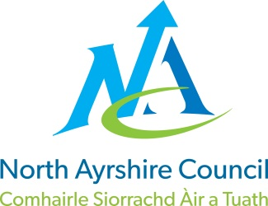
COMMUNITIES & EDUCATION DIRECTORATE
Executive Director (Interim): Caroline Amos
Cunninghame House, Irvine KA12 8EE
Tel: 01294 310000 www.north-ayrshire.gov.uk

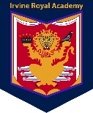

IRVINE ROYAL ACADEMY
Kilwinning Road
Irvine
Ayrshire KA12 8SJ
Telephone: 01294 278756
Email: irvineroyal@ea.n-ayrshire.sch.uk

LS/IH

21.12.21

Dear Parent/Carer

Can I start by thanking you all for your fantastic support throughout this term. Despite the continual challenges, we have endeavoured to provide a high level of service – I am exceptionally proud of my staff for doing so. You will have noted from our last three newsletters that we have continued to add value to the school experience and thus afford your young people the opportunity to achieve beyond the classroom – we have succeeded in that regard.

It is unfortunate that we enter the Christmas break with such uncertainty – that said, our staff are fully prepared for whatever comes our way in 2022. Irrespective of any changes, we will ensure that your young person is supported to attain and achieve to the best of their ability and that their health and wellbeing remains a key focus. We will strive to ensure that learning and teaching continues and that our resources are deployed effectively.

We have recently issued our Senior Phase Prelim schedule (17th – 28th January 2022) to S4 – S6 pupils – a copy can be found on the website (www.irvineroyal.co.uk). In the main, Prelims will take place in classes – this is due to the latest government guidance.

As previously communicated, the school will close at 2.30pm tomorrow – the times of the school day have been altered slightly and lunch will commence from 1.30pm.

Finally, if you have not yet had the chance to view our recent concert, ‘A Virtual Christmas’, I would urge you do so: https://youtu.be/LExAa0ASZfo

Wishing you and your family a happy and safe Christmas and New Year!

Linzie Sloan

Linzie Sloan
Head Teacher

