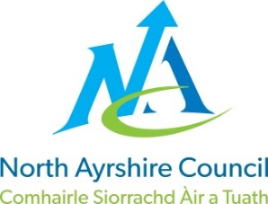
COMMUNITIES & EDUCATION DIRECTORATE
Executive Director : Audrey Sutton
Cunninghame House, Irvine KA12 8EE
Tel: 01294 310000 www.north-ayrshire.gov.uk

IRVINE ROYAL ACADEMY
Head Teacher : Linzie Sloan
Kilwinning Road
Irvine
Ayrshire KA12 8SJ

Telephone : 01294 278756
Email : irvineroyal@ea.n-ayrshire.sch.uk

LS/CPW

10 May 2022

Dear Parent/Carer

I am writing to make you aware that following the tragic loss of one our pupils, Kaden Collins, the Funeral arrangements have now been confirmed by the family.

Kaden’s funeral will take place on Tuesday 17 May 2022 at 12.00pm at the Cooperative in Irvine and then Knadgerhill Cemetery at 1.00pm. I am aware that a number of pupils wish to attend Kaden’s Funeral and would ask that Parents/Carers accompany their young person to what will be a very upsetting experience.

A significant number of our staff will also be in attendance and thus classes will be collapsed whilst the Funeral is taking place.

Please do not hesitate to get in touch if you have any further queries – in particular, if you require suitable uniform attire for your young person – we will help out in any way that we can.

Yours sincerely

Linzie Sloan

L Sloan
Head Teacher

