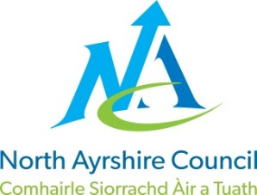
COMMUNITIES & EDUCATION DIRECTORATE
Executive Director: Audrey Sutton
Cunninghame House, Irvine KA12 8EE
Tel: 01294 310000 www.north-ayrshire.gov.uk

IRVINE ROYAL ACADEMY
Head Teacher: Linzie Sloan
Kilwinning Road
Irvine
Ayrshire KA12 8SJ

Telephone: 01294 278756
Email: irvineroyal@ea.n-ayrshire.sch.uk

JG/JG

7 June 2022

Dear parent

I am very much looking forward to your young person joining us here at Irvine Royal Academy officially on Thursday 18 August 2022.

On that morning they should report to the Sandy Road entrance for 8:45 am where I, along with other staff and their S3 guides, will meet them and support them in getting to their registration classes. To support their sense of belonging to IRAc they should be in full school uniform (those who did not receive a tie on the induction days will be given one that day), if you require additional uniform this can be ordered through our school website.

If you have any questions or queries please do not hesitate to contact the school to speak to the relevant Principal Teacher of Guidance as noted below:

Arran – Liz Davidson
Bute – Lorraine Clifford
Cumbrae – Laura Gibson

We all at IRAc are looking forward to your young person becoming part of our school community.

Yours faithfully

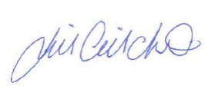

Jill Gilchrist
DHT

