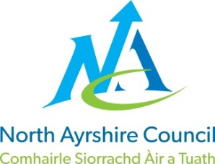
COMMUNITIES & EDUCATION DIRECTORATE
Executive Director: Audrey Sutton
Cunninghame House, Irvine KA12 8EE
Tel: 01294 310000 www.north-ayrshire.gov.uk

IRVINE ROYAL ACADEMY
Head Teacher: Linzie Sloan
Kilwinning Road
Irvine
Ayrshire KA12 8SJ

Telephone: 01294 278756
Email: irvineroyal@ea.n-ayrshire.sch.uk

29 August 2022

Dear Parent/Carer

Vaping

Can you please remind your young person that vaping is NOT permitted inside the school building or in the school grounds.

Since our return, the fire alarm has been set off and the emergency services called – this has been due to vaping.

Parents/Carers will be contacted to come up to the school to meet with a member of SLT, should your young person be caught vaping. This message has been relayed at all House Assemblies and in Registration.

Yours faithfully,

Linzie Sloan

L Sloan
Head Teacher

