Garden Tasks for Classes

Listed below are the jobs that need completing in the garden. There are some jobs that are necessary as part of the ongoing maintenance of the garden and are essential to ensure all members of our school community can access this space safely – these are highlighted in green. Other tasks are more seasonal

TASK | DETAILS | TOOLS REQUIRED
Clear weeds from paths | All weeds to be removed from between paving slabs. Weeds once removed to be put in one of the compost bins | 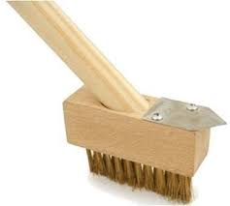
Sweep Paths | Paths need to be kept clear of rubbish – plastic items to go into normal bin all leaves etc. to go in a compost bin | 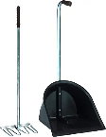  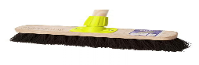
Litter Picking | All plastic litter and rubbish to be put in green bin next to stairs | 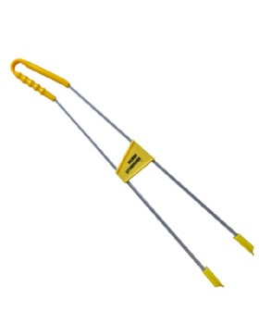
Raking Grass | Use rake to remove all debris and from the grass – plastic items to go into normal bin all leaves etc. to go in a compost bin | 