NORTH AYRSHIRE COUNCIL
COMMUNITIES DIRECTORATE (EDUCATION SERVICE)

CONFIGURATION OF 35 HOUR WEEK: SESSION 2022/2023

SCHOOL: Irvine Royal Academy
The 35 hour working week is comprised of three elements:
- 22.5 hours maximum class contact.
- 7.5 hours minimum personal allowance.
- 5.0 hours remaining time.
Agreed activities up to an annual maximum of 190 hours detailed below:

Activity  (from) Annex D | Time  Allocation
Parents’ Evenings (Face-to-face and Virtual) | 14 hours
Meetings Department:  Staff:  ELT: | 10 hours
 | 5 hours
 | 7 hours (From Additional Time)
Tracking/Reports/Interventions/Attainment Analysis | 40 hours
Union Meetings | 3 hours
Assessment and Moderation | 30 hours
Curriculum Development and Working Groups | 26 hours
Digital Platform Preparation and Administration | 30 hours
Additional Time – Preparation/Correction/QA/PRD/P7 Open Evening | 27 hours
Flexibility | 5 hours
Total | 190 hours
Plus In-Service Days | 5 days

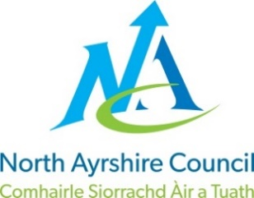
Head Teacher: Linzie Sloan – 5/9/22
School Union Representative(s):
Dane Love – SSTA
Lorraine Clifford – EIS

